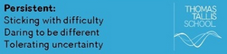
What were the causes and consequences of the Industrial Revolution c1750-1900?
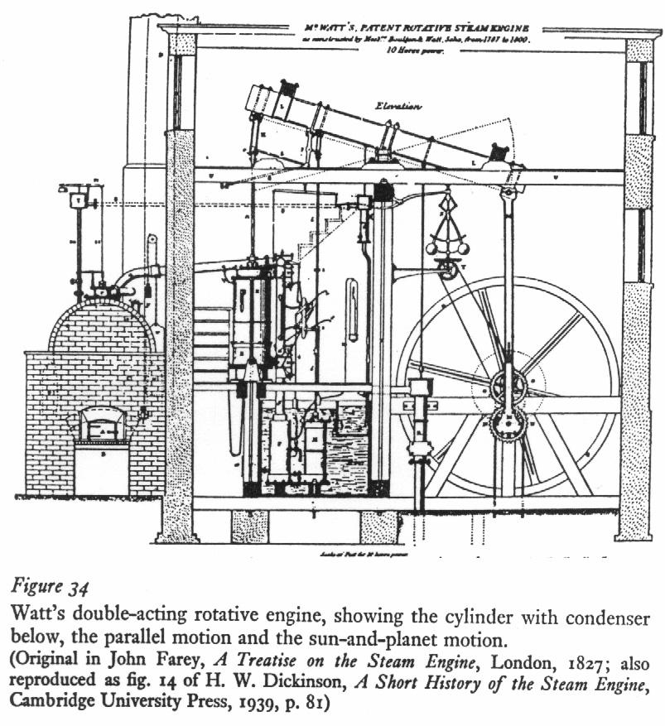

This is a diagram of Boulton and Watt’s steam engine from 1782. Using cogs and gears they turned the up and down movement into rotary motion. This invention meant that the water wheel could be replaced as the main source of power and the steam engine could be used to power the machinery in the new factories. By 1820 all new factories were built to run on steam power alone.

Overview
- What factors enabled Britain to have an industrial revolution 1750-1900??
- What were the effects of Industrial change 1750-1900?
- Were children’s working conditions in the factories really terrible in the period by 1830?
- Were children’s working conditions in the coal mines really terrible in the period by 1830?
- How far did Greenwich Marsh change during the period 1750-2000?

A List of Key Terms and their meanings in this topic.

Getting started with the Mystery! Background contextual information. Share your thinking and tolerate uncertainty. Think about this image in pairs and share your thoughts.
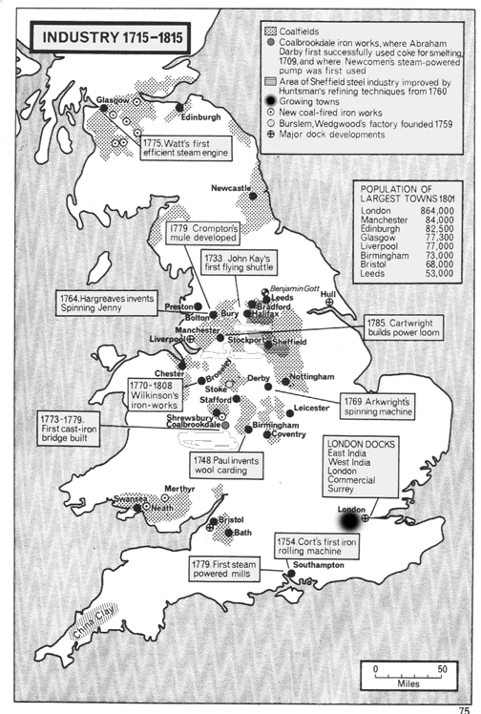
Nature : This is a
Origins: This was produced by....in X.
Purpose: The purpose of this image was too...
Content: The image shows
Knowledge: There were a range of views about..

Development Activity 1. Thinking through causation and consequence of the Mystery. In pairs think through the categories that help explain the mystery. Share your thinking with another pair sticking with difficulty and tolerating differences of view.

1People in this period of time began to marry much earlier and have more children that survived. Population grew in Britain from 9 million in 1700 to 41 million in 1900. More children meant that they could work as jobs in the countryside and towns grew. It was an economic incentive for a couple to have children. |  | 7During the 1700’s onwards the British Empire began to grow fast. With the growth of Empire trade began to grow which British merchants controlled. The countries in the Empire had to buy British goods and sell raw materials cheaply to Britain. A lot of money was made by merchants to invest in British industry.
2 The new machinery that was being invented needed a source of power. Water power was unreliable and the invention of the steam engine by Boulton and Watt in 1782 meant that it could now be used to power machinery in mills and factories on a more reliable basis. |  | 8 There were many individuals in Britain who saw that there were many opportunities to develop new businesses. These people would develop their ides and make a plan to launch a business with the backing of investors. This is so for agriculture, industry and transport. These people are called entrepreneurs.
3 Britain had many areas of the country in which coal and iron ore could be found. These raw materials were important in providing the machinery and the power in order to support the revolution in industry. Coal and iron reserves could be found in many areas of the British Isles. |  | 9 The rising population led to an increase in demand for food and cloth. This stimulated change in the agricultural and textile industries. More people also needed cooking pots and a source of heat and this stimulated change in the iron and coal industries. The growth in population also meant there were more workers.
4The slave trade enabled British merchants to grow particularly rich. The slave trade poured money into Britain. Goods were sold in Africa for a profit, slaves were taken to the West Indies and sold for a profit, and raw materials were brought to Britain at a profit. This was then invested in the development of industry. |  | 10 Further developments of Watts steam engine were made after 1782. By the 1820’s nearly all factories were being built not with a water wheel next to them but with a space for steam engines. The steam engine allowed developments in coal, iron and transport.
5 Entrepreneurs need money in order to fund their business plan. Most of them had to borrow money from investors in order to start their business up and get it running. British merchants had made a lot of money and provided much of the investment needed to fund the industrial revolution. |  | 11There were many new machines invented during the period that enabled the way in which things were made to speed up. In the textile industry new spinning and weaving machines in even bigger and bigger factories churned out more and more textiles to sell at home and abroad.

Development Activity 2. Although Britain had a lot of raw materials such as coal and iron to help the industrial revolution happen, this is not the only explanation of why it happened. It should be noted that many historians argue that there are much deeper underlying factors which explain why the industrial revolution occurred in Britain.
Complete the table below which offers a number of different explanations for the causes of the industrial revolution. You will need to select evidence from the text boxes to help support the explanations.

Causal factors of the  Industrial Revolution | Evidence to support this causal factor
Reason 1  Britain had plenty of raw  materials and designers with new ideas for machines. | 1  2
Reason 2  Britain had a growing  population. | 1  2
Reason 3  Money made from the slave  trade and other overseas  trade enabled British  merchants to make a lot of  money to invest in Britain. | 1  2
Reason 4  The invention of the steam  engine in 1782 and its impact. | 1  2
Reason 5  The British entrepreneurs  and investors. | 1  2

Development Activity 3.
Look carefully at the five factors. Are any of the factors linked closely together?
Explain which factors are linked in a diagram like the one below.

Without money made from overseas trade there would be less money in Britain. | Money made from overseas trade and investment are linked because... | With less money in Britain there would not have been the investors to support new business ideas.

Development Activity 4. Independent Enquiry on the Mystery following collaboration. You are building an explanation of causes and/or consequences. This might involve factors e.g. Political, Economic and Social. Four paragraphs.. one and half pages.

“The most important factor in the development of the industrial revolution was the money made from the growth of the British Empire”. Do you agree?

There were many factors that help to explain the development of the industrial revolution. I agree/partly agree/disagree with the view that the money made from the Empire was the most important.
· The money made from the growth of the British Empire was important in the industrial revolution. This is because..

· However there are other important factors that help explain the development of the industrial revolution. For example..

· Overall it is important to recognise that all the factors are interlinked. For example..

The key to understanding the causes of the industrial revolution are the factors that caused a rise in demand for industrial produce. Therefor the most important factors were..

What were the effects of Industrial change 1750-1900?

Development Activity 1. Co-operate in pairs appropriately and stick with difficulty.
Your teacher as given you a set of sixteen cards. You should cut them up and sort them in to the following four groups;
- Changes in transport
- Changes in population
- Changes in work
- Changes in health and medicine
There should be four in each group.

Development Activity 2. Co-operate in pairs appropriately and stick with difficulty.
In each group there should be two cards that tell you about what these things were like in 1750 and two cards that tell you what these things were like in 1900. Decide which these cards are, and keep them well organised.

Development Activity 3. Co-operate in pairs appropriately and stick with difficulty.
On a piece of A3 paper you are going to design a poster about the main effects of the industrial revolution. Lay your poster out like the one below, using the same pattern for population
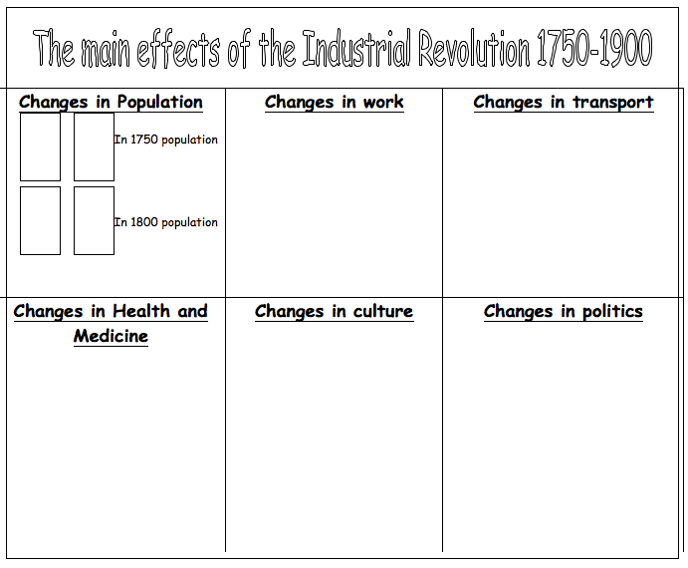

Development Activity 4. Co-operate in pairs appropriately and stick with difficulty.
On you poster you will be aware that whilst there is a space for changes in culture and politics, there are no cards. You should design two cards for each category, one to tell you about 1750 and the other to tell you about 1900. They should be twice the size of the original cards so that they fill approximately the same space.

In order to do this you will need to refer to the information on culture and politics in the history text book “Peace and War”. The information for 1750 you will find on page 3 and the information for 1900 you will find on page 7. When you have designed your cards stick them on to your poster.

Development Activity 5. Co-operate in pairs appropriately and stick with difficulty.
There are a number of other thing that you can do to your poster in order to make it look more attractive;
Add more pictures and illustrations
Do some drawings to compliment the themes in the poster
Add colour, carefully thought out
Decorate the edges of your poster in a plain and simple but effective manner.

Development Activity 6. Co-operate in pairs appropriately and stick with difficulty.
When your happy that you poster is complete you should take it to the library and photocopy it to A4 size so that you can stick it in your book. You should then hand in your A3 size poster for your teacher to make a display

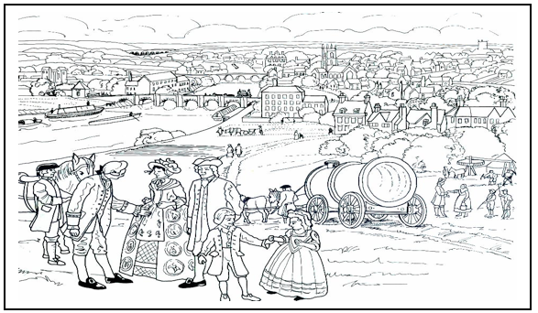 | A picture of a town in 1750.

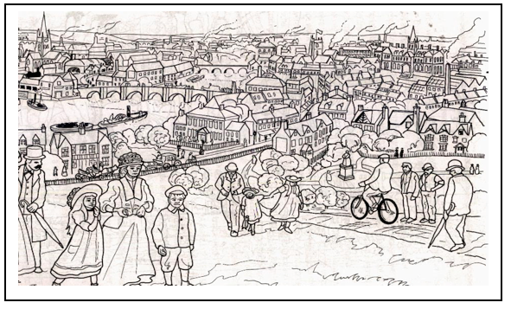 | The same town in 1900.

Here’s what the students do for their GCSE Paper for Causation

Question Number 4 or 5. Co-operate, share, stick with difficulty and tolerate uncertainty.
In what ways did developments in industry lead to changes in transport and housing on Greenwich Marsh during the 1750-2000 period? You may use the following in your answer.
- Changes in Industry in the early 19th Century
- The Millenium developments
You must also include information of your own.

Target: knowledge recall and selection, factors relevant to continuity and change in a historical context in a historical context (AO1/AO2).

Level | Mark | Descriptor
1 | 1-4 | Simple or generalised comment is offered, supported by some knowledge. Candidate offers generalised comment with little supporting detail or offers details about a very limited aspect of the question.
2 | 5-8 | Statements are developed with support from material which is mostly relevant and accurate. Candidate may provide details to support several points  Maximum 7 marks for answers that do not describe an aspect in addition to those prompted by the stimulus material.
3 | 9-12 | The response shows understanding of the focus of the question and deploys sufficient accurate and relevant material to support the points made. Candidates provide several relevant pieces of evidence to support a range of points, which show understanding of question coverage.  Maximum 10 marks for answers that do not explore aspects in addition to those prompted by the stimulus material.

Q4/5 You are building an explanation in 18 mins. This might involve factors e.g. P, E, S. Three paragraphs… one page.

- One reason for is PEEx
- A further reason is PEEx
- A final reason for is PEEx

Question Number 6 /7. Co-operate, share, stick with difficulty and tolerate uncertainty.
Did change occur on Greenwich Marsh over the period 1750-2000 mainly for reasons of housing development?

Target: Analysis of significance/ causation/change (AO 1 & 2: 16 marks)

Level | Mark | Descriptor
1 | 1-4 | Simple or generalised comment is offered, supported by some knowledge. Candidate makes generalised statements or describes one aspect in limited detail.  Writing communicates ideas using everyday language and showing some selection of material but the response lacks clarity and organisation. The candidate spells, punctuates and uses the rules of grammar with limited accuracy
2 | 5-8 | 5–8  Statements are developed with support from material which is mostly relevant and accurate. Candidate states that there was some continuity or change and provides detailed descriptions of aspects of each period.  Maximum 7 marks for answers that do not describe an aspect in addition to those prompted by the stimulus material.  Writing communicates ideas using a limited range of historical terminology and showing some skills of selection and organisation of material, but passages lack clarity and organisation. The candidate spells, punctuates and uses some of the rules of grammar with general accuracy.
3 | 9-12 | The response shows understanding of the focus of the question and deploys sufficient accurate and relevant material to support the points made. Candidate provides an analysis of each period and makes comparisons between periods.  Maximum 10 marks for answers that do not explore aspects beyond those prompted by the stimulus material.  Writing communicates ideas using historical terms accurately and showing some direction and control in the organising of material. The candidate uses some of the rules of grammar appropriately and spells and punctuates with considerable accuracy, although some spelling errors may still be found.
4 | 13-16 | A sustained analysis, supported by precisely-selected and accurate material and with sharply focused development of points made. Answer as a whole focuses well on the question. Candidate recognises the need to compare aspects of progress with areas of stagnation, in order to make a judgement.NB: No access to Level 4 for answers which do not explore aspects beyond those prompted by the stimulus material,  Writing communicates ideas effectively, using a range of precisely- selected historical terms and organising information clearly and coherently. The candidate spells, punctuates and uses the rules of grammar with considerable accuracy, although some spelling errors may still be found.
Marks for SPaG
 | 0 | Errors severely hinder the meaning of the response or candidates do not spell, punctuate or use the rules of grammar within the context of the demands of the question.
 | 1 | Candidates spell, punctuate and use the rules of grammar with reasonable accuracy in the context of the demands of the question. Any errors do not hinder meaning in the response. Where required, they use a limited range of specialist terms appropriately.
 | 2 | Candidates spell, punctuate and use the rules of grammar with considerable accuracy and general control of meaning in the context of the demands of the question. Where required, they use a good range of specialist terms with facility.
 | 3 | Candidates spell, punctuate and use the rules of grammar with consistent accuracy and effective control of meaning in the context of the demands of the question. Where required, they use a wide range of specialist terms adeptly and with precision.

Q5b You are building an analysis and evaluation of a viewpoint or interpretation and should be written in 24 mins. This will involve looking at evidence to support the view and evidence to challenge the view and these may involve factors to be addressed e.g. P, E, S. Two main parts.. one and half pages.

Introduction. There is evidence to support and challenge this view. It is argued that

· There is evidence to support the view. For example PEEx
· However there is evidence to challenge this view and suggest other factors were more significant. For example PEEx

In conclusion whilst there is evidence to both support and challenge the view, the view that is most convincing is X.

KS3/4 | Progress  Chart  History | AO1 Recall select and communicate Knowledge and understanding of history. | AO2 Describe, explain, analyse and evaluate causes, consequences, changes, continuities and their significance. | AO3a) Describe, explain, analyse and evaluate  a) a range of source material. | AO3b) Describe, explain, analyse and evaluate  b) how different historical events have been interpreted and represented.
 |  | Imaginative  Using intuition  Making connections  Playing with possibilities | Collaborative  Co-operating appropriately  Giving and receiving feedback  Sharing the product | Inquisitive  Wondering and questioning  Exploring and investigating  Challenging assumptions | Imaginative  Using intuition  Making connections  Playing with possibilities
 |  | Disciplined  Crafting and improving  Reflecting critically  Developing techniques | Persistent  Sticking with difficulty  Daring to be different  Tolerating uncertainty | Disciplined  Crafting and improving  Reflecting critically  Developing techniques | Persistent  Sticking with difficulty  Daring to be different  Tolerating uncertainty
9  A**  Creator | a. I am confident  b. I am secure in  c. I am beginning | I can go beyond excelling in all of the qualities of this Assessment Objective, which are thoroughly explained in the Grade A descriptor.I craft and refine my work selecting a wide range of sophisticated techniques with skill and flair. I critically reflect on my strengths and weaknesses, taking control of my learning. | I can go beyond excelling in all of the qualities of this Assessment Objective, which are thoroughly explained in the Grade A descriptor.  I collaborate creatively, regularly giving intelligent feedback and making excellent use of advice and guidance.I thrive on challenge and can manage uncertainty in the knowledge that this is essential for my creativity. | I can go beyond excelling in all of the qualities of this Assessment Objective, which are thoroughly explained in the Grade A descriptor.I can creatively explore a range of ideas independently. I ask challenging questions that help me to generate my own investigations informed by detailed and imaginative research and analysis. | I can go beyond excelling in all of the qualities of this Assessment Objective, which are thoroughly explained in the Grade A descriptor.I rely on my instincts to help me play with new ideas and create inventive connections in my learning.I thrive on challenge and can manage uncertainty in the knowledge that this is essential for my creativity.
8  A*  Creator | a. I am confident  b. I am secure in  c. I am beginning | I craft and refine my work selecting a wide range of sophisticated techniques with skill and flair. I critically reflect on my strengths and weaknesses, taking control of my learning.I can go beyond excelling in all of the qualities of this Assessment Objective, which are thoroughly explained in the Grade A descriptor. | I collaborate creatively, regularly giving intelligent feedback and making excellent use of advice and guidance.I thrive on challenge and can manage uncertainty in the knowledge that this is essential for my creativity.I can go beyond excelling in all of the qualities of this Assessment Objective, which are thoroughly explained in the Grade A descriptor. | I can creatively explore a range of ideas independently. I ask challenging questions that help me to generate my own investigations informed by detailed and imaginative research and analysis.  I can go beyond excelling in all of the qualities of this Assessment Objective, which are thoroughly explained in the Grade A descriptor. | I rely on my instincts to help me play with new ideas and create inventive connections in my learning.I thrive on challenge and can manage uncertainty in the knowledge that this is essential for my creativity. I can go beyond excelling in all of the qualities of this Assessment Objective, which are thoroughly explained in the Grade A descriptor.
7  A  Creator | a. I am confident  b. I am secure in  c. I am beginning | I craft and refine my work selecting a wide range of sophisticated techniques with skill and flair. I critically reflect on my strengths and weaknesses, taking control of my learning.I can recall, select, organise and deploy detailed historical knowledge effectively and with consistency. I show thorough understanding of the historical periods, themes and topics studied. I communicate ideas using historical terms accurately and appropriately. | I collaborate creatively, regularly giving intelligent feedback and making excellent use of advice and guidance.I thrive on challenge and can manage uncertainty in the knowledge that this is essential for my creativity.I can demonstrate understanding of the past through developed, reasoned and well-substantiated explanations. I make perceptive analyses of the key concepts, features and characteristics of the periods studied, and the interrelationships between them. | I can creatively explore a range of ideas independently. I ask challenging questions that help me to generate my own investigations informed by detailed and imaginative research and analysis.I can evaluate and use critically a wide range of sources of information in an historical context to investigate historical questions, problems or issues independently, and reach reasoned and substantiated conclusions. | I rely on my instincts to help me play with new ideas and create inventive connections in my learning. I thrive on challenge and can manage uncertainty in the knowledge that this is essential for my creativity.I can recognise and comment on how and why events, people and issues have been interpreted and represented in a wide range of different ways, and provide a thorough consideration of their value in the historical context.
6  B  Constructor | a. I am confident  b. I am secure in  c. I am beginning | I can confidently craft and refine my work. I can skilfully select and use a range of techniques. I am able to reflect on my strengths and weaknesses in detail.I can recall, select, organise and deploy historical knowledge with increasing accuracy and relevance. I show good understanding of the historical periods, themes and topics studied. I communicate ideas using historical terminology confidently. | I collaborate effectively. I enjoy giving thoughtful feedback and I make good use of advice and guidance to improve my work.I can confidently manage to keep going when things are difficult. I understand that not knowing is part of the process of being creative and I enjoy taking risks.I can demonstrate understanding of the past through structured descriptions and explanations of the main concepts, features and characteristics of the periods studied with confidence. My descriptions are accurate and my explanations show good understanding of relevant causes, consequences and changes. | I can confidently explore a range of ideas independently and ask challenging questions based on my careful research. I can carry out skilful analysis.I can confidently evaluate and use critically a range of sources of information in an historical context to investigate historical questions, problems or issues, and reach reasoned conclusions, which are well supported. | I am confident in trusting my instincts. I enjoy playing with ideas and making thoughtful connections in my learning.  I can confidently manage to keep going when things are difficult. I understand that not knowing is part of the process of being creative and I enjoy taking risks.I can confidently recognise and comment on how and why events, people and issues have been interpreted and represented in different ways, and provide reasoned consideration of their value in the historical context.
5  C  Constructor | a. I am confident  b. I am secure in  c. I am beginning | I can confidently craft and refine my work. I can skilfully select and use a range of techniques. I am able to reflect on my strengths and weaknesses in detail.I can recall, select, organise and deploy historical knowledge with accuracy and relevance. I show sound understanding of the historical periods, themes and topics studied. I communicate ideas using historical terminology appropriately. | I collaborate effectively. I enjoy giving thoughtful feedback and I make good use of advice and guidance to improve my work.  I can confidently manage to keep going when things are difficult. I understand that not knowing is part of the process of being creative and I enjoy taking risks.I can demonstrate understanding of the past through structured descriptions and explanations of the main concepts, features and characteristics of the periods studied. My descriptions are accurate and my explanations show understanding of relevant causes, consequences and changes. | I can confidently explore a range of ideas independently and ask challenging questions based on my careful research. I can carry out skilful analysis.I can evaluate and use critically a range of sources of information in an historical context to investigate historical questions, problems or issues, and with some limited guidance, to reach reasoned conclusions.  I can confidently explore a range of ideas independently and ask challenging questions based on my careful research. I can carry out skilful analysis. | I am confident in trusting my instincts. I enjoy playing with ideas and making thoughtful connections in my learning.  I can confidently manage to keep going when things are difficult. I understand that not knowing is part of the process of being creative and I enjoy taking risks.I can recognise and comment on how and why events, people and issues have been interpreted and represented in different ways, and provide an appropriate consideration of their value in the historical context.
4  D  Experimenter | a. I am confident  b. I am secure in  c. I am beginning | I can craft and refine my work with increasing skill. I can competently use a range of techniques. I can reflect on my strengths and weaknesses with growing confidence.I can nearly always recall, select, organise and deploy historical knowledge with accuracy and relevance. I show mainly sound understanding of the historical periods, themes and topics studied. I communicate ideas using historical terminology appropriately. | I often work well with others. I enjoy giving and receiving feedback which I use to improve my work. I am experimenting with a variety of ways to share my work.I am developing a range of ways to keep going when things are difficult. I am able to cope with not knowing and I try to take risksI can nearly always demonstrate understanding of the past through structured descriptions and explanations of the main concepts, features and characteristics of the periods studied. My descriptions are mainly accurate and my explanations show understanding of relevant causes, consequences and changes. | I am developing the ability to explore a range of ideas independently and ask interesting questions that help me carry out more developed research and analysis.I am developing a range of ways to keep going when things are difficult. I am able to cope with not knowing and I try to take risks. I can nearly always evaluate and use critically a range of sources of information in an historical context to investigate historical questions, problems or issues, and with some limited guidance, to reach reasoned conclusions. | I am able to trust my instincts. I can play with ideas and make some interesting connections in my learning.  I am developing a range of ways to keep going when things are difficult. I am able to cope with not knowing and I try to take risks. I can nearly always recognise and comment on how and why events, people and issues have been interpreted and represented in different ways, and provide an appropriate consideration of their value in the historical context.
3  E  Experimenter | a. I am confident  b. I am secure in  c. I am beginning | I can craft and refine my work with increasing skill. I can competently use a range of techniques. I can reflect on my strengths and weaknesses with growing confidence.I can confidently recall, select and organise some relevant historical knowledge to show some basic understanding of historical periods, themes and topics studied. I can confidently communicate ideas using everyday language. | I often work well with others. I enjoy giving and receiving feedback which I use to improve my work. I am experimenting with a variety of ways to share my work.I am developing a range of ways to keep going when things are difficult. I am able to cope with not knowing and I try to take risks.I can confidently demonstrate understanding of the past through description of reasons, results and changes in relation to the events, people and issues studied. I can confidently provide limited descriptions of events, issues or periods, including characteristic ideas, beliefs and attitudes. | I am developing the ability to explore a range of ideas independently and ask interesting questions that help me carry out more developed research and analysis.I can confidently understand sources of information and, taking them at their face value, begin to consider their usefulness for investigating historical issues and draw simple conclusions. | I am able to trust my instincts. I can play with ideas and make some interesting connections in my learning.  I am developing a range of ways to keep going when things are difficult. I am able to cope with not knowing and I try to take risks.I can confidently identify some differences between ways in which events, people or issues have been represented and interpreted, and may identify some of the reasons for these.
2  F  Apprentice | a. I am confident  b. I am secure in  c. I am beginning | I am beginning to learn how to craft and refine my work. I am trying to use new techniques and reflect on my strengths and weaknesses.I can recall, select and organise some relevant historical knowledge to show some basic understanding of historical periods, themes and topics studied. I can communicate ideas using everyday language. | I can work well with others. I can give and receive feedback with support which I sometimes use to improve my work. I am beginning to share my work.I am beginning to stick at things when they are difficult and I am getting better at coping with not knowing.I can demonstrate understanding of the past through description of reasons, results and changes in relation to the events, people and issues studied. I can provide limited descriptions of events, issues or periods, including characteristic ideas, beliefs and attitudes. | I am beginning to explore ideas and ask questions. I have attempted some simple research and analysis.I can understand sources of information and, taking them at their face value, begin to consider their usefulness for investigating historical issues and draw simple conclusions. | I am learning how to trust my instincts, I try to make connections in my learning.I am beginning to stick at things when they are difficult and I am getting better at coping with not knowing. I can identify some differences between ways in which events, people or issues have been represented and interpreted, and may identify some of the reasons for these.
1  G  Apprentice | a. I am confident  b. I am secure in  c. I am beginning | I am beginning to learn how to craft and refine my work. I am trying to use new techniques and reflect on my strengths and weaknesses.  I can sometimes recall, select and organise some relevant historical knowledge to show some basic understanding of historical periods, themes and topics studied. I can sometimes communicate ideas using everyday language. | I can work well with others. I can give and receive feedback with support which I sometimes use to improve my work. I am beginning to share my work.I am beginning to stick at things when they are difficult and I am getting better at coping with not knowing.I can sometimes demonstrate understanding of the past through description of reasons, results and changes in relation to the events, people and issues studied. I can sometimes provide limited descriptions of events, issues or periods, including characteristic ideas, beliefs and attitudes. | I am beginning to explore ideas and ask questions. I have attempted some simple research and analysis. I can sometimes understand sources of information and, taking them at their face value, begin to consider their usefulness for investigating historical issues and sometimes draw simple conclusions. | I am learning how to trust my instincts, I try to make connections in my learning. I am beginning to stick at things when they are difficult and I am getting better at coping with not knowing. I can sometimes identify some differences between ways in which events, people or issues have been represented and interpreted, and may occasionally identify some of the reasons for these.
Working  Towards |  | I have produced very few ideas. I have attempted to some research. | I have occasionally attempted to describe past events and developments. | I have attempted to record very few of my ideas from thinking about sources.. | I am working towards understanding that the past has been represented in different ways.

