A LEVEL HISTORY
HOW DO WE PERFORM?
Entry requirements Recommended B grade at GCSE History and English. Minimum entry 5 grade A*-C at GCSE, including A*-C grades in English, Maths and History.

Proven Track Record History is a popular subject, with two groups running at both AS and A2. The History team includes very experienced staff, with an outstanding record for examination results. Our excellent record with results enables a number of students to progress on to study History at university every year. Each year we have at least one students continuing with History at Oxford or Cambridge.
A2 Results: 11 of past 12 years =100 pass rate.
2014 A*-A 28%, A*-B 66%, A*-C 93%, A*-D 100%

WHY STUDY THIS COURSE?
It will develop your critical and analytical thinking skills, in particular your ability to construct and sustain a reasoned argument. Historical processes of cause, effects, change and continuity are explored. You will evaluate historical evidence. You will develop you research, note-taking and essay writing techniques and an understanding of the nature of history as a discipline. The second year provides an opportunity for you to hone your independent research skills you also have the opportunity to explore historiographical interpretations and increasingly to reach reasoned judgements on the views of other historians. Possible subject career paths Areas that require sharp analysis and argument, or thorough and systematic management of evidence: Law, Politics, Journalism, Local Government, Teaching, Museum Curating and archive work. There are also many roles and opportunities in industry and business for students with a background in history. It is seen as a favourable fourth subject for those wanting to go into medicine and is a facilitating subject for entry to the Russell Group top 20 universities.

Entry requirements
A-D grade at AS in History, attendance to June/July lessons and initial research notes for
Germany coursework.

Enrolment requirements
Automatic continuance from AS. (If transferring from another school, attendance to June/July
lessons for start of A2 courses is necessary).

WHAT DOES THE COURSE ENTAIL?
The first year explores “Revolutions in early modern and modern Europe”. Unit 1 is on Britain 1625-1701 and Unit 2 on Russia 1894-1924. Through these units you will consider changes in rule from monarchy to republic and autocracy to socialist state, within context of wider social economic and religious change. You will also develop an awareness of issues of class and ideology. Each of these unit are assessed by examinations (Unit 1:30% and Unit 2: 20% of A Level each or 60 and 40% of AS Level qualification)
The second year of the course explores “Conflict in ideology in late 19th and 20th Century World” In Unit 3 you will either examine changes in political ideology and forms of government in Germany 1871-1990 Or Civil rights and race relations in the USA 1850-2009. For Unit 4 you will examine the conflict between Communism and Capitalism and the causes of the Cold War c.1944-53. Unit 3 is assessed by examination (30% of A Level) and Unit 4 is a coursework essay 4000 words (20% of A Level).

WHERE CAN I FIND OUT MORE?
Speak to Ms Collins (Head of History), Ms Odd, Mr Hier, Mr Quigg, Ms Evans or Mr Tomlin.
Email us on ncollins@thomastallis.org.uk
Check out our Weebly at historyattallis.weebly.com Please note at your A Level will be the first year of a new specification. Our website currently reflects the existing specification.

Unit 1: Britain 1625-1701-Breadth study with interpretations  2 hour 15 mins exam  - Two essay questions assessing the period  - One question analysing and evaluating historical interpretations  Specimen essay question:  To what extent was Charles I personally responsible for the problems which faced monarchy in the years 1629-46?  Specimen interpretations question:  In the light of differing interpretations, how convincing do you find the view that ‘as a result of the Glorious Revolution, parliament became pre-eminent’ in government the country? |  | 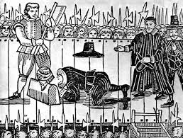
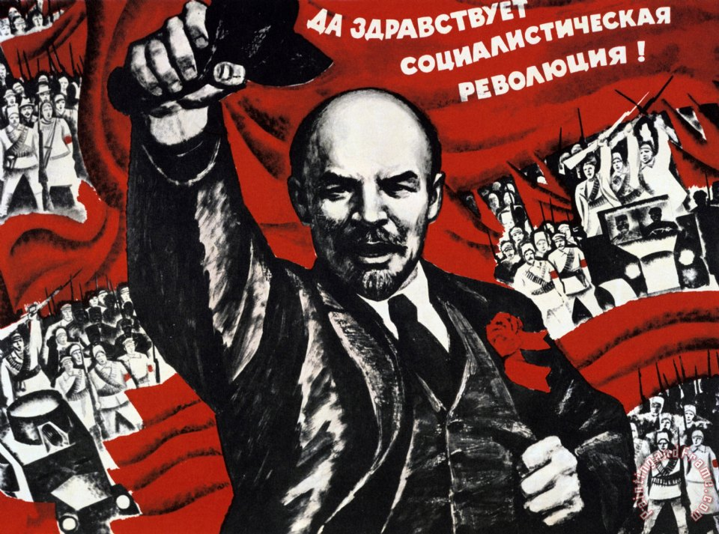 | Unit 2: Russia 1894-1924-Depth Studies 1 hour 30 mins exam.  - One question assessing and evaluating two sources  - One essay question on key issues of the topic.  Specimen sources question:  How far could the historian make use of sources 3&4 together to investigate the problems facing the Tsarist system during WWI?  Specimen essay question:  ‘The weaknesses and divisions of the opposition were primarily responsible for the failure of the 1905 revolution’ How far do you agree?

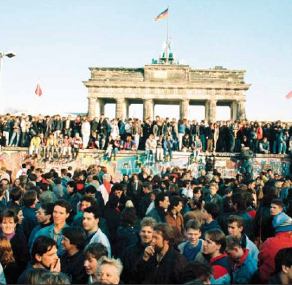 | Unit 3: Germany 1871-1990- Themes in breadth and depth Two hours 15 mins Exam  - One question assessing and evaluating sources  - One essay questions assessing the period in breadth  - One essay question assessing the period in depth  Specimen sources question:  Assess the value of the sources for revealing the approaches of Martin Luther King to civil rights and the nature of relationships within the civil rights movement in the 1960s.  Specimen breadth question:  How has the portrayal of lives of African- Americans in fiction and film produced a change in the perceptions of African- Americans by the white majority 1850-2009?  Specimen depth question:  ‘It was the flood of refugees from East Germany to West Germany which made unification inevitable in 1990’ How far do you agree with this statement?
Unit 4: Causes of the Cold War : Historical Enquiry Coursework  You will complete independent research into the cause of the Cold War. You will design an enquiry question and identify three works by different Historians to focus on. You will need to analyse and evaluate their interpretations, based on wider research and reading.  The assignment should consist 3,000-4,000 words |  | 