GCSE History Unit 2 option 2C
Life in Germany c1919-c1945.

KQ3 How did the Nazi’s impact on the way in which German people lived 1933-45?
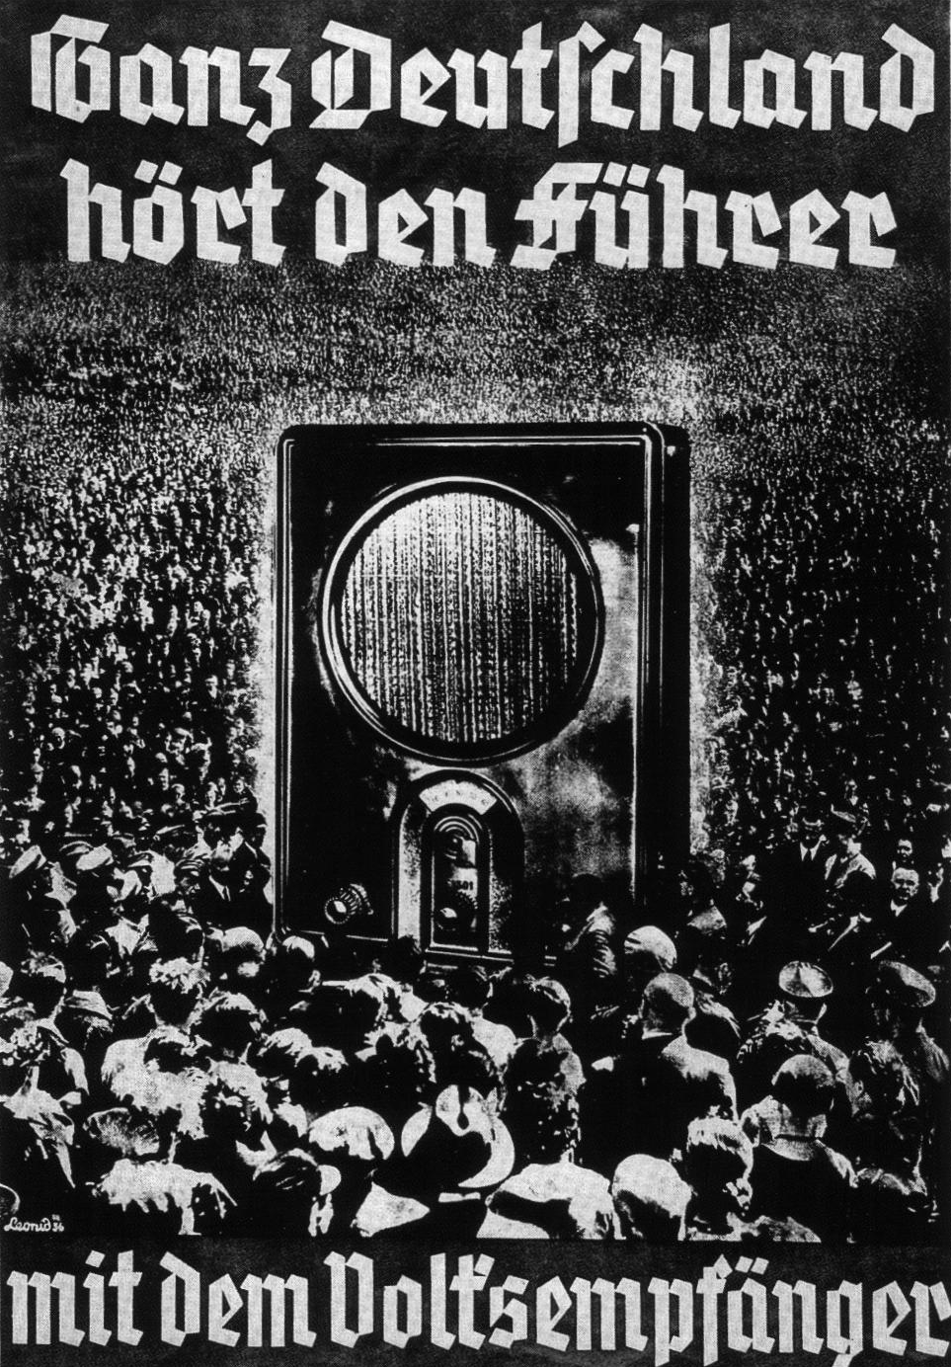

The Reich Propaganda Minister Joseph Goebbels won the struggle for control of radio and formed the Reich Radio Company, which controlled all local radio stations. Millions of very cheap radios called “The People’s Receiver” were made. By 1939 70% of German households had a radio which were unable to pick up foreign broadcasts.

- In a Nutshell: Overview of developments 1919-33.

- Causes and Analysis of the rise of the Nazi Party, including:
Focus 1. What was the impact of Nazi policies towards young people and women?
Focus 2. What was the impact of Nazi economic policies?
Focus 3. What was the impact of Nazi policies on race?

- Thematic Analysis of Wider context through a Mystery game;
Why did President Hindenburg appoint Hitler as Chancellor of Germany in January 1933?

- Cracking the Puzzle – Preparing for assessment.
A List of Key Terms and their meanings in this topic.

Nazis | The NSDAP, National socialist German workers party.
Control thinking | To select information to disseminate through media so as to shape attitudes, values and beliefs.
Propaganda | To distribute selected information through the media to control the thinking of the public.
Joseph Goebbels | Propaganda Minister of the German Reich 1933-45.
Baldur von Shirach | Youth Leader of the German Reich 1933-45.
Hitler Youth | Youth Organisation for German boys 14-18.
League of German Girls | Youth Organisation for German girls 14-18.
Bernard Rust | Reich Minister of Education 1933-45.
Education system | Schools, local education authorities, universities and the Ministry of Education.
University | Higher education system for post 18 education.
Degenerate art | Style of art denounced by the Nazis has un-German.
Berlin Olympics 1936 | Olympic games held in Berlin in 1936

(I) In a Nutshell:
Overview of Nazi social impact on Germany 1933-45.

Content overview
- Nazi policies towards women and the young.
- Economic changes.
- Nazi treatment of minorities including the ‘final solution’.

Nazi policies towards young people and women; their importance to the Nazi state and party including the nature and purpose of education in schools for boys and girls; the role and effectiveness of youth movements including preparation for war, charity work and military role in the war years. The emergence of rebel groups, for example the Edelweiss Pirates. The role of women within the family, society and employment, and changes to their role during the period

The impact of economic policies to reduce unemployment: the New Plan, labour service, construction of autobahns and rearmament. Changes in the standard of living for German workers, Strength Through Joy.

The importance of Nazi beliefs in Aryan supremacy and the ‘master race’. The treatment of minority groups, for example Jews, gypsies and disabled people. The changes in policies during the period and the escalating discrimination and persecution including the Nuremberg Laws and Kristallnacht up to and including the ‘final solution’.

(II) Causes and Analysis of developments:
The social impact of the Nazi Party?

Activity 1 – On your marks…..
The timeline makes many brief references to the events of the period. Colour code any event which with little explanation, appear to suggest either the Weimar Republic was mainly stable (green), Weimar Republic was becoming increasingly unstable (yellow) or the Nazi Party was growing in influence (red).

Activity 2 – Get set…..

Your teacher will give you an A4 copy of a concept map. Stick it in your book. You will need to fill it in at the end of each key focus area. Your teacher will guide you. As well as adding information to your concept map you can add a colour scheme and also some line drawings or pictures linked to themes outlined in the information.

Activity 3 – Go…..
As well as the lessons and activities that develop from them, read your book independently and visit the library. There are also many excellent websites listed in the back of this activity booklet to check out. Try and develop your own individual interest in this area of focus rather than waiting to be taught by your history teacher.

Focus 1. What was the impact of Nazi policies towards young people and women?

Activity 1
Hitler appointed Bernard Rust the Reich Minister of Science Education and Popular Culture on April 30th 1934. Rust had been a regional SA leader and was a former retired provincial schoolmaster having been sacked by the state of Hanover for his fanatical Nazi ideas in 1930. Stick the following flow diagram in your books.

Dr Bernard Rust
Reich Minister of Science, Education and Popular Culture

Minister. Science.
Minister. Education including public schools, colleges and universities.

Minister. Popular Culture including youth organisations.

The education system was quickly Nazified.
- Text books from Kindergarten to university were rewritten to reflect Nazi ideas.
- Teachers were sent for intensive training in Nazi principles, especially racial ideas.
- Every teacher had to join the National Socialist Teachers League.
- Every University professor had to join the Nazi Association of University Lecturers.
- All the Education Departments of Local Authorities and individual States were taken under the control of the Reich Minister of Education.
- New schools called “Napolas” were introduced to train future leaders of German institutions.

Activity 2
Copy this typical timetable for German girl’s school. Explain why girls studied domestic science and eugenics. Information on p134 will be helpful.

 | Monday | Tuesday | Wednesday | Thursday | Friday | Saturday
8:00-8:45 | German
8:50-9:35 | Geography | History | Singing | Geography | History | Singing
9:40-10:25 | Racial Science | Racial Science | Racial Science | Ideology | Ideology | Ideology
10:25-11:00 | Break, with Sports and special announcements.
11:00-11:30 | Domestic science
11:30-12:05 | Mathematics
12:10-12:55 | Eugenics | Health/Biology | Eugenics | Health/Biology | Eugenics | Health/Biology
1:00-2:00 | Lunch
2:00-6:00 | Sport

Activity 3
Used the information on p134 to write a report on a boy called Walter who was 12 in 1938. You will need to explain the development of his knowledge and understanding in each subject on the report proforma.

Walter’s school report June 1938.
German
Physical Education
Biology
Mathematics
History
Geography
Religious Studies
Singing
Ideology

Activity 4
Read the extracts from Karl Hartland “ A boy in your situation“ written in 1988. Karl was the son of a Jewish banker, and he describes his memory of school in this book. Then write a sub-heading Education for the Jews. Use his extracts to write down five key ways in which Jewish people were not given equality of opportunity in German schools from 1933 onwards.

Put a sub heading How far did the Nazi’s try to control Germany’s universities?

Activity 5
Read the following text from William Shirer’s “The rise and fall of the Third Reich”. Use the information to explain how the Nazis controlled German universities. Your explanation should have the following points.
- The powers of the Reich Minister of education
- Nazi principles toward University education.
- The effects of Nazi policies on the curriculum studied in German Universities.
- The effects of Nazi policies on the University lecturers.
- Were the policies a success or a failure?

It was surprising to some how many members of the university faculties knuckled under to the Nazification of higher learning after 1933. Though official figures put the number of professors and instructors dismissed during the first five years of the regime at 2,800—about one fourth of the total number—the proportion of those who lost their posts through defying National Socialism was, as Professor Wilhelm Roepke, himself dismissed from the University of Marburg in 1933, said, “exceedingly small.” Though small, there were names famous in the German academic world: Karl Jaspers, E. I. Gumbel, Theodor Litt, Karl Barth, Julius Ebbinghaus and dozen of others. Most of them emigrated, first to Switzerland, Holland and England and eventually to America. One of them, Professor Theodor Lessing, who had fled to Czechoslovakia, was tracked down by Nazi thugs and murdered in Marienbad on August 31, 1933.

A large majority of professors, however, remained at their posts, and as early as the autumn of 1933 some 960 of them, led by such luminaries as Professor Sauerbruch, the surgeon, Heidegger, the existentialist philosopher, and Pinder, the art historian, took a public vow to support Hitler and the National Socialist regime. “It was a scene of prostitution,” Professor Roepke later wrote, “that has stained the honorable history of German learning.” And as Professor Julius Ebbinghaus, looking back over the shambles in 1945, said, “The German universities failed, while there was still time, to oppose publicly with all their power the destruction of knowledge and of the democratic state. They failed to keep the beacon of freedom and right burning during the night of tyranny.”

The cost of such failure was great. After six years of Nazification the number of university students dropped by more than one half—from 127,920 to 58,325. The decline in enrollment at the institutes of technology, from which Germany got its scientists and engineers, was even greater—from 20,474 to 9,554. Academic standards fell dizzily. By 1937 there was not only a shortage of young men in the sciences and engineering but a decline in their qualifications. Long before the outbreak of the war the chemical industry, busily helping to further Nazi rearmament, was complaining through its organ, Die Chemische Industrie, that Germany was losing its leadership in chemistry. Not only the national economy but national defense itself was being jeopardized, it complained, and it blamed the shortage of young scientists and their mediocre caliber on the poor quality of the technical colleges. Nazi Germany’s loss, as it turned out, was the free world’s gain, especially in the race to be the first with the atom bomb. The story of the successful efforts of Nazi leaders, led by Himmler, to hamstring the atomic-energy program is too long and involved to be recounted here. It was one of the ironies of fate that the development of the bomb in the United States owed so much to two men who had been exiled because of race from the Nan and Fascist dictatorships: Einstein from Germany and Fermi from Italy.

Activity 6 Complete sections 3 and 4 of your concept map, selecting your 4 pieces of information carefully. Underline the key words in an appropriate colour.

Activity 7
Hitler appointed Baldur von Shirach as “Youth leader of the German Reich” in June 1933. Shirach was responsible for the organisation of German Youth from 6-18 when conscription for the Labour Service and army began. He organised boys and girls into various cadres of the Hitler Youth. Parents found guilty of trying to prevent their children from joining the organisations were subject to heavy prison sentences. Stick a copy of the following flow diagram into your books.
Dr Bernard Rust
Reich Minister of Science, Education and Popular Culture

Minister. Science.
Minister. Education including public schools, colleges and universities.

Minister. Popular Culture.
Baldur von Shirach “Youth leader of the German Reich” directly responsible to Hitler.

The Nazi policy toward German youth organisations.
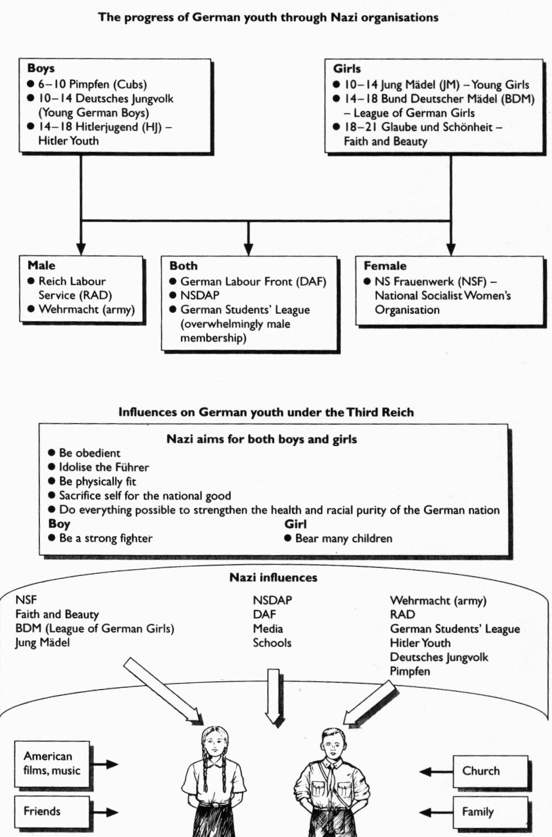

Activity 8
Draw a bar chart to show the following statistics on the Membership of the Hitler Youth.
1932 | 107,956
1934 | 3,500,000
1936 | 6,000,000 plus

Activity 9
Read the diary of the fictitious young boy in the Hitler Youth from 1934-1939. Summarise the two key things that the boy did during these years for each year, and how he was encouraged to show loyalty and support to Hitler and the Nazi’s.

The activities of a member of the Hitler Youth 1934-39.
1934
1935
1936
1937
1938
1939

Activity 10
In this activity you will try to analyse whether Nazi youth policy was successful. There were a range of variables that could affect the impact of the Hitler Youth. Use sources 1-6 and decide which evidence you could use for each.

Responses to Youth policies. | Sources you could use. | Evidence
Enthusiasm

Conformity for career

Conformity through fear

Conformity through apathy

Non-conformity/disillusion

Opposition/criticism

Activity 11

Complete sections 1 and 2 of your concept map, selecting your 4 pieces of information carefully. Underline the key words in an appropriate colour.

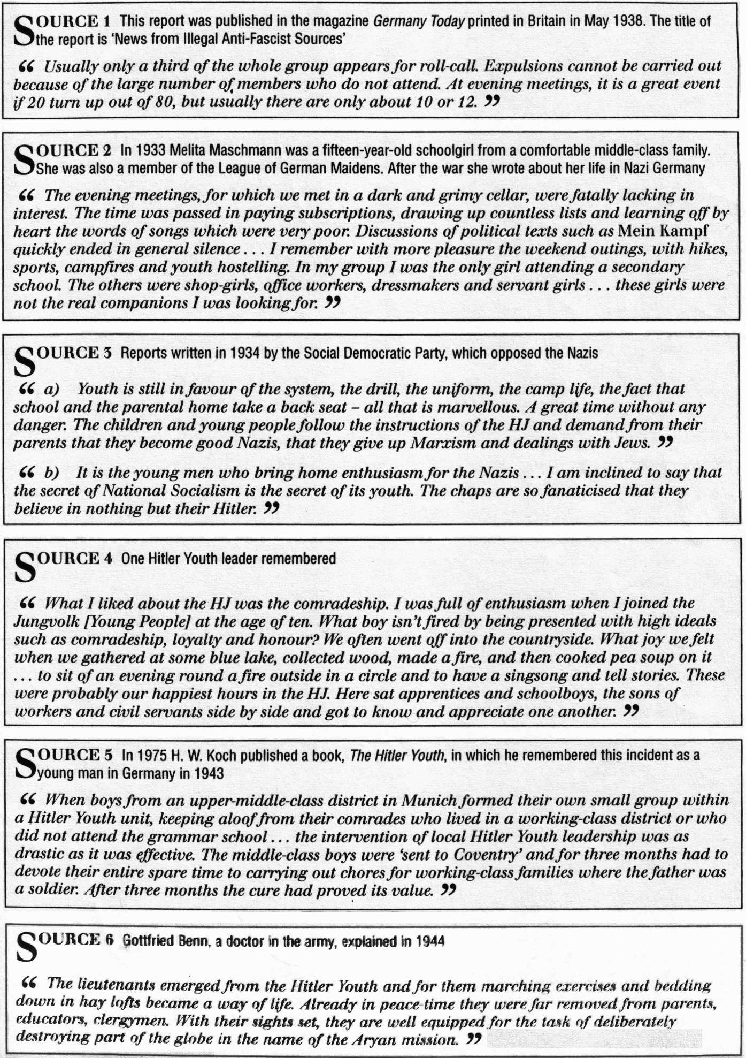

Activity 12
Describe and explain the role of women in Nazi Germany, and analyse the extent of change that occurred from the role of women in the Weimar era.

Role of women | Description and explanation | Extent of change
Family p136 | 1  2  3
Society p137 | 1  2  3
Employment p138 | 1  2  3

Activity 13
What evidence is there that these were good years to be a woman in Germany?

Evidence that these were good years to be a woman in Germany | Evidence that these were difficult years to be a woman in Germany
1  2  3 | 1  2  3

Activity 14
Design a spider diagram or concept map which explains how the experiences of the Second World War affected women. The diagram should include the following sections; the contradictions of Nazi policy, Jobs done by women, Coping with the effects of War, Changes in 1943.

Activity 15
Complete sections of the Concept map.
Focus 2. What was the impact of Nazi economic policies?

Activity 1
Describe the two main Nazi economic plans, explain how they worked and analyse how successful they were using information SHP Germany 1918-1945 textbook.

Describing the man, the plan and its aims! | Explaining how it worked | Analysing its effectiveness
The New Plan – Dr Hjalmar Schacht p126  1  2  3 | 1  2  3  4 | Advantages  1  2  3  Disadvantages  1  2  3
The Four Year Plan – Hermann Goering p127  1  2  3 | 1  2  3  4 | Advantages  1  2  3  Disadvantages  1  2  3

Activity 2
Working in pairs analyse whether or not Nazi economic plans achieved an “economic miracle” using information SHP Germany 1918-1945 textbook p128-129.

Aspect of the economy | Strengths of Nazi economic achievement | Limitations of Nazi economic achievement
Imports/Exports | 1  2 | 1  2
Unemployment | 1  2 | 1  2
Government spending | 1  2 | 1  2
Investment | 1  2 | 1  2
Production | 1  2 | 1  2
Workers | 1  2 | 1  2

Activity 3
Describe what Strength through Joy using information SHP Germany 1918-1945 textbook p123-124.

Activity 4
Analyse whether or not the workers were better off as a result of Nazi economic plans using information SHP Germany 1918-1945 textbook p123.

Evidence to suggest the workers were better off as a result of Nazi economic plans. | Evidence to suggest that the workers were not better off as a result of Nazi economic plans.
1  2  3 | 1  2  3

Activity 5
Analyse whether or not everyone was better off as a result of Nazi economic plans using information SHP Germany 1918-1945 textbook p122.

Groups of German people 1933-45 | How they benefited from from Nazi economic policy | Problems that continued or developed as a result of Nazi economic policy.
1 Small businesses | 1  2 | 1  2
2 Farmers | 1  2 | 1  2
3 Big business | 1  2 | 1  2
4 Unskilled workers | 1  2 | 1  2

Activity 6
Complete sections of the Concept map.
Focus 3. What was the impact of Nazi policies on race?

Activity 1
Describe and explain key ideas and thoughts of the Nazis with regard to different ethnic groups within Germany using information SHP Germany 1918-1945 textbook p76 and 102.

Question
What did the Nazis mean by their aim of a racial Germany? P76
What were the ideal physical and social features of the ideal German according to the Nazis. P103-104
How did the Nazis believe they would create a racial Germany? P76 | 1  2  3
Why did the Nazis fear inferior races? P102 | The problem  The answer  Achieved by  The result
Were any Aryans regarded as problems and what should be done with them? P104
Why did the Nazis fear the gypsies and what actions did they take against them? P104

Activity 2
Describe and explain the ways in which the Nazis dealt with what they considered to be burdens on the community using information SHP Germany 1918-1945 textbook p104.

Describe the way in which the Nazis dealt with burdens on the community | Explain the impact on German people and society
Step 1.  Propaganda was | 1  2  3
Step 2.  The Sterilisation Law was | 1  2  3
Step 3.  The concentration camps were | 1  2  3
Step 4.  The euthanasia campaign was about | 1  2  3

Activity 3
Put a sub title “The Nuremburg Laws” September 1935. Stick the copy of the Law in your book. Write a paragraph describing and explaining the impact of the law on the Jewish community.
The Nuremburg Laws September 1935

The Laws for the Protection of German Blood and German Honour
(September 15, 1935) Moved by the understanding that the purity of German blood is essential to the further existence of the German people, and inspired by the uncompromising determination to safeguard the future of the German nation, the Reichstag has unanimously resolved upon the following law, which is promulgated herewith:
Section 1
- Marriages between Jews and citizens (German: Staatsangehörige) of German or kindred blood are forbidden. Marriages concluded in defiance of this law are void, even if, for the purpose of evading this law, they were concluded abroad.
- Proceedings for annulment may be initiated only by the Public Prosecutor.
Section 2
Extramarital sexual intercourse between Jews and subjects of the state of Germany or related blood is forbidden.
- (Supplementary decrees set Nazi definitions of racial Germans, Jews, and half-breeds or Mischlinge --- see the latter entry for details and citations and Mischling Test for how such decrees were applied. Jews could not vote or hold public office under the parallel "citizenship" law.)
Section 3
Jews will not be permitted to employ female citizens under the age of 45, of German or kindred blood, as domestic workers.
Section 4
- Jews are forbidden to display the Reich and national flag or the national colours.
- On the other hand they are permitted to display the Jewish colours. The exercise of this right is protected by the State.
Section 5
- A person who acts contrary to the prohibition of Section 1 will be punished with hard labour.
- A person who acts contrary to the prohibition of Section 2 will be punished with imprisonment or with hard labour.
- A person who acts contrary to the provisions of Sections 3 or 4 will be punished with imprisonment up to a year and with a fine, or with one of these penalties.
Section 6
The Reich Minister of the Interior in agreement with the Deputy Führer and the Reich Minister of Justice will issue the legal and administrative regulations required for the enforcement and supplementing of this law.
Section 7
The law will become effective on the day after its promulgation; Section 3, however, not until 1 January 1936.

Activity 4
Put a sub title “Anti-semitic actions taken by the Nazis 1933-38”. Stick the timeline of measures taken by the Nazis against the Jews from 1933-1938 in your book. Highlight in one colour Anti-semitic laws, another colour anti-semitic regulations and in a final colour anti semitic attacks p106.

Activity 5
Describe and explain what happened on Kristallnacht 9-10 November 1938, and identify the reasons why using information SHP Germany 1918-1945 textbook p107- 109.

Questions about Kristallnacht 9-10 November 1938.
What happened? | Description  1  2  3  4
Why? | Explanation  1  2  3  4
Impact? | Explanation  1  2  3  4

Activity 6
Describe and explain the stages in the development and escalation of the persecution and mass murder of Jews and other racial, religious and political undesirables using information SHP Germany 1918-1945 textbook p156-158.

Describe the way in which the Nazis dealt with the Jewish community after 1939 | Describe and explain the impact on German people and society
Stage 1.  The policy of Ghettoisation p156 | 1  2  3
Stage 2.  The policy of murder by Einsatzgruppen p156 | 1  2  3
Stage 3.  The policy of mass murder and genocide by the Final Solution. P156-8 | 1  2  3

Activity 7
Describe and explain how the Jewish community resisted this persecution at each stage using information SHP Germany 1918-1945 textbook p159.

Activity 8
Complete sections of the Concept map.

(III) Thematic Analysis of wider context:

Mystery game: When and for what reason did Walter become a committed Nazi?
Mystery Game. Walter was born in Germany in 1926. He was the youngest of 3 brothers and 2 sisters. He was very proud of the country he was growing up in and was considerably affected by the events in Germany and Europe during his lifetime. He joined the army aged 18 in 1944 and died fighting in January 1945 in the East. When and for what main reason did Walter become a committed Nazi supporter
1 A photograph of Walter on holiday with his family in 1931 shows him doing a Nazi salute. His father is smiling and sitting behind Walter was a veteran of the First World War.

2 Walter started school in 1931. He was taught about the problems that Germany faced since the end of the first world war, and that a strong leader was needed to make Germany a great country once more.

3 In 1932 there was a general election. Walter and his family listened to the radio programmes and he saw Nazi posters, which showed that Hitler could be Germany’s saviour.

4 In 1933 Baldur von Shirach was appointed as Germany’s youth leader. His aim was to create a system of organizing Germany’s youth to be obedient to Nazi ideas.

5 In 1934 Bernard rust was appointed as Germany’s education Minister. His aim was to create a curriculum in which young people would be educated to support Nazi ideas.

6 In 1933 Joseph Goebbels was appointed as Germany’s propaganda minister. His aim was to use Germany’s media to spread Nazi ideas.

7 In 1936 Walter joined the young German boys League. He was taught to be obedient and to support the aims of his country’s leaders.

8 By 1937 when Walter began secondary school many of his teachers belonged to the Nazi teachers organization. They encouraged strong support for Hitler who was trying to restore German greatness.

9 In 1934 Walter remembers going to the cinema and seeing images of the Nazi rallies at Nuremburg in the great German film “Triumph of the Will”

10 In 1940 Walter became a member of the Hitler Youth aged 14. He had very fond memories of the camps and visits that his group took part in.

11 In secondary school Walter was taught about the superiority of the Aryan race in both biology and history lessons.

12 In 1936 Walter watched the Olympic games in Berlin and was proud of German Aryan athletes who out performed the athletes in gold medals from all other countries.

13 In 1944 Walter became a local leader of the Hitler Youth. This gave him responsibility in encouraging other Hitler youth members to support Nazi ideas.

14 In 1939 the Second World War began. Walter’s teachers taught him to be loyal to Hitler and the German army in their war efforts.

15 Walter remembered that all the newspapers, cinema newsreels and radio programmes encouraged German people to support the war form 1939 onwards.

(IV) Cracking the Puzzle- Preparing for Assessment

Past Exam Questions to be answered in 75 minutes
Answer Questions 1 and 2, EITHER Question 3 OR 4 and then EITHER Question 5(a) and 5(b) OR 6(a) and 6(b).

Q1 Study source A.
What can you learn from Source A about Nazi views of women? (4)
(5) 6mins
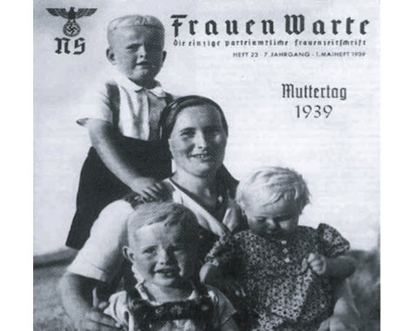

Source A: From the front cover of Women’s Viewpoint, the official Nazi magazine for women.
This issue was published on Mother’s Day in 1939.

Q2 The boxes below show two actions taken against German Jews. Choose one and explain how it affected the lives of Jews living in Germany. (9) 13 mins
The passing of the Nuremberg Laws, 1935

Kristallnacht (Night of the Broken Glass) 1938

Either
Q3 Why was control of education so important to the Nazi government?(12) You may use the following in your answer and any other information of your own.
• 97% of teachers joined the Nazi Teachers’ League
• Lessons on ‘Race Studies’ were introduced in all schools
• 1937: The first special ‘Adolf Hitler School’ opened

Or Q4 Why were the Nazis able to persecute the Jews and other minority groups in Germany in the years 1933–39? (12) You may use the following in your answer and any other information of your own.
• 1935: Nuremberg Laws were passed
• Goebbel’s Ministry for Propaganda gave daily orders to newspapers on what they could write
• By 1939 the SS had more than 240,000 members

Either Q5

a) Describe how the Nazi’s managed to reduce unemployment 1933-1939. (9) 13 mins

b) “The Nazis were successful in overcoming Germanys economic problems in the years 1933-39” Do you agree? Explain your answer. (16) 24mins
You may use the following in your answer and any other information of your own.

1934. The New Plan.
1936. Goering’s Four Year Plan
Between 1933-1939 German government total debt rose from 11 billion RM’s to 42 billion RM’s

Or Q6
a) Describe why the so many young people joined the Hitler Youth movement. (9) 13 mins

b) ‘The main role of education in Nazi Germany was to prepare boys and girls for different roles.’ Do you agree? Explain your answer. (16) You may use the following in your answer and any other information of your own.
• Girls studied Domestic Science
• Boxing was compulsory in school for boys
• All pupils had lessons in Race Studies

And finally

1 Revisit the Concept map for Germany KQ3 you have developed for this unit and ensure that you have made a summary of the key events and developments.

- Complete the Trigger Memory Activity for Germany KQ3 using your background notes. An explanation on how to complete this is in your guidance booklet.

- There are many excellent websites on German History 1919-1945, which can be used to revisit the material covered so far. These include -

Use these websites to gather further interpretations of the period.

- As a class, design and play a game for the Game Show Presenter Game called detente. There are further games that can be played to reinforce the development of your knowledge and understanding at WWW.schoolhistory.co.uk

- Revisit the examination criteria and advice on tackling the examination questions given in the guidance booklet.

6 Apply these techniques to the specimen examination. You may be asked to work individually, in pairs or in group

