GCSE History Unit 2 option 2C
Life in Germany c1919-c1945.

KQ2 How far did the Nazi government gain and maintain control over the German people?
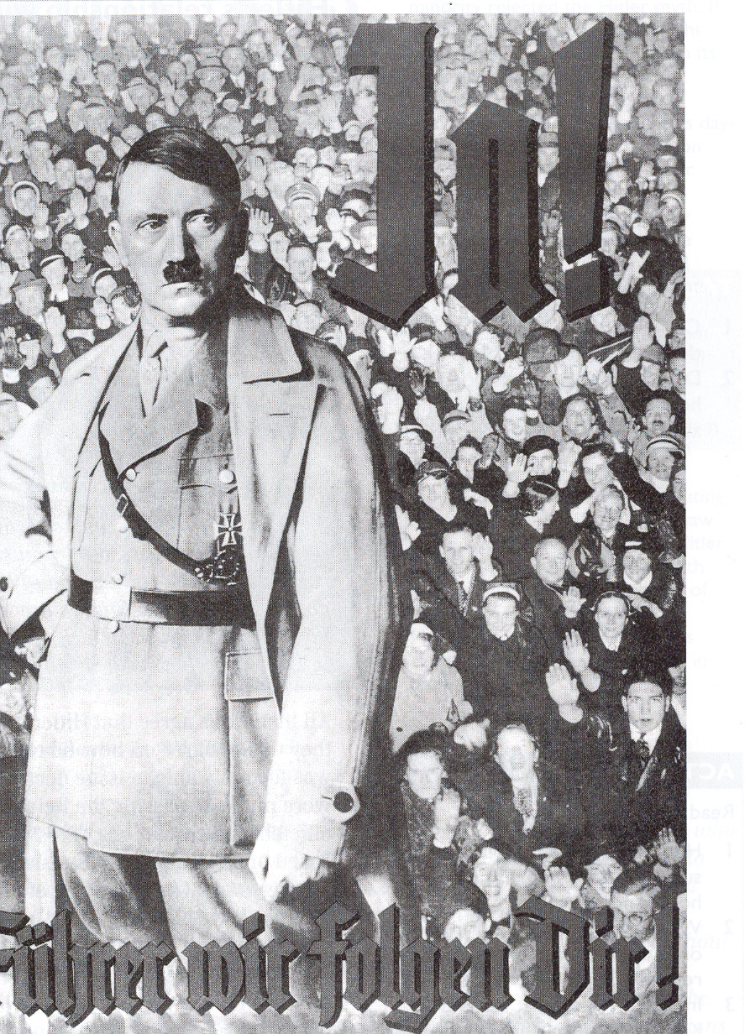

A Nazi Party Poster: ‘Yes ! Leader, we will follow you.’

- In a Nutshell: Overview of developments 1919-33.

- Causes and Analysis of the rise of the Nazi Party, including:
Focus 1. How and in what ways did the Nazi’s change the way in which Germany was controlled?
Focus 2. How effective were the Nazi methods of control over the German people?
Focus 3. What was the nature and extent of opposition to Nazi control?

- Thematic Analysis of Wider context through a Mystery game;
Why was Dietrich Bonhoeffer executed in April 1945?

- Cracking the Puzzle – Preparing for assessment.
A List of Key Terms and their meanings in this topic.
Dietrich Bonhoeffer | Protestant Church leader, an opponent of the Nazis who was arrested and eventually executed
Catholic Church | Branch of Christianity, led by Pope in Rome. 1/3 of Germans were Catholic in 1933.
Centre and Nationalist Parties | Parties that believed in traditional values and accepted social structures. They wanted strong foreign policies.
Communist | Believer in a system of government with government control of the economy and a society where all arte equal and there is no private ownership
Concentration Camps | Where opponents were kept, often doing labour. Later some became death camps.
constitution | Document laying down basic laws of how a country should be run
coup | Sudden seizure of power by a small group
DAF | Workers and employers Nazi organisation set up to replace the banned Trade Unions. It included the ‘Beauty of Labour’ and ‘Strength through Joy’ organisations
democracy | A system of government where leaders are voted in to office by the people
dictatorship | Rule by one all-powerful person or group
Emergency Decree | President could make laws without the Reichstag in time of emergency
Enabling Act | Change to the Constitution, made in March 1933. Gave Hitler the right to make laws without consulting the Reichstag
Fuhrer | Leader-Title used by Hitler after August 1934, amalgamating the roles of President and Chancellor
Gauleiter | Regional Nazis Party leader, each one in control of the 32 Gau (regions) that Germany was divided into
German Women’s Enterprise | Nazis Party organisation that all women’s groups were forced to merge into in 1933. It worked to spread Nazi values on the role of women
Gestapo | State secret police after 1936. Spied on the population
Himmler, Heinrich | Head of the SS
Hitler Youth | Nazis organisation from 1936. all previous youth groups were merged into it. Established to spread Nazi ideas amongst the young
Nazis Party (NSDAP) | The only political party after 1934. Local party leaders ran each region, whilst party organisations controlled people’s work and lives.
Opposition | People that were against Hitler and the Nazis
Plebiscites | Vote by all people on an important issue
Police State | Overseen by the SS, there was a range of different organisations used to control the German people if they were seen to step out of line. These included the SS, the SD, the Gestapo, the Police, courts, prisons and concentration camps.
Polycracy | A system of government in which there are many different groups with roles and responsibilities that overlap. This can increase the control that the overall leader has.
Protestant Church | Branch of Christianity. 2/3 of Germans were members of the Protestant Church
RAD | The Reich Labour Service. All 18-25 year old men had to do 6 months work service with them.
Reichstag fire | German parliament burnt down in 27th feb 1933
SA | Stormtroopers, Hitler’s private army led by Rohm
SS | First Private bodyguards for Nazi leaders, later arrested people
Trade Unions | Organisations run to protect workers rights

(I) In a Nutshell:
Overview of rise of Nazi Party in Germany 1919-33.

Content overview
- The creation of the Nazi state.
- Methods of Nazi control.
- Opposition and resistance to the Nazi’s..

The creation of the Nazi state involves the reasons why Hitler was able to gain total power in Germany, including the significance of the existing constitution and the role of von Papen and von Hindenburg in 1932–33, and of the key events of 1933–4: the Reichstag Fire, the Enabling Act, the banning and removal of rival power groups including political parties, trade unions and the Night of the Long Knives. The nature of Hitler’s role as Fuhrer.

Methods of control relate to both national and local groups and systems. They include the role of the SS, concentration camps and local wardens; laws restricting civil liberties; treatment of the press, political parties, churches and opposition groups and individuals, the uses of censorship, and the role of Goebbels. The purpose and effectiveness of different types of propaganda, for example films, posters, rallies.

Opposition and resistance involve its nature and extent, including the significance of the White Rose Group and Pastor Niemoller.

(II) Causes and Analysis of developments:
The Government of the Third Reich?

Activity 1 – On your marks…..
The timeline makes many brief references to the events of the period. Colour code any event which with little explanation, appear to suggest either the Nazi regime was mainly unstable and vulnerable (green), Nazi regime was becoming increasingly stable through legal changes (yellow) or the Nazi regime was stable and consolidated (red).

Activity 2 – Get set…..

Your teacher will give you an A4 copy of a concept map. Stick it in your book. You will need to fill it in at the end of each key focus area. Your teacher will guide you. As well as adding information to your concept map you can add a colour scheme and also some line drawings or pictures linked to themes outlined in the information.

Activity 3 – Go…..
As well as the lessons and activities that develop from them, read your book independently and visit the library. There are also many excellent websites listed in the back of this activity booklet to check out. Try and develop your own individual interest in this area of focus rather than waiting to be taught by your history teacher.

Focus 1. How and in what ways did the Nazi’s change the way in which Germany was controlled?

Activity 1. From democracy to dictatorship 1933-34.

Hitler’s appointment as Chancellor on 30 January 1933 meant he was leader of the Reichstag. However, his power over Germany was limited. The political system was still a Democracy, with a President, the Reichstag and the Reichsrat. The Nazis only had 33.1 % of the seats in the Reichstag. Furthermore, the fundamental laws protected the rights of citizens. In his attempts to gain greater power Hitler faced many decisions. For each of the decisions below, consider the potential impact of each. Decide which choice you think would be the best to help consolidate Hitler’s power and place a small tick in the box of your choice.
Decision | Choice A | Choice B | Hitler’s choice
1st Feb 1933.  There are Non-Nazis in the government, such as Von Papen because the Nazis don’t have a majority in the Reichstag. | Call another election for the Reichstag | Abolish the Reichstag | p.63
2) If it was decided to call an election, what sort of campaign should be fought? | A campaign using propaganda, whilst passing a law that makes it difficult for opposition party campaigns to be carried out. | Use violence to injure and kill opponents. | p.63
3)27th Feb 1933  Someone sets fire to the Reichstag. | Keep quiet about the fire, in case people think it is a Nazi plot. | Blame it on Communists, so they will be arrested and the President may use Article 48 to remove rights such as freedom of speech. | p.63
4) 5th March 1933  Hitler only gets 44% in the election | Get the Reichstag to vote to change the Constitution, giving Hitler the power to pass laws without consulting them. | Abolish the Reichstag and ignore the President, using violence to kill off any opposition. | p.68/67
5) 31st March 1933  The Reichsrat still have Democratically elected representatives from the 18 German local state parliaments. None of these have Nazi majorities. | Hold local elections, using propaganda to gain more Nazi representatives. | Stop them being chosen democratically and appoint Nazis to all State government posts. | Photocopied sheet
6) 2nd May 1933  Many of the biggest trade unions are loyal to the Social Democratic party. | Try to persuade them to support the government. | Ban them, arrest the leaders, take over their offices and replace them with a Nazi workers organisation. | Photocopied sheet
7) May 1933  The Communist and Social Democratic parties still prove a threat. | Allow them to exist and persuade them to support the government. | Use violence and others methods to crush the SPD and Communist parties. | Photocopied sheet
8)14th July 1933  The Centre and Nationalist parties helped Hitler in the past but could be opponents | Allow them to continue and persuade them to support the government. | Make them illegal and ban their activities | Photocopied sheet
9) July 1933  The Churches had a powerful influence over people’s beliefs and actions, some church members had voted Nazi, many hadn’t. | Make an agreement with the Pope, the head of the Catholic church and unite all German Protestant churches under a Nazi leader. | Ban religious activity. | Photocopied sheet
10)29th June 1934  The army was important and popular, but some of the Army leaders disliked the Nazis. The SA helped them to gain power, but were getting out of hand and its leader Ernst Rohm wanted different policies to Hitler. | Weaken the SA and reassure the army. | Replace the Army with an expanded SA. | Photocopied sheet
11) August 1934  Hindenburg president died | Allow another President to be elected. | Make himself President as well as Chancellor. | P74

Decision | Choice A | Choice B | Hitler’s actions
1) 1st Feb 1933  There are Non-Nazis in the government, such as Von Papen because the Nazis don’t have a majority in the Reichstag. | Call another election for the Reichstag | Abolish the Reichstag | p.63
2) If it was decided to call an election, what sort of campaign should be fought? | A campaign using propaganda, whilst passing a law that makes it difficult for opposition party campaigns to be carried out. | Use violence to injure and kill opponents. | p.63
3)27th Feb 1933  Someone sets fire to the Reichstag. | Keep quiet about the fire, in case people think it is a Nazi plot | Blame it on Communists, so they will be arrested and the President may use Article 48 to remove rights such as freedom of speech. | p.63
4) 5th March 1933  Hitler only gets 44% in the election. | Get the Reichstag to vote to change the Constitution, giving Hitler the power to pass laws without consulting them. | Abolish the Reichstag and ignore the President, using violence to kill off any opposition. | p.68/67
5) 31st March 1933  The Reichsrat still have Democratically elected representatives from the 18 German local state parliaments. None of these have Nazi majorities. | Hold local elections, using propaganda to gain more Nazi representatives. | Stop them being chosen democratically and appoint Nazis to all State government posts. | P/C sheet
6) 2nd May 1933  Many of the biggest trade unions are loyal to the Social Democratic party. | Allow them to continue and persuade them to support the government. | Ban them, arrest the leaders, take over their offices and replace them with a Nazi workers organisation. | P/C sheet
7) May 1933  The Communist and Social Democratic parties still prove a threat. | Allow them to continue and persuade them to support the government. | Use violence and others methods to crush the SDP and Communist parties. | P/C sheet
8) 14th July 1933  The Centre and Nationalist parties have helped Hitler in the past but could be opponents. | Allow them to continue and persuade them to support the government. | Make them illegal and ban their activities. | P/C sheet
9) July 1933 The Churches had a powerful influence over people’s beliefs and actions, some church members had voted Nazi, many hadn’t. | Make an agreement with the Pope, the head of the Catholic church and unite all German Protestant churches under a Nazi leader | Ban religious activity. | P/C sheet
10)29th June 1934  The army was important and popular, but some of the Army leaders disliked the Nazis. The SA helped them to gain power, but were getting out of hand and its leader Ernst Rohm wanted different policies to Hitler. | Weaken the SA and reassure the army | Replace the Army with an expanded SA | P/C sheet
11) August 1934 President Hindenburg died. | Allow another President to be elected | Make himself President as well as Chancellor. | P74

Activity 2. From democracy to dictatorship 1933-34.
Use the pages of the textbook or photocopied sheet as indicated to identify which choice of action Hitler did in each case. Colour in the choice he made, using a coloured pencil. Then in the final box briefly explain what Hitler did.

Activity 3. Three key events in the transition.
It is important to look at some of the key events from the period 1933-1934 in more detail. Complete the following tables to illustrate the significance of these events.
The Reichstag fire – 27th February 1933
What happened on the night? (p.63) | On 27th Feb…
What interpretations are there for what happened? (p.64) | - Van Der Lubbe claimed..  - The Nazis claimed…  - Much evidence suggests that…
What short term impact did the event have? (p.63) | It enabled the Nazis to put pressure on their opponents:  - The Prussian Police arrested..  - President Hindenburg passed…
What long term impact did the event have? (p63) | The emergency decree stayed in place for..

The Enabling Act –23rd March 1933
What provoked Hitler to try to get the Enabling Act? | In the elections of 5th March the Nazis still didn’t achieve…(p68)  This meant other members in the Reichstag could still block his legislation (laws)
What did Hitler do so he could get the votes he needed? | - He banned..(p68)  - He used intimidation where the Reichstag met to vote on the Act. For example…(p68)  - Despite this pressure, the Social Democrats……..But the others..(p68)
What was the Enabling Act? | It was a change to the Constitution which allowed Hitler to …(p68)
What long term impact did the Act have? | It created a Nazis Dictatorship. In 11 years..(p68)

The Night of the Long Knives 30th June 1934
In what ways did the SA pose a problem for Hitler? (p70) | - The SA were beginning to interfere…  - Rohm wanted Hitler to continue….  - Most importantly, Rohm wanted to control…
What was Hitler’s relationship with the army? (p70) | - The army had previously opposed the Nazis…..  - Many of the army chiefs….  - However, the army was supported by…  - The army was important for….
What happened on the night of the 30th June 1934? (Source 3, p70) | Rohm and 200 other leading SAs were arrested…..
What was the long term impact of the events? | Hitler had wiped out the only real threat to him.  He had gained the support of the army generals.

Activity 4. How did Hitler deal with potential opposition groups.
a) Look at the following groups and sort into those that Hitler suppressed (crushed) and those he allowed to exist.

- The Communists and Social Democrats
- The Centre and Nationalist parties
- The Trade Unions
- State Parliaments
- The Army
- The SAs
- The Catholic Church
- The Protestant Church

b) Why do you think Hitler crushed some groups but allowed others to exist?

Activity 5. How is it best to understand Hitler’s consolidation of power?
- With which of the following statements on the period 1933-1934 would you agree?

  - ‘Once Chancellor, Hitler had total control over Germany.’
  - ‘Hitler crushed some groups but allowed other groups to continue to exist as he increased his control over Germany.’
  - ‘Within the first year and a half Hitler had established control over Germany.’
  - ‘Hitler was not prepared to compromise over control of every group in Germany.

- What does this reveal about Hitler’s consolidation of his power and control
by August 1934?

Activity 6. The concept map!
Complete factor 1 of your concept map, selecting your 4 pieces of information carefully. Underline the key words in an appropriate colour.

Activity 7. How was power distributed in the Nazi system of government?

On your copy of the German political system from 1934, stick in the descriptions of the role of each part of the political system and link the boxes to show the connections between them.

Activity 8. A strong or weak dictator?

Sort the following statements into two paragraphs; those that suggest that Hitler was an all powerful Dictator by August 1934 and those which suggest he was a weak dictator by August 1934
He had the power to make laws, due to the Enabling Act of 1933
He had the power to chose all party and government officials, army leaders and ministers.
Hitler was often uncertain and indecisive, unwilling to make decisions. Government minister decided specific policies.

He kept existing government organisations but also gave powers to party organisations so there was overlap. ( A Polycracy)
Hitler was the Furher. This was a singular overall leader.
Hitler was often away from the capital, at his retreat. Then he was difficult to contact and left power with others.

There was no formal decision making structure. People’s ideas could be adopted by getting Hitler’s direct approval.
He stayed up at night and got up late. He spent a lot of time watching films rather than becoming informed of events.
Hitler preferred to concentrate on foreign policy and often left other decisions to his ministers.

Activity 9. Back to the concept map!
Complete section 2 of your concept map, selecting your 4 pieces of information carefully. Underline the key words in an appropriate colour.

Focus 2. How effective were the Nazi methods of control over the German people?

Activity 1. How the Nazi Party controlled the people.

a) Write the following sub-heading and complete the introduction:

How was the Nazis Party used to restrict people’s freedom?
By 1938 the Nazis party had five million members. Numbers had reached this level due to a combination of propaganda and coercion (force). People joined for a number of reasons. For example….. (page 87)

The organisation of the Nazi Party enabled the Nazis to supervise every citizen. Each Gau (region) was led by a Gauleiter. They…….(page79). The other important people in the structure were the Block Leaders. They acted as informers,……(page81)

Stick your copy of the structure of the Nazis Party and how it controlled the German State into your books.

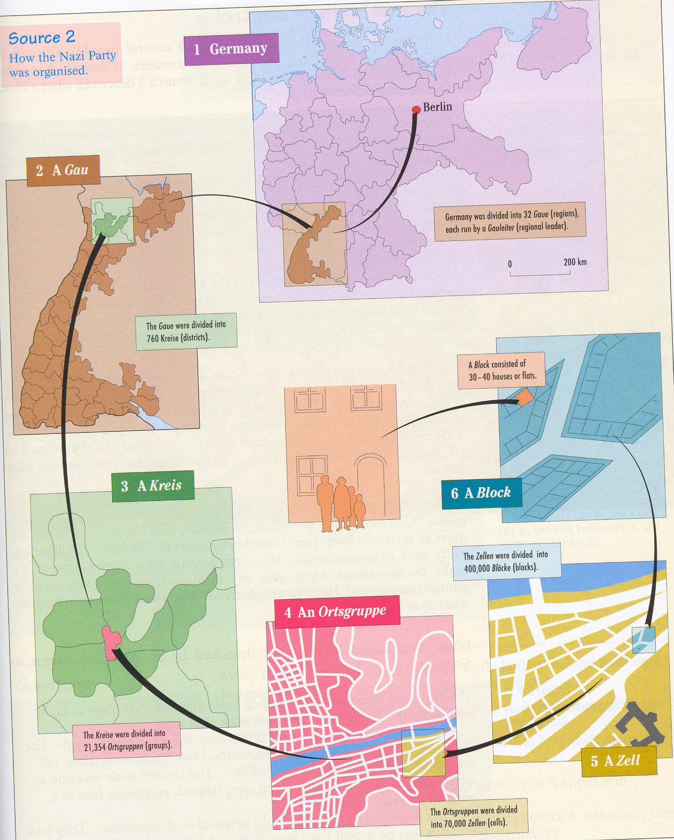

Activity 2. Nazi Party organisations.
The Nazi Party led a wide variety of organisations which established either control or influence over many areas of peoples lives. This was called Gleichshaltung (co-ordination) Complete the following diagram to show the role of the Nazis Party in controlling people’s lives
p.123 DAF(Beauty of Labour) p.123 DAF(Strength through Joy)

Reich Labour Service RAD

p.130 The Hitler Youth p.136 German Women’s Enterprise
Work
Leisure

Nazis party organisations

Childhood
Women

Activity 3. The police state.
Write the following heading and stick your copy of the structure of the Nazis Police into your books.

How was the Nazis Police state used to restrict people’s freedom?

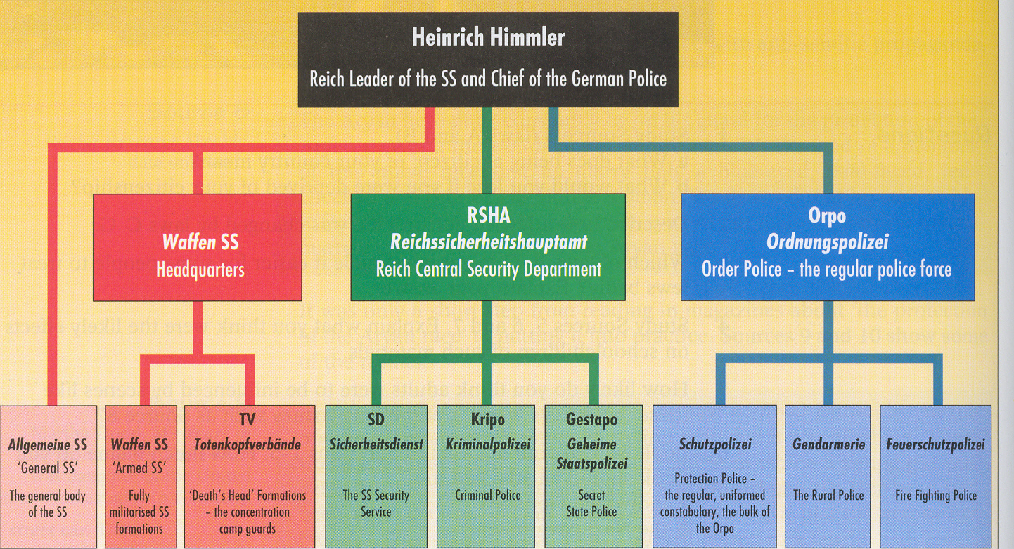

Activity 4. Different roles for different branches of the police.
Complete your own version of the following table by matching the aspects of the Nazis Police State with the correct roles they carried out in controlling the German people:

The aspect of the Nazis police state | Role in controlling the people
The SS –originally the private bodyguard for leading Nazis. It had 500 men by 1939. | They tapped telephones, intercepted mail and spied on people. They used a network of informers to identify and arrest opposition to Hitler.
Concentration Camps | They became the main means of terrorising or intimidating Germans into obedience. They had unlimited power to arrest people without trial, search houses, or confiscate property.
The Gestapo – originally the Prussian Secret Police. In June 1936 it became the State secret police. | As laws were changed and punishments made harsher, these organisations were increasingly active. Higher and higher numbers were arrested, sentenced and punished for crimes.
Rather than replacing the original police, courts and prisons, the Nazis took the police over and made the judges swear an oath of loyalty | Opponents were taken there for questioning, torture, hard labour and ‘re-education’. By 1939 prisoners were used as slave labour. Later they became the scenes of mass Genocide (killing of whole groups of people).

Activity 5. Back to the concept map!
Complete sections 3 & 4 of your concept map, selecting your 4 pieces
of information carefully. Underline the key words in an appropriate colour.

Put a sub heading What role did propaganda play in controlling the thoughts of German people after 1933?

Activity 6. The role of the Ministry of Propaganda.
Soon after the appointment of Hitler has Chancellor in January 1933 Hitler set up a Propaganda Ministry under Joseph Goebbels, who supervised a vast machinery for control of all aspect of the media. Highlight a copy of the following flow diagram.

Dr Joseph Goebbels
Reich Propaganda Minister
President Chamber of Culture
Director of Propaganda

Minister. Ministry for Popular Enlightenment and Propaganda
President of the Reich Chamber of Culture
Director of Central Propaganda Office of the Nazi party.

Departments of Broadcasting, Press, Film, Theatre, Arts and Music.
7 Presidents in charge of Press, radio, Film, Literature, Theatre, Music and Fine Arts.
Departments for active Nazi Propaganda through media.
Regional offices
Regional offices
Regional offices

Activity 7. Control of the media and how it was used to get across the Nazi message.
Use the information on p112-115 to complete your copy of this thinking matrix.
Means of propaganda | How Goebbels controlled it. | How Goebbels used it.
Newspapers

Radio

Film   | Censorship of the films that were produced for both entertainment and political purposes, so that nazi ideas were encouraged. | - Encouraged popular quality propaganda films. Eg Jud Suss about an evil Jew.  - Audiences watched propaganda newsreels.
Festivals/Celebrations

Art and Culture

Music
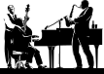
Theatre

Literature


Activity 8
Complete sections 5 and 6 of your concept map, selecting your 4 pieces of information carefully. Underline the key words in an appropriate colour.
Focus 3. What was the nature and extent of opposition to Nazi control?

Activity 1

What forms can opposition take and how common was it in Nazi Germany?
Complete the following table using page 90:

Form of opposition | Evidence of extent of this form of opposition
Attempted coups d’etat
(take over)

Underground resistance and open opposition

Passive resistance and non-cooperation with the Party and State
Private grumbling

Activity 2

Why didn’t most private grumbling become open opposition?
- Cut out the eight cards which give reasons why opposition was not more open. Try to decide their order of importance, putting the one you think most important at the top.
- Stick them in your books in the order of importance.
- Next to your two top factors, explain why they had such an impact.

Activity 3
Where did opposition to the Nazis come from and how effectively were they dealt with?

Your teacher will divide the class into 4 groups. You are each going to study a different opposition group.

Political opponents | Youth | The Churches | The Army

a) You must read the information sheets provided carefully to produce a summary of the role of that group including the following information:
- How did the group oppose the Nazi regime?
- What did the Nazis do to deal with them?
- How effectively was this opposition group dealt with?

- Report back your findings to the rest of the class, so that you have all completed the note-taking sheet on opposition.

Opposition group | Nature of opposition
Political opponents | How did the group oppose the Nazi regime?  What did the Nazis do to deal with them?  How successfully was this opposition group dealt with?
Youth | How did the group oppose the Nazi regime?  What did the Nazis do to deal with them?  How successfully was this opposition group dealt with?
The Churches | How did the groups oppose the Nazi regime?  What did the Nazis do to deal with them?  How successfully was this opposition group dealt with?
The Army | How did the group oppose the Nazi regime?  What did the Nazis do to deal with them?  How successfully was this opposition group dealt with?

Activity 5
Complete sections 5 and 6 of your concept map, selecting your 4 pieces of information carefully. Underline the key words in an appropriate colour.

(III) Thematic Analysis of wider context:
Mystery game
Why was Dietrich Bonhoeffer executed in April 1945?

Mystery Game. Dietrich Bonhoeffer was the Pastor of the German Protestant Church who became involved in underground resistance to the Nazis. He was arrested by the Gestapo in April 1943 and sent to Flossenburg concentration camp where he was executed in 1945. What you must consider is Why was Dietrich Bonhoeffer executed in 1945?

Statements
1 Bonhoeffer joined the underground resistance movement in 1940.

9 Bonhoeffer believed that Christianity taught to treat everyone equally, no matter who they were.

2 The Enabling Act (1933) changed the constitution, giving Hitler the power to make new laws on his own, thus making Germany a Dictatorship.

10 In 1937 the Gestapo closed Bonhoeffer’s church training college and banned him from preaching and publishing his ideas.

3 Hitler believed that Aryans (German people) were superior to other races such as Jews.

11 Bonhoeffer’s brother-in-Law was arrested and tortured until he revealed other opponents, including Bonhoeffer.

4 The Nazis tried to be the only ones influencing people’s thoughts and behaviour, through the establishment of Nazis Party organizations.

12 By 1938 various laws had been passed which discriminated against Jews. In November, they destroyed Jewish Synagogues, shops and homes

5Concentration camps were set up for Hitler’s enemies. They were supposed to ‘correct’ opponents but many people died in concentration camps.

13 In October the Gestapo arrested a member of the Abwehr for currency smuggling. When interrogated he confessed about the Abwehr and mention members including Bonhoeffer’s Brother-in Law.

6 The judges in the Courts were forced to take an oath of loyalty to Hitler.

14 In 1941 the mass execution (genocide) of Jews and other groups began, with some concentration camps becoming extermination camps.

7 From the mid 1930s the Nazis attempted to control religion so set up the Reich church, with Nazis in positions of power.

15 Bonhoeffer had a trial which lasted only half an hour, without someone to defend him. He was sent to a concentration camp.

8 In 1939 Bonhoeffer became involved in the Abwehr, the German army counter-intelligence service which aimed to overthrow Hitler.

16 Hitler established a police state, with the Gestapo (the State secret police), the SS and concentration camps.

(IV) Cracking the Puzzle- Preparing for Assessment

Past Exam Questions to be answered in 75 minutes
Answer Questions 1 and 2, EITHER Question 3 OR 4 and then EITHER Question 5(a) and 5(b) OR 6(a) and 6(b).

Q1 Study source 1 and 2.
What can you learn from this source about the way in which the Nazis intended to gain control ? (4) 6mins
Source 1. Goering writing in his diary in February 1933 about the forthcoming March elections.

“Radio causes me some trouble. All the important positions are held by supporters of the old system. They have to be got rid of as soon as possible, that is by 5th March, lest they endanger the election.”

Q2 The boxes below show two events. Choose one and explain how Hitler consolidated Nazi Power. (9) 13 mins
The Enabling Act March 1933
The Night of the Long Knives 1934

Either Q3 Why was there so little opposition to Hitler and the Nazi’s? (12) 18mins
You may use the following in your answer and any other information of your own.

1 Unemployment fell from 6 million in 1932 to 100 thousand in 1939.
2 The Police state.
3 Formation of the Ministry of Propaganda in 1933.

Or Q4 How effectively did the Nazi’s deal with opposition? (12) 18mins
You may use the following in your answer and any other information of your own.
The picture shows the Nazi’s organised the burning of books which contained ideas that they did not approve of after they took power in January 1933.

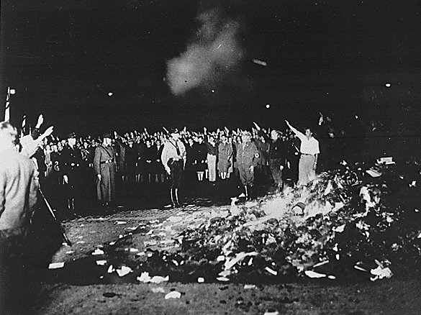

Either Q5

a) Describe how the Nazis managed the media in order to get their message across. (9) 13 mins

b) “Hitler was a strong and powerful dictator” Do you agree? Explain your answer. (16) 24mins
You may use the following in your answer and any other information of your own.

1. 1 June 1934 The Night of the Long Knives
2. 2 July 1933 The Concordat with the Catholic Church is signed
3. 3 Aug 1934 The Death of President Hindenburg

Or Q6
a) Describe why the so many people were supporting the Nazi Party by 1938. (9) 13 mins

b) “The use of propaganda was the main reason for the lack of opposition to Nazi rule.’ Do you agree? Explain your answer. (16) 24mins
You may use the following in your answer and any other information of your own.

1. Cheap radios were made available
2. 1933: Dachau concentration camp opened
3. The ‘Strength Through Joy’ organisation arranged holidays for workers

And finally

1 Revisit the Concept map for Germany KQ2 you have developed for this unit and ensure that you have made a summary of the key events and developments.

- Complete the Trigger Memory Activity for Germany KQ2 using your background notes. An explanation on how to complete this is in your guidance booklet.

- There are many excellent websites on German History 1919-1945, which can be used to revisit the material covered so far. These include –

Top 5 GCSE History Websites on German History 1919-45
1 http://www.educationforum.co.uk/GCSEHistory.htm
2 http://www.schoolhistory.co.uk/revision/germany.shtml
3 http://www.schoolshistory.org.uk/gcse.htm
4 http://www.spartacus.schoolnet.co.uk/Germany.htm

Use these websites to gather further interpretations of the period.

4. There are games that can be played to reinforce the development of your knowledge and understanding at WWW.schoolhistory.co.uk

5. Revisit the examination criteria and advice on tackling the examination questions given in the cracking the puzzle section.

6. Apply these techniques to the specimen examination. You may be asked to work individually, in pairs or in small groups.

