Why was king Charles I executed?

Task 1
Complete the following sentences to make a paragraph by joining the appropriate head with the tail. The heads are in order.

Heads | Tails
King Charles and his Royalist army | to send a King to his death.
Two years later he fought another | the place Westminster Hall.
Parliament decided the King | out of 135 who were supposed to be there turned up.
The date was set for January 20th 1649, | lost the Civil War between 1642 and 146.
However on the first day of the trial only 68 people | Civil War against Parliament and lost again.
They were probably to scared | had to be put on trial for treason.

Task 2
Source 1 is a description of King Charles’s trial. Source 2 is a picture of the trial. The historian who wrote source 1 used source 2 to help him describe what happened. Match each sentence in source 1 to the correct part of the picture and write it in the box provided.

Source 1 Written by a modern historian.

- At one end of the hall were the benches for the judges.
- In the middle, raised above everyone else, was John Bradshaw, the President of the Court.
- Down either side of the hall were lines of soldiers.
- Opposite the judges was a dock-with a crimson chair facing the judges.
- Around the top were galleries for the more important spectators.

Source 2.
The trial of Charles I, 1649.
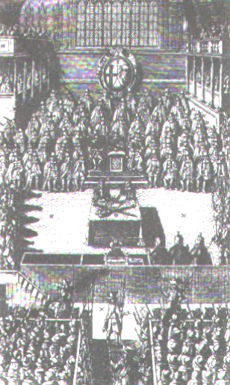

Task 3
In groups you should read once through the play about the trial of King Charles I and then be ready to read it to the whole group.

- Your teacher will organise you into groups of 9.
- Each person in the group should have a role within the play, and your group should first decide who is playing each of the roles.
- Once you have done this, your group should read through the play once.
- Before you perform it to the rest of the group you should try and give the play some drama by the way you use your voice and by acting out the very last scene of the execution.

Task 4
In draft design a Newspaper article explaining what happened before, during and after the trial of King Charles I. Lay your Newspaper article out like this;

The story of King Charles I, his trial and Execution 1649.
Read all about it!
1 King Charles was brought to trial because… | 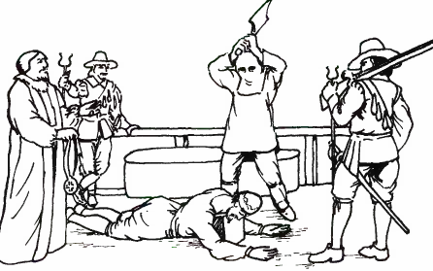  3 This is what happened after the trial…
2 This is what happened during the trial… | 4 These are my thoughts about this event…

The story of King Charles I, his trial and Execution 1649.
Read all about it!
1 King Charles was brought to trial because… | 3 This is what happened after the trial…
2 This is what happened during the trial… | 4 These are my thoughts about this event…

Source 2.
The trial of Charles I, 1649.

Source 2.
The trial of Charles I, 1649.

