E2 A World Divided: Superpower Relations 1944-1990.

KQ4 How successfully did détente introduce a new era into superpower relations 1969-80?

the Strategic Arms Limitation Talks (SALT) and agreements; Helsinki Accords; the impact of economic realities.

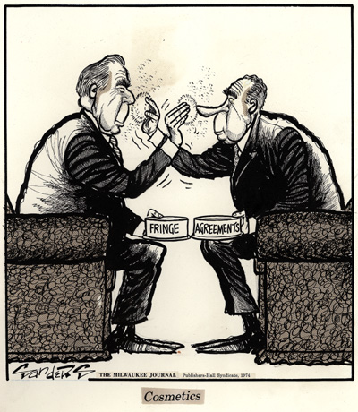

- In a Nutshell: Overview of developments 1969-80.

- Causes and Analysis of developments: The development of detente 1969-80.

- Thematic Analysis of Wider context: What do the historians think and how does this develop my emerging interpretation?

- Cracking the Puzzle – Preparing for assessment.

(I)In a Nutshell: Overview of developments in Détente 1969-80?

Content overview
This relates to the period of improved relations between the USA and the USSR during the 1970s, when the influence of the realist school, articulated notably by Kissinger, appeared to shape US diplomacy. Students should understand why both powers wished to seek accommodation and the notable features of this accommodation, ie the Strategic Arms Limitation Treaty of 1972, the Anti-Ballistic Missile Treaty of the same year and the Helsinki Accords for liberalisation in Eastern Europe and the USSR. The reference to economic realities refers to the increasing economic problems of the Soviet bloc in the 1970s and the economic resilience of the West after the oil price shock of 1973 producing a growing imbalance of potential power. Students should understand the reasons for the breakdown of détente in 1980 with the Soviet invasion of Afghanistan and the election of Thatcher in 1979 and Reagan in 1981.

Activity 1 – On your marks…..
The timeline makes many brief references to the events of the period. Colour code any event which with little explanation, appear to suggest either reasonable relations (green), hostility (yellow) or confrontation (red).

(II) Causes and Analysis of developments: The development of detente 1969-80?

i) Activity 1; The causes of the emergence of detente.
a) What was Detente?
b) Why did the Superpowers seek détente?
c) How significant were the economic causes of détente?
d) What was the impact of the role of individuals to détente?
e) What was the most significant cause of Détente?

ii) Activity 2; The analysis of relations during these years.
a i and ii) To what extent was there co-operation and conflict during the period of Detente?
b) How significant were the economic results of détente?

iii) Activity 3; The causes of the breakdown of détente by 1981..
- Why had Détente come to an end by 1981?
- What was the most significant cause of the failure of Détente?

Activity 1 A : What was Detente?

Using Phillips p174 and Lightbody p66-67, explain what they describe as the emergence of detente. Summarise the line of argument and include brief quotes to illustrate.

Phillips on detente p174. Top 5 points
Lightbody on detente p66-67. Top 5 points

Activity 1 B : Why did the Superpowers seek Détente? (including what motivated Brezhnev and the Soviet leadership to pursue detente)? Factors include I, E, Ind, AR and GP?
Conceptual factors impacting on the emergence of détente. | America (USA)  Nixon and the American leadership | Russia (USSR)  Brezhnev and the Soviet leadership
Ideology. Democracy v Marxism (L 68-69, P 175-77)  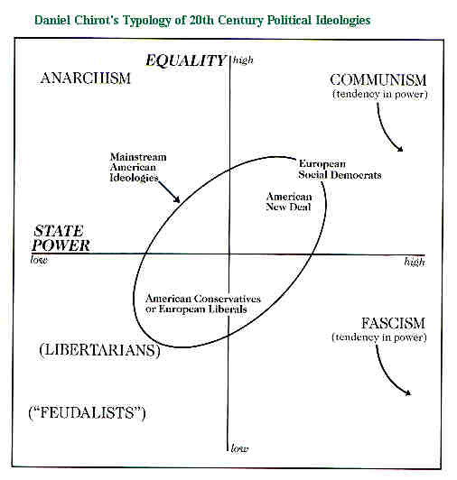 | 1 Detente  2 National Interests  3 Domestic ideology  4 Ostpolitik | 1 Detente  2  3
Economic. Capitalism v Communism (L 68-70, P 175) 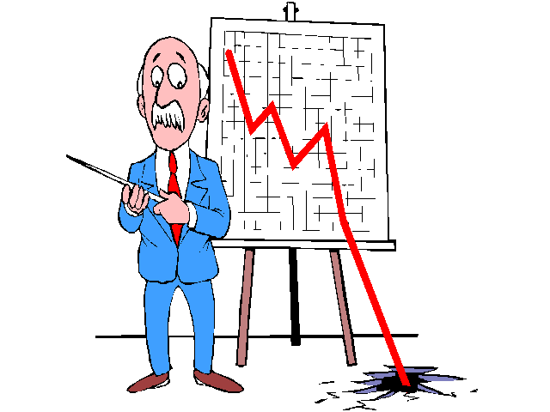 | 1 Korean war costs  2 Arms costs  3 Domestic economic needs | 1 Arms costs  2 Domestic economic problems  3 Trade opportunities
Role of Individuals (L 67-70, P 175-77)  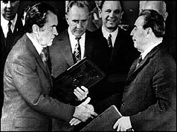 | 1 Kennedy/Johnson  2 Nixon  3 Kissenger  4 Brandt (FDR) | 1 Krushchev  2 Dobrynin  3 Brezhnev
Arms Race and security (L 67-72, P 174-75)  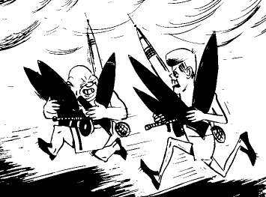 | 1 Issue of Parity  2 Fear of War  3 Cost of Arms Race | 1 Fear of War  2 Military threat from China  3 Cost of Arms Race
Geo Political balance of power (L 68-71, P 175-76)  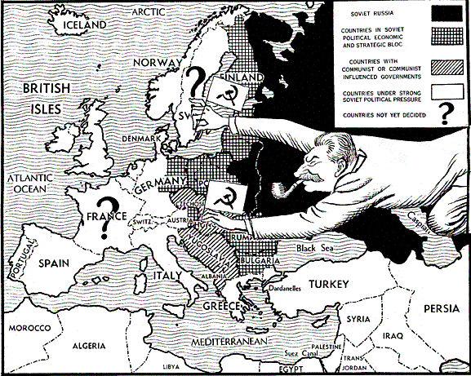 | 1 Asia  2 China  3 Middle East  4 Europe | 1 Asia  2 China  3 Middle East  4 Europe

Activity 1 C : How significant were the economic causes of détente?

Economic Development | Description and explanation of the economic causes of détente.
Wider economic context | Western economic developments oil crisis 1973  The 1973 oil crisis started in October 1973, when the members of Organization of Arab Petroleum Exporting Countries or the OAPEC (consisting of the Arab members of OPEC, plus Egypt, Syria and Tunisia) proclaimed an oil embargo "in response to the U.S. decision to re-supply the Israeli military" during the Yom Kippur war; it lasted until March 1974.[1] OAPEC declared it would limit or stop oil shipments to the United States and other countries if they supported Israel in the conflict. With the US actions seen as initiating the oil embargo, the long-term possibility of embargo-related high oil prices, disrupted supply and recession, created a strong rift within NATO; both European nations and Japan sought to disassociate themselves from the US Middle East policy. Arab oil producers had also linked the end of the embargo with successful US efforts to create peace in the Middle East, which complicated the situation. To address these developments, the Nixon Administration began parallel negotiations with both Arab oil producers to end the embargo, and with Egypt, Syria, and Israel to arrange an Israeli pull back from the Sinai and the Golan Heights after the fighting stopped. By January 18, 1974, Secretary of State Henry Kissinger had negotiated an Israeli troop withdrawal from parts of the Sinai. The promise of a negotiated settlement between Israel and Syria was sufficient to convince Arab oil producers to lift the embargo in March 1974. By May, Israel agreed to withdraw from the Golan Heights.[1]
Developments in the Soviet economy  (P 175)  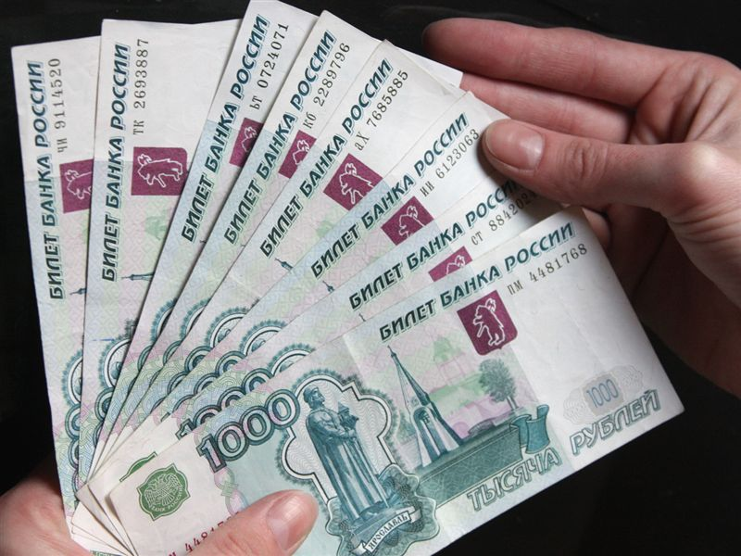 | 1  2  3  4  5
Developments in the American economy.  (P 175-76)  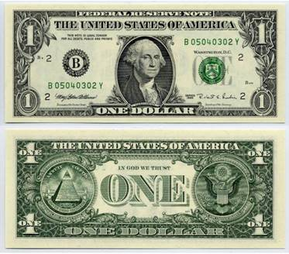 | 1  2  3  4  5

Activity 1 D : What was the impact of the role of individuals on détente (including Brezhnev, Nixon, Ford and Carter) in these years 1969-80?

Role of individual | Describe and explain their contribution to detente.
Brezhnev (P 177-81, L 68-70)  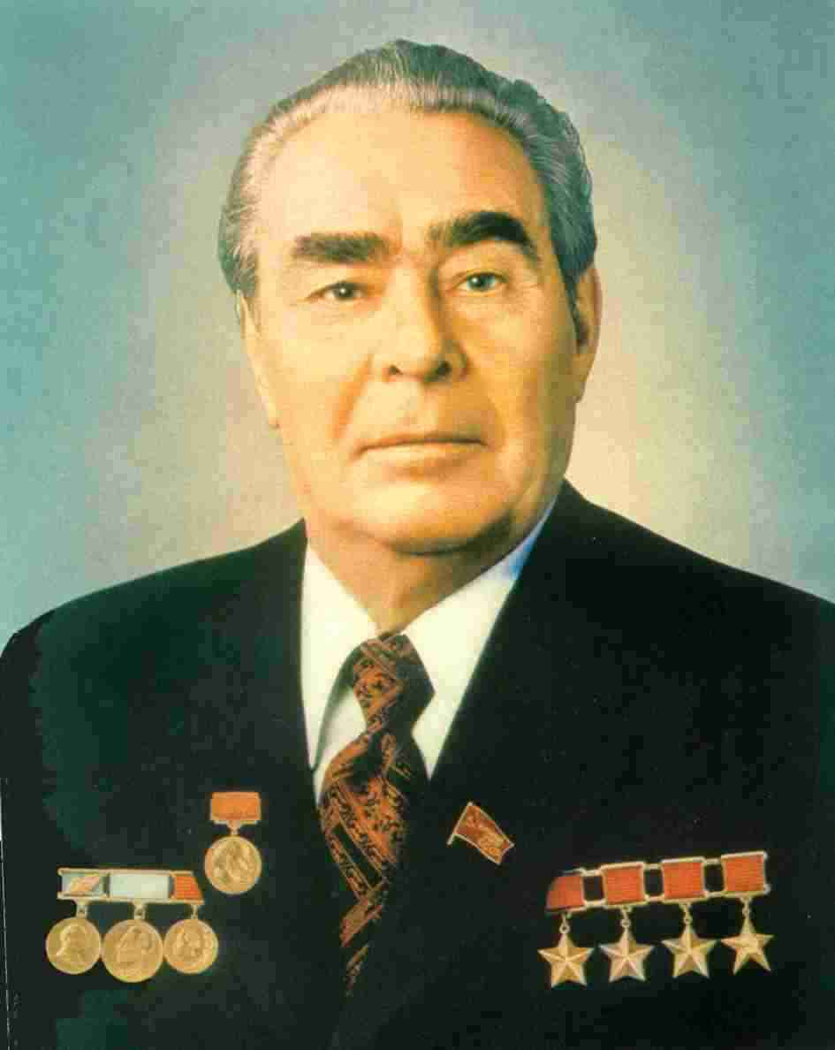 | 1  2  3  4
Nixon (P 178-80, L 68-71)  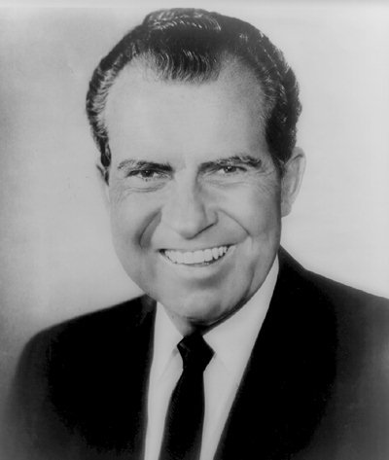 | 1  2  3  4
Ford (P 179, L 71-72)  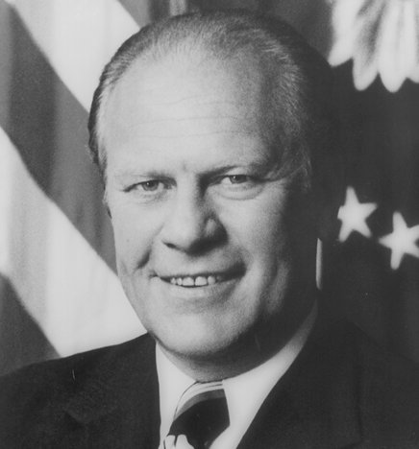 | 1  2  3  4
Carter (P 180, L 72)  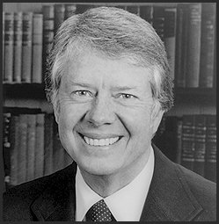 | 1  2  3  4
Activity 1 E essay: Which of these ingredients is the most significant cause of detente?

Explore in pairs and then in a whole class discussion how these causal factors of detente are interlinked.

Using the knowledge and understanding that you have developed, answer the following question in as much detail as you can. You might find it helpful to use the thinking frame below.

How far was the bid for detente due to economic environment of the Superpowers?

There are a number of causes of detente. It is important to understand that there are different views as to which of these are most significant, but what is agreed is that they all contributed to and interlink to explain the emergence of detente.

- It is important to acknowledge the range of causes of detente. For example..

- However it is argued that the most significant cause of detente is..

- It is important to recognise that these causes interlink. For example..

Activity 2 A i: To what extent was there co-operation and conflict during the period of détente 1969-74? Using L p66-71, 75-76, 83-85, 88-89 and P 177-179 complete your copy of the following table in order to identify the extent of co-operation or conflict 1969-74.

The nature of Superpower relations 1969-74
Co-operation | Conflict
Conciliatory rhetoric: | Hostile rhetoric:
Use of diplomacy/negotiations: | Limitations to diplomacy:
Reluctance to intervene in international incidents: | Intervention in international incidents:
Acceptance of others sphere of influence: | Conflict over sphere of influence:
Arms/military limitations: | Arms/military development:
Summary of relations 1969-74

Activity 2 A ii: To what extent was there co-operation and conflict during the period of détente 1975-79? Using L p71-72, 86-87, 89-91 and P p179-181, complete your copy of the following table in order to identify the extent of co-operation or conflict 1975-79.

The nature of Superpower relations 1975-79
Co-operation | Conflict
Conciliatory rhetoric: | Hostile rhetoric:
Use of diplomacy/negotiations: | Limitations to diplomacy:
Reluctance to intervene in international incidents: | Intervention in international incidents:
Acceptance of others sphere of influence: | Conflict over sphere of influence:
Arms/military limitations: | Arms/military development:
Summary of relations 1975-79

Activity 2 B : How significant were the economic results of détente by 1980?

Economic Development | Description and explanation of the economic results of détente.
Wider economic context (P 178-81 L 68-71) | Western economic developments  Eastern bloc economic developments
Developments in the Soviet economy (P 178-81 L 68-71) | 1  2  3  4  5
Developments in the American economy. (P 178-81 L 68-71) | 1  2  3  4  5

Activity 3 A : Why had détente come to an end by 1981? Why did the Superpowers attempt at détente fail? Factors include I, E, Ind, AR and GP?
Conceptual factors impacting on the emergence of peaceful co-existence | America (USA)  Carter and Reagan and the American leadership | Russia (USSR)  Brezhnev and the Soviet leadership
Ideology. Democracy v Marxism (P 182 and 185, P 71, 76, 90 and 98) | 1 Soviet breach of Helsinki accords  2 Reagan’s fourth pillar | 1 On Soviet human rights abuses  2 Brezhnev doctrine
Economic. Capitalism v Communism (L p71 and 97, P 185) | 1 US economic depression  2 Oil access | 1 US trade cuts
Role of Individuals (L p72, 86, 96-97P 184-189) | 1 Ford  2 Carter  3 Vance  4 Reagan | 1 Brezhnev  2 The Gerontocracy
Arms Race and security (L72, 86, 89-90 P 185-186) | 1 SALT II stopped  2 Military arms growth  3 Supplying arms to LEDCs | 1 Arms military growth
Geo Political balance of power (L p71-72, 97, P 181, 185) | 1 Soviet interventions in Africa  2 Vietnam  3 Relations with China | 1 Soviet interventions in Africa  2 Vietnam  3 Afghanistan
Activity 3 B essay: Which of these ingredients is the most significant cause of the failure of detente?

Explore in pairs and then in a whole class discussion how these causal factors for detente are interlinked.

Using the knowledge and understanding that you have developed, answer the following question in as much detail as you can. You might find it helpful to use the thinking frame below.
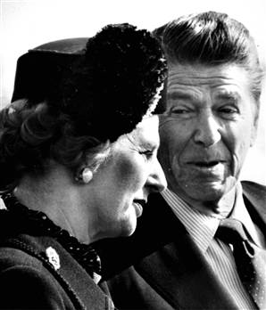

How far was the failure of detente due to changes in leadership of the Superpowers?

There are a number of causes of the failure of detente. It is important to understand that there are different views as to which of these are most significant, but what is agreed is that they all contributed and interlink to explain the emergence of detente.

- It is important to acknowledge the range of causes of the failure of detente. For example..

- However it is argued that the most significant cause of the failure of detente is..

- It is important to recognise that these causes interlink. For example..

(III) Thematic Analysis of wider context: What do the historians think and how does this develop my emerging interpretation?

i) How successful was the bid for detente between he Superpowers 1969-80?
ii) Analyse Lightbodys interpretation.

The reasons for the continuation of the Cold War have variably been interpreted as being due to the desire for supremacy by either the USA or the USSR, or because of misjudgements and insecurity, leading to a desire to contain the other.

Activity 4 – Divide yourself into two groups. One group should take the position that the bid for detente between the Superpowers was successful 1969-80, the second that it was unsuccessful.
Each group should prepare a five minute presentation according to the position you have been asked to take. Each group will be given a set of event cards for the period 1969-80, your group must spin these events according to their interpretation.

1 In the aftermath of the Cuban Missile Crises USA and USSR were keen to consider reconciliation and Western European countries like Germany and France wanted to pursue their own more independent relations with USSR and Eastern European countries. | 2 In 1967 China perfected the H Bomb and in 1969 become openly hostile to USSR. Also in 1969 USSR developed nuclear parity with USA and guaranteed MAD in event of a nuclear war. These developments resulted a transition from a confrontational bi polar Cold War to a diplomatic triangular Cold War. | 3 Before 1968 differences between the superpowers over Americas role in Vietnam and USSR’s repression of the Czech uprising had prevented the development of more co-operative relations despite the signing of the Nuclear Non Proliferation Treaty of 1968.
4 Nixon became President in 1968 and his new foreign policy endorsed peaceful coexistence, and supported the idea of intervention only when vital interests were at steak. Pragmatism and national interests were now considered by governments before any ideological straightjacket as a conduct for foreign policy. | 5 By 1969 USA no longer had an overwhelmingly nuclear superiority. Mutually Assured Destruction was now a reality in the event of a nuclear war and Kissinger was interested in limiting the risks of nuclear conflict in brokering deals in the new triangular Cold War. | 6 In September 1969 USA criticised USSR for troop build up the Chinese border. This led to America being courted by both China and the USSR since neither wanted to be isolated against an alliance of two other superpowers.
7 In 1971 China was admitted to the UN, and Nixon visited Beijing in Feb 1972. This resulted in the Shangai communiqué including a joint declaration that neither would seek dominance in the Pacific and would co-operate to resist the interventions of others, namely Russia, to do so. | 8 Nixon visited Moscow for a summit in May 1972, which resulted in SALT that fixed the number of ICBMs held by both sides and ABM Treaty which restricted the deployment of this system to two areas. There were also wider agreements on matters relating to health, environment and trade deals. | 9 There was a huge increase in trade between USA and Ussr, from 67 million dollars in 1971 to 490 million dollars by 1973 added to a wheat deal of October 1972 referred to as the Great Grain Robbery. Further US and USSR summits were held in Washington in 1973 and Moscow in 1974.
10 In 1973 America began the final phase of its withdrawal from Vietnam. By 1975 Saigon had fallen to the communists and this was a extremely bitter pill for US to swallow. | 11 There was considerable US concern over USSR support for Egypt and the Arab states in the Yom Kippur war 1973, and support for the communist movements in other Third World states. | 12 In 1974 Nixon was forced to resign over Watergate. Ford could make no further headway with SALT, and trade restrictions began to emerge with USSR because of linkage to US concerns over the lack of emigration rights of USSR jews to Israel.
13 By 1975 relations between the US and USSR began to cool after Soviet intervention in the Angolan Civil War of 1975. Further interventions in Mozambique, Somalia and Ethiopia served to intensify hostility. | 14 The treatment of Soviet dissidents further brought into focus USSR’s human rights abuses, which US argued conflicted with the Helsinki Accords o 1975. By 1976 Ford ordered the word détente to be struck of all his Presidential election speeches and literature. | 15 In 1976 President Carter and his secretary of state Vance clashed openly with Brezhnev over the terms of SALT II, which was eventually signed by Carter at the Vienna summit of June 1979.
16 In December 1979 USSR invaded Afghanistan in support of the left wing government against Islamic fundamentalist insurgency in the wake of the Iranian revolution of 1979. In response Carter scrapped SALT II and boycotted the Moscow Olympics of 1980. | 17 By January 1980 US relations had improved so much with the PRC that China was awarded most favoured nation status. | 18 In November 1980 Reagan was elected President with a mandate for counter action to forstall the threat posed by the USSR throughout the world, but especially in Central America, Africa and the Middle East.

Activity 5 – Analyse Lightbody’s interpretation of détente, by reading his essay on the extent to which it introduced a new era into the Cold War 1969-80 p67-72 and begin to think about your own evolving interpretation.
Lightbody suggests

Activity 6 – Analyse Phillip’s interpretation of the achievements of detente p177-183 and begin to think about your own evolving interpretation.
Phillips suggests

Cracking the Puzzle- Preparing for Assessment

- Revisit the living graph. Consider whether the line you previously plotted for nature of relations between the Superpowers in the period 1969-80 accurately reflects you emerging interpretation. If not, adjust it.

- Complete Trigger Memory Activity 1969-80 using your background notes. An explanation on how to complete this is in your guidance booklet.

- There are many excellent Cold War websites which can be used to revisit the material covered so far. These include -

http://en.wikipedia.org/wiki/Cold_War

http://www.coldwar.org/

http://www.spartacus.schoolnet.co.uk/ColdWar.htm

http://www.academicinfo.net/histcold.html

http://www.wilsoncenter.org/index.cfm?fuseaction=topics.home&topic_id=1409

http://www.wilsoncenter.org/coldwarfiles/index.cfm?fuseaction=resources.detail&thisunit=0&resourceid=9

Use these websites to gather further interpretations for the period.

- As a class, design and play a game for the Game Show Presenter Game called detente.

- Revisit the examination criteria and advice on tackling the examination questions given in the guidance booklet.

- Apply these techniques to the specimen examination. You may be asked to work individually, in pairs or in group.

