“Sources of evidence are like pieces of a jigsaw from which historians can build a more complete picture of events and developments in order to help them answer questions about the past”.
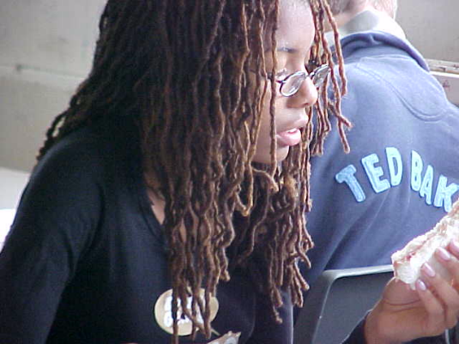
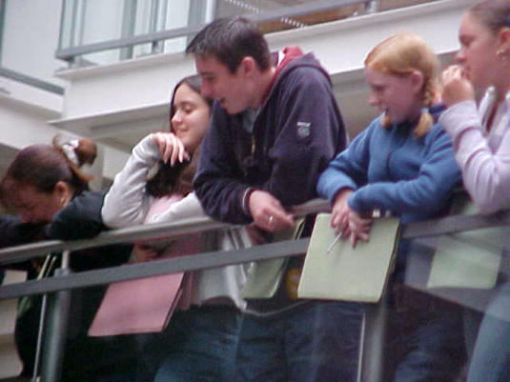

Historical evidence

Puzzling it out

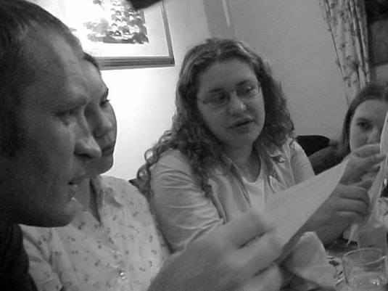


“ A document is like a witness, and like most witnesses it rarely speaks until one begins to question it.”


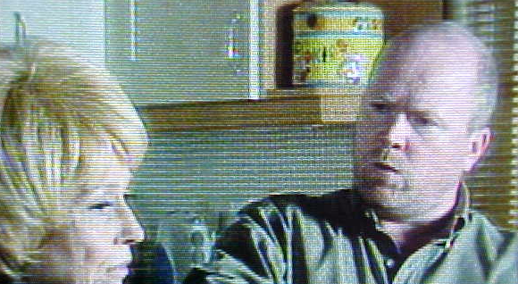
Key points about Unit 3 Surgery Source work examination.

1 Paper 2 lasts for 1 hour and 15 minutes and is worth 25% of the total marks available in the syllabus.

2 The paper mostly tests; Assessment Objective 3a : use historical sources critically in their context by comprehending, analyzing, evaluating and interpreting them and why historical events, people situations and changes have been interpreted and represented in different ways. (84%)
However, within question 5 you will also be assessed on Assessment Objective 1 and 2: to recall, select and deploy relevant knowledge of the syllabus content and to communicate it effectively through description, analysis and explanation. This means that you must revise a historical topic set by the exam board in preparation for the exam. (16%)

3 This paper will involve a detailed investigation of an historical issue taken from the Transformation of Surgery c1845-c1918

4 There will be a range of source material taken from the topic (about 6-8 sources of evidence). Candidates are advised to spend a few minutes reading through this information and underlining and making notes about the content of sources and its provenance on the exam paper. Candidates will be expected to use their contextual knowledge to help them comprehend, interpret, evaluate and use the sources.

5 There will be 5 compulsory questions set. Candidates are then instructed to answer all the questions on the paper. The questions are worth different amounts of marks, and students will need to make sure that their answers are more detailed and thorough on those questions worth more marks. As a rule students should spend just less than one and a half times the amount of marks in minutes in answering the question EG 6 marks, 9minutes; 10 marks 15 minutes; 16 marks 24 minutes.

6 In answering the questions candidates are expected to use their knowledge of the topic to help them comprehend, interpret and evaluate the sources, and in question 5, to explain answers by reference to knowledge and the sources. When candidates are instructed to use a source they must do so. Answer 5s which show little or no contextual knowledge or that do not refer to the sources will not achieve the higher levels.

7 Candidates need to remember that they will be expected to answer questions about the usefulness and reliability of historical evidence. It is wise to remember that all sources of evidence have both strengths and limitations, and that historians identify what these are by considering the author, audience, content, context and relationship to other evidence.
Author. Who wrote the source?
Audience. Who the source was intended for?
Relationship to other known evidence. Does it agree or not?

The usefulness and reliability of evidence depends on AARCC.

Content. What does the evidence tell us?
Context. When was the evidence made?

8 Candidates will be rewarded for using brief quotes from the sources in order to back up their answer. Avoid copying out lengthy parts of a source, since this will not be rewarded.

Summary of Exam Technique for Unit 3.

1 You will be competing against 25,000 other pupils throughout the country so it is important that you do yourself justice.
2 Spend approximately 5 minutes reading through the background information and the sources and make notes about their content and their argument, and complete your table quickly.
3 With each of the questions underline the key words on the exam paper. Fix in your mind the first part of the question "Why", "What", "How far" and stick to it.
4 Remember that this is an evidence based paper and you will need to demonstrate your source work skills as well as your knowledge to answer the questions. In order to analyse a source you should use its author, audience, content, argument, the circumstances in which it was produced and relationship to other known facts.

Type of GCSE questions. | Examples of GCSE question types. | How do I organize my answer to receive a good grade?
1 Comprehension and inference. (6) 9mins | Study source A.  What can you learn about X from the source A? | From Sources A and B I can infer…because it shows…  I can also infer…because it shows..
2 Analysis of source for Portayal. Evaluation of interpretation of a single source. (8) 12mins | Study source B  What impression has the author/artist tried to give of X?  Or  What impression of X has been created by the display?  (8) | There are several ways in which the author/artist X  Firstly the author/artist mentions /shows Y.  Secondly, the author uses language/symbols such as Z  Finally, they W
3 Cross referencing for support.  Interpretation, cross referencing and evaluation of sources to reach conclusion. (10) 15mins | Study sources D, E and F  How far do sources D,E and F suggest that X  Or  How far does Source E support the portrayal of X in source D? | To some extent, sources D, E and F suggest that X. However to some extent they also challenge X the notion that X  In some ways the sources support X. For example……  (use P, C)  However sources D, E and F also challenge X. For example…(use P, C)
4 Evaluation of sources for comparative value to reach conclusion (10) 15 mins | Study sources E and F.  Which of sources D or E is more useful to the historian enquiring into X?  Or  Compare the value of sources E and F for someone enquiring into the development of X? | Source B and C have strengths and limitations in utility for an historian enquiring about X  Source B is of … utility. For example it shows…It also shows… Another reason is has utility is…However its utility is limited as….  Source C also has…….. utility For example it shows…It also shows… Another reason is has utility is…..  Overall source…is more useful that source…for someone enquiring into X because….
5 Reaching a judgment. Evaluation of interpretations using knowledge and sources. (16) 24mins | Study sources B, F and G.  ‘X’ How far do you agree with this statement? Use your own knowledge, sources B, F and G and any other sources you find useful to explain your answer.  (12) | There is evidence to support this view, but there is also evidence to question this viewpoint.  There is evidence to support the view. For example….(Use P,C,K)  There is evidence to challenge the view. For example….(Use P,C,K)  In conclusion it is evident that…..

