KQ1 To what extent did the ideas about the causes of illness change 50-1350, and how did they impact on approaches to treatment and prevention?
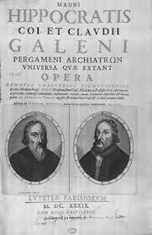

Key Enquiries
1 What factors help us to understand change and continuity in Medical developments 50-1350?
2 What were your chances of a long life if you were born in 50-1350?
3 How far did the Church and the Renaissance impact on developments in Medicine 50-1350?
4 How far did ideas about the causes of illness change 50-1350?
5 How far did approaches to treatment and prevention of illness change 50-1350?
6 How far did public health provision change 50-1350?

Language and Literacy
Key Terms and their meanings in Medicine 50-1350.

Aqueducts

Astrology

Blood letting

Christian church

Contagious disease

Galen

Hippocrates

Latrines

Medieval period

Miasma

Monasteries

Physician

public health

Roman Empire
sewers
Theory of Four Humours
Theory of Opposites

What factors help us to understand change and continuity in Medical developments 50-1350?
Focus : Factors of change and continuity in Medical developments 50-1350.
Activity 1: Factors that help us to understand why change took place in Medicine 50-1350. Stick a copy in your book and highlight the key point.
Role of Individuals  Individuals like Galen adopted and further researched the ideas of the Ancient Greek doctor Hippocrates. Galen developed the theory of the four humours further into the theory of the opposites. The works of Galen and Hippocrates were widely available throughout the Roman Empire. The Romans began to leave Britain in 383 AD as their Empire started to collapse throughout Europe |  | New Ideas  The Romans adopted many of the ideas of the Ancient Greeks about disease and illness, and although there were few new developments by the Romans about causes and treatments (other than Galen’s theory of the opposites) there were many developments in thinking about public health. |  | Role of Government  When the Romans conquered Britain in 43AD they brought their ideas about Medicine and public health with them. They had a strong centralised government system who organised large scale projects and raised taxes to pay for them. The role of the Roman army was very significant in establishing the stability for these projects to be completed.
 |  | FACTORS OF CHANGE 50-1350 in MEDICINE
Science and Technology  The Romans developed a skilled class of engineers who had planned and built great aqueducts to bring clean water to cities. There were also public toilets, fountains, bath houses and supplies to forts and private homes. Once used there were sewers designed to take waste water away |  | War  War and public health went hand in hand for the Romans since they needed healthy soldiers to maintain and expand the Roman Empire. They built their towns and army forts in healthy sites away from marshland and polluted water.Roman forts also had hospitals for soldiers staffed by surgeons and assistants. |  | Communication and Education  The works of Hippocrates and Galen were maintained by the Romans and doctors trained using their methods and these methods were used throughout the Empire in hospitals by doctors and surgeons. The Romans began to leave Britain in 383 AD as their Empire started to collapse throughout Europe

Activity 3: Factors that help us to understand why continuity took place in Medicine 50-1350. Stick a copy in your book and highlight the key point.
Role of Individuals  Individuals like Hippocrates and Galen continued to be preserved by the Church in the years after the Roman Empire collapsed. However there were few significant individuals in Medieval Britain 383 AD to 1350 AD to really promote new approaches to the causes and treatments of illness and disease. |  | Old Ideas  Greek ideas about Medicine were very influential on the Romans. After the Romans left Britain in 383 AD the Church preserved these ideas but also bound them up with ideas of God. There were little progress in Medicine by 1350 in terms of new ideas. Roman public health systems fell into ruin. Traditional cures and remedies continued to be important, and prayer was encouraged. |  | Role of Government  When the Romans started to leave Britain in 383 AD, the government of Britain became much more fragmented with competing groups trying to establish control Angles, Saxons, Viking and later Normans. their wars were destructive and disrupted stability so that governments had little time or resources to aid medical developments.
 |  | FACTORS OF CHANGE 50-1350
Science and Technology  The disruption brought about by the collapse of Roman rule and the onset of war, meant that resources were divereted into military and the skilled engineers that managed the development of public health systems were lost. The Medieval times witnessed little development in terms of science and technology. |  | War  A thousand years of disruptive wars on the collapse of the Roman Empire throughout Europe meant that much of the progress made by the Romans was destroyed and that governments were not sufficiently powerful and wealthy to prioritise medical developments. |  | Communication and Education  Emperor Constantine converted to Christianity in 313 AD and Christianity quickly spread. As the Roman Empire collapsed the Church was the only significant international organisation that could preserve and transmit the knowledge left by the Romans. The Church controlled training and preserved record but did not encourage new ideas.

How far did the changing ideas impact on medicine 50-1350?
Focus.
AF2 Causation and Change
Activity 1: How did Roman ideas affect Medicine and public health in Britain c43 AD- 383 AD? Read through the factors of change in Medicine c43AD to 383 AD above. Write your own paragraph to show how far the ideas of the Romans changed Medicine and public health.

Activity 2: How did Anglo-Saxon, Viking and Norman ideas in the Middle Ages affect Medicine and public health c 383 AD - 1350 AD? Read through the changes and continuities in Medical ideas from Roman times to Medieval Britain c383 AD to 1350 AD.
Ideas that ended with the Roman rule in 383 AD | Ideas that continued from Roman Britain to the Medieval Britain. | New influences in the Medieval Britain
Government became very weak. Roman public health systems collapsed and there wasn’t the money or power to replace them. | Doctors continued to be trained according to the ideas of Hippocrates and galen, because they were adapted to fit in with the teachings of the Christian Church who preserved what they could and controlled the teaching of doctors and surgeons. | The Christian Church dominated thinking and there was a strong belief that suffering in this life was temporary and controlled by God as a test of perseverance before beginning the afterlife in heaven.
Much of the knowledge of the Greek and roman thinkers and writers were lost in the wars that characterised Medieval Britain. | Traditional cures and remedies continued to be very important throughout. Supernatural and spiritual explanations of illness meant that charms and prayer were encouraged as treatments in Medieval Britain | The Christian Church actively resisted the influence of new ideas because they were seen as a threat to the spiritual explanation. However the Church did organise medical training and preserved the knowledge of Ancient Doctors.
There was lots of fighting but no central organisation of armies and no organised medical treatments for soldiers other than what the Church was able to provide | In addition treatments based on the theory of illness of imbalanced Four humours, that were encouraged by Galen, continued to be used in Medieval Britain | The Christian Church stressed the importance of caring for the sick, but caring rather than treating. Prayer was encouraged as a priority over medical interventions.
AF2 Causation and Change
Activity 3: How far did changing ideas impact on medicine in the period 50-1350?
Analyse how far changing ideas impacted on medicine by plotting your own living graph and labelling some of the significant points related to changing ideas on it.

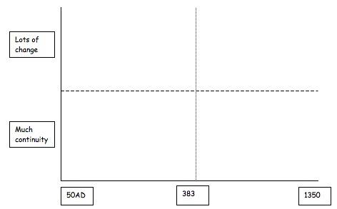

During the period 50-383 AD in Roman Britain new ideas about Medicine and public health were encouraged. These included new ideas on the causes and treatments of illness based on the Four Humours. | During the period 50-383 AD in Roman Britain, the Romans developed a strong system of government which gave both stability and raised money to concentrate on developing public health and medical developments throughout Britain. | During the period 50-383 AD in Roman Britain a system of fresh water supply, sewers and army hospitals were developed throughout the main cities of Roman settlement in Britain 43AD to 383 AD.
During the Medieval Britain  383-1350 spiritual and supernatural ideas about the causes of illness predominated as the Christian Church established their control of Medical training and education. | During the Medieval Britain  383-1350 their was a period of intermittent wars for over a thousand years with Anglo saxons, Vikings and Normans competing for power. Government was not sufficiently stable to support developments in Medicine and the influence of the Church was very strong | During the Medieval Britain  383-1350 the public health systems established by the Romans fell into ruin and their was an absence of stability, money and desire to continue the progress the Romans had made.

Activity 4: How far did changing ideas impact on medicine between 50 and 1350?
Using Activities 1-3 Then organise your thoughts and answer the following question using either of the suggested thinking frames below.

Thinking frame 1
Intro: Whilst there were some changes in medicine during the period 150-1350 because of the changing context, there were many ideas that remained the same.

Part 1: There were some significant changes in the context for medical developments during the period 50-1350. For example…

Part 2: However many ideas and practices within medicine remained the same in the period 50-1350. For example….

Thinking frame 2
Intro: Whilst there were some ideas that continued in the context for medical developments during the period 50-1350, there were many significant changes.

Part 1: There were some ideas that continued in the context of Medical developments during the period 50-1350. For example…

Part 2: However there were many significant changes in the context of medical developments in the period 50-1350. For example….

How far did ideas about the causes of illness change 50-1350?
Focus : Changing ideas about the Causes of illness.

Activity 1: The ideas of the Greek doctor Hippocrates on Medicine.
Explain the importance of the Greek doctor Hippocrates to medicine by completing the following mind map using DC SHP Medicine text p20-21.
Hippocratic Oath p20 | Books p20 | Observing and recording p21
 | The significance of Hippocrates in medical developments.
Causes of disease and the theory of the four humours p21 | Exercise p21 | Natural treatments p21

Activity 2: The ideas of the Roman doctor Galen on Medicine.Explain the importance of the Roman doctor Galen to medicine by completing the following mind map using DC SHP Medicine text p26-29.

Research/dissection p28 | Books p29 | Observing p28
 | The significance of Galen in medical developments.
Causes of disease and the theory of the opposites p28 | Exercise p26 | Natural treatments p26

AF2 Causation and Change
Activity 3: The theory of the Four humours as the cause of illness and disease.
Complete the following table using WB SHP Medicine p6, and then write a paragraph to explain the theory of the Four humours which was central to the explanation of the causes of illness in Roman Britain. The four Humours had to be in balance for good health and if not, then this was the cause of illness. The humours needed to be rebalanced to restore health. Each humour was linked to a season and the four elements e.g. in winter this is linked to more water which produces too much phlegm so you have to cough and sneeze to expel it to restore the balance.
Humour | Season | Element | Qualities | Ancient name
Blood | Spring | Air | Warm and moist | Sanguine
Yello bile | Summer | Fire | Warm and dry | Choleric
Black bile | Autumn | Earth | Cold and dry | Melancholic
Phlegm | Winter | Water | Cold and moist | Phlegmatic

AF2 Causation and Change
Activity 4: How far did Medical ideas from the Ancients continue to be used in the Middle Ages?
Identify evidence to show continuity in ideas about the causes of disease between Ancient times and the Medieval period by completing the following thinking matrix using WB SHP Medicine text p6-7.

Ideas from the Ancient times. | Description of ideas | Evidence of idea still being used in the Medieval period.
The Four Humours |  | 1  2
Galen and the theory of Opposites |  | 1  2
Prescription medicines of Physicians |  | 1  2
Astrological ideas |  | 1  2
The book Vade Mecum |  | 1  2

AF2 Causation and Change
Activity 5: How were the causes of the Black Death 1348 explained at the time ?
Describe and explain what was thought to be the different possible causes of the Black Death 1348 WB SHP Medicine text p8-9 and the Great Plague 1665 DC SHP Medicine text p71.

Possible explanations of the causes of the Black Death. | Evidence that this explanation of disease was used at the time.
A punishment from God

The positioning of planets

Poisonous fumes or Miasma (bad air)

Imbalance of the Four Humours

AF2 Causation and Change
Activity 6: Why was there so little progress after the Romans left Britain (in 383 AD) by 1350?
Using DBL SHP Medicine text p36-37 and p42, write a paragraph to explain what happened after the Romans left Britain and why there was little development in changing explanations of the causes of disease and illness.

 | Explanation
1 The end of the Roman Empire p36-37

2 What the end of the Roman Empire led to p37.

3What ideas existed about the causes of disease c383-1350 p42 | God or the Devil.  The Four Humours.  Common sense - bad air and dirt.  Desperate explanations.

AF2 Causation and Change
Activity 7: How far did changing ideas impact on medicine in the period 50-1350?
Analyse how far changing ideas impacted on medicine by plotting your own living graph and labelling some of the significant points related to changing ideas on it.

During the period 50-383 AD in Roman Britain the theory of the four humours was very prominent which stressed that the causes of disease were imbalanced humours and could therefore be treated by restoring the balance. | During the period 50-383 AD in Roman Britain the idea that dirt and uncleanliness could be a cause of disease were very strong and this explains the importance that the Romans placed on good public health systems. | During the period 50-383 AD in Roman Britain praying to the gods were also encouraged eg the god of healing Ascepious, and when the Empire adopted Christianity in 313AD prayer was also encouraged.
During the period 383-1350 in Medieval Britain the influence of the Christian Church encouraged more spiritual explanations of the causes of illness and disease | During the period 383-1350 in Medieval Britain the ideas of Galen were continued with certain illnesses and disease being explained by the imbalance of the four humours. | During the period 383-1350 in Medieval Britain explanations of the causes of illness based on astrology and miasma were also encouraged

AF2 Causation and Change
Activity 8: How far did ideas about the causes of illness impact on medicine between 50 and 1350?
Using WB SHP Medicine text p, work through the activities 1-7 Then organise your thoughts and answer the following question using either of the suggested thinking frames below.

Thinking frame 1
Intro: Whilst there were some changes in explanations of causes of illness in medicine during the period 150-1350, there were many ideas that remained the same.

Part 1: There were some significant changes in explanations for the causes of illness for medical developments during the period 50-1350. For example…

Part 2: However many ideas about the causes of illness in medicine remained the same in the period 50-1350. For example….

Thinking frame 2
Intro: Whilst there were some ideas about the causes of illness that continued in the context for medical developments during the period 50-1350, there were many significant changes.

Part 1: There were some explanations of the causes of illness that continued in Medical developments during the period 50-1350. For example…

Part 2: However there were many significant changes in explanations of the causes illness in medical developments in the period 50-1350. For example….

How far did approaches to treatment of illness change 50-1350?
Focus Change in treatments and preventions.

AF2 Causation and Change
Activity 1: the treatments of Hippocrates and Galen were still widely used in 1350. Using DC SHP Medicine text p18, 21, 26 identify as many treatments encouraged by Greek and Roman doctors that were still being used in Medieval Europe by 1350.
Ancient Doctor | Treatments they used
Hippocrates p18,20-21 | 1  2  3
Galen p26, 28 | 1  2  3

AF2 Causation and Change
Activity 2: Treatment of illness and disease in Roman Britain c43 AD - 383 AD.
Using DBL SHP Medicine text p26-27 make notes on Roman healers, their experience and methods.

Who could you get Medical help from in Roman Britain? What experience did they have? | How would they treat you
Home remedies. p26 | 1  2  3
Gods and their priests. p26 | 1  2  3
Trained doctors. p27 | 1  2  3
Treatments encouraged by Galen p31 | 1  2  3

AF2 Causation and Change
Activity 3: Treatment of illness and disease in Medieval Britain c383 AD - 1350 AD.
Using DBL SHP Medicine text p38-41 make notes on Medieval healers, their experience and methods.

Who could you get Medical help from in Medieval Britain? What experience did they have? | How would they treat you?
Trained physicians. p38-39, p43  Experience | 1  2  3
In hospitals. Gods and their priests, and care homes. p40  Experience | 1  2  3
Trained doctors disappeared! Local healers p38  Experience | 1  2  3
Women p41  Experience | 1  2  3

AF2 Causation and Change
Activity 4: How did they treat the sick in Medieval Britain c383 AD - 1350 AD.
Using DBL SHP Medicine text p44-45 make notes on Roman healers, their experience and methods.

How would they treat you in Medieval Britain? What experience did they have? | How would they treat you?
The physician and the urine chart. p44 | 1  2  3
Bleeding p45 | 1  2  3
Home remedies p45 | 1  2  3

AF2 Causation and Change
Activity 5: What were hospitals like in 1350?
a) Complete the following thinking matrix using DC SHP Medicine text p86.

Hospitals in 1350 | Evidence of what hospitals were like in 1350
Hospitals | 1  2
Patients | 1  2
Doctors and nurses | 1  2
Treatments | 1  2

Activity 6: How far did treatments change in medicine in the period 50-1350? Analyse how far changing ideas impacted on treatments in medicine by plotting your own living graph and labelling some of the significant points related to changing ideas on it.

During the period 50-383 AD in Roman Britain treatments were often based on the theory of the four humours. For example if it was thought that your humours were inbalanced then they were restored e.g. bloodletting was used for too much blood. | During the period 50-383 AD in Roman Britain treatments there were trained doctors who followed Galens theory of the opposites. Treatments were often based on diet, exercise, lifestyle but also beginning to incorporate knowledge of plants and herbs from throughout the Empire. | During the period 50-383 AD in Britain, Roman treatments had spread. Although this was not quick because few doctors travelled to Britain, the army legions did have doctors and surgeons so that by the time the Romans left most doctors were following Roman ideas of treatments.
During the period 383-1350 in Medieval Britain treatments there was little change in the training of doctors, but doctors became far fewer in number. For hundreds of years those who were sick mainly got help from the family, local wise women and men who had built up their knowledge through practise. | During the period 383-1350 in Medieval Britain looking after the sick was an important part of the work of the Christian Church and this led to the founding of many hospitals in Churches. By 1350 there were about 500 hospitals but they did not cater for the very sick and were more like care homes for rest and prayer | During the period 383-1350 in Medieval Britain treatments were often the role of women within the family and sometimes they consulted local wise women. They were not allowed to train as doctors or physicians and surgeons in the growing universities from 1200 onwards.

AF2 Causation and Change
Activity 7: How far did treatments change in medicine between 50 and 1350?
Using Activities 1-6 organise your thoughts and answer the following question using either of the suggested thinking frames below.

Thinking frame 1
Intro: Whilst there were some changes in treatments in medicine during the period 50-1350, there were many ideas that remained the same.

Part 1: There were some significant changes in treatments of illness and disease during the period 50-1350. For example…

Part 2: However many treatments which remained the same in the period 50-1350. For example….

Thinking frame 2
Intro: Whilst there were some treatments of illness and disease that continued during the period 50-1350, there were many significant changes.

Part 1: There were some treatments that continued during the period 50-1350. For example…

Part 2: However there were many significant changes in treatments in the period 50-1350. For example….

How far did public health provision change 50-1350?
Focus. Roman and Medieval public health campaigned.

Activity 1: The Romans big idea...Public Health.
The siting of towns and cities and the supply of fresh water and a sewerage network was a priority of the Romans. Look carefully at the diagram below and explain in a thorough paragraph how this public health system worked.
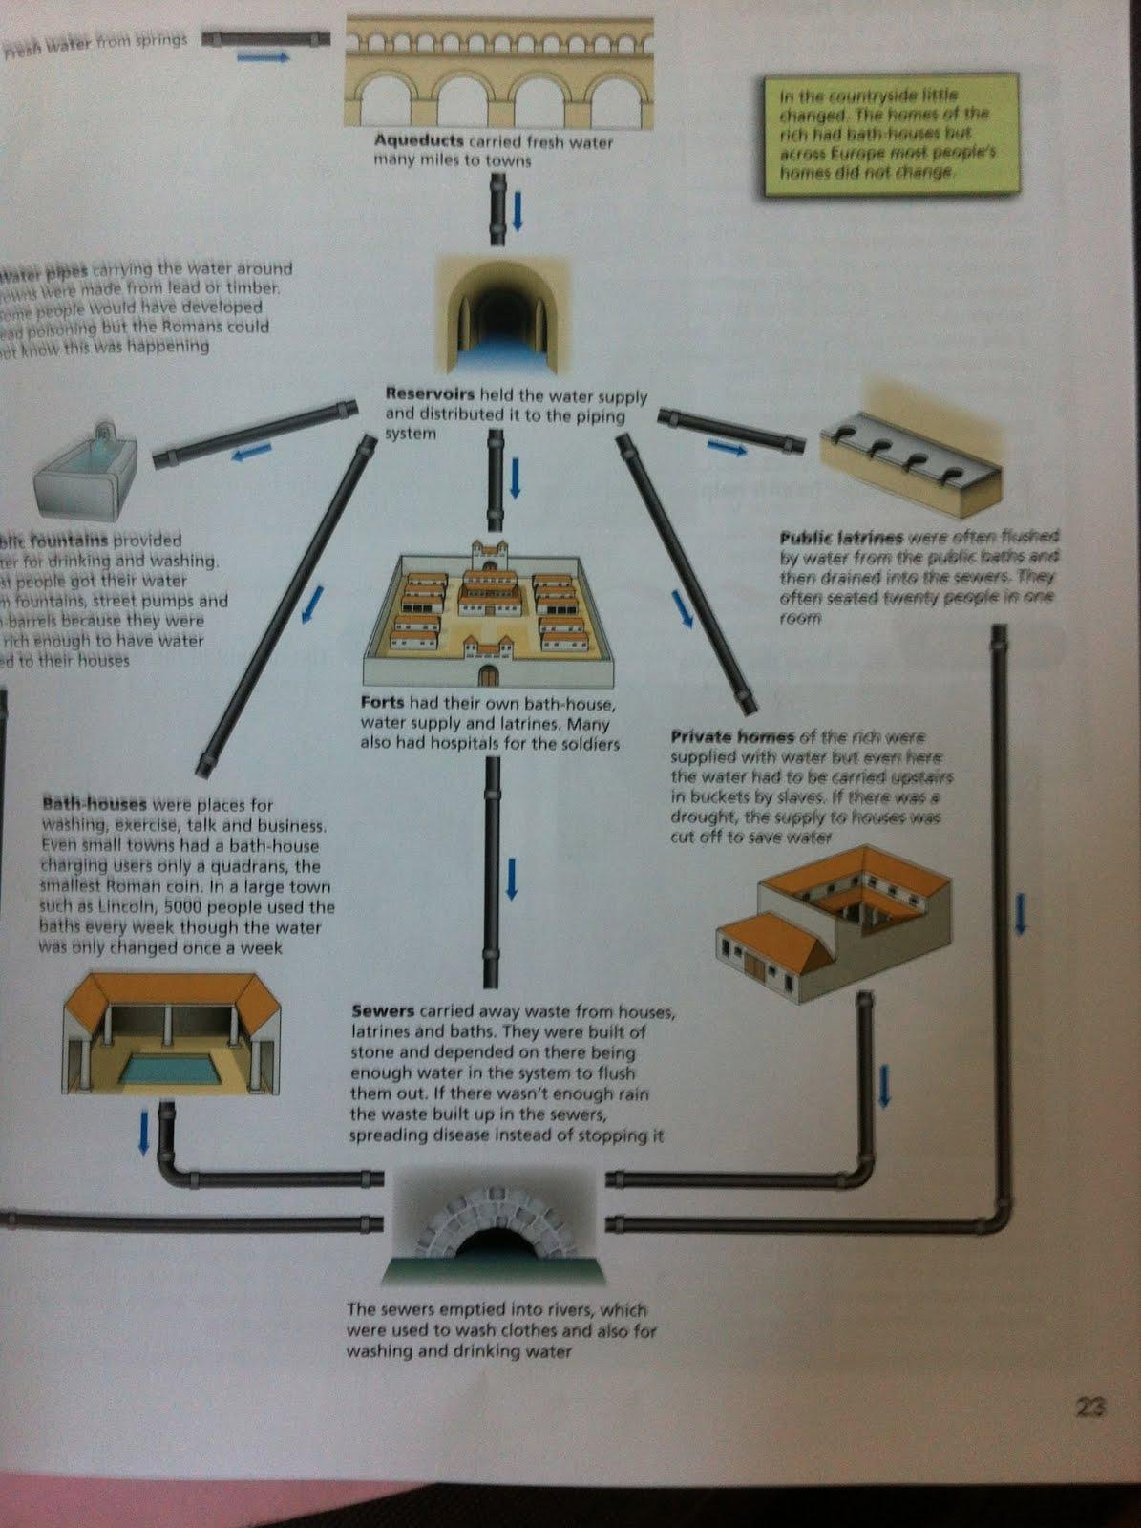

AF2 Causation and Change
Activity 2: Did public health facilities in Roman Britain really protect people’s health?
Using DBL SHP Medicine text p24-25 make notes on how well the Roman public health systems protected peoples health.

Evidence | How far did Roman public health systems really protect peoples health?
Source 1  Town life | 1  2  3
Source 2  Away from towns | 1  2  3
Source 3  Impact of the army | 1  2  3
Source 4  Public health in towns | 1  2
Source 5  The impact of contagious disease | 1  2  3

Activity 3: Did the Roman public health system collapse? Using DC SHP Medicine text p40-41 make notes on how far the Roman public health systems collapsed in York..
Case Study | How far did the Roman public health system collapse?
Roman York to 383AD | 1  2
Saxon York 400AD-800AD | 1  2
Viking York 800AD-1066 | 1  2

Activity 4: Why did public health deteriorate in the years after the Romans and why didnt peoples efforts work. Using DBL SHP Medicine text p46-47 make notes on why the Roman public health systems deteriorated.
Reasons why public health deteriorated after the Romans.
Medieval towns | 1  2
Animals | 1  2
Wealth and skilled engineers | 1  2
Why didn’t peoples efforts work? | 1 Wars.  2 Government.  3 The teaching of the Church.

Activity 5: Public health systems inside Medieval monasteries.
Using DBL SHP Medicine text p47 make notes on the public health systems of the Monasteries.
Activity 6: How far did public health change in the period 50-1350?
Analyse how far public health systems developed by plotting your own living graph and labelling some of the significant points related to changing ideas on it.

When the Romans conquered Britain in 43AD they brought their ideas about Medicine and public health with them. They had a strong centralised government system who organised large scale projects and raised taxes to pay for them. The role of the Roman army was very significant in establishing the stability for these projects to be completed. | The Romans developed a skilled class of engineers who had planned and built great aqueducts to bring clean water to cities. There were also public toilets, fountains, bath houses and supplies to forts and private homes. Once used there were sewers designed to take waste water away | War and public health went hand in hand for the Romans since they needed healthy soldiers to maintain and expand the Roman Empire. They built their towns and army forts in healthy sites away from marshland and polluted water.Roman forts also had hospitals for soldiers staffed by surgeons and assistants.
During the period 383-1350 in Medieval Britain there was disruption brought about by the collapse of Roman rule and the onset of war. This meant that resources were divereted into military and the skilled engineers that managed the development of public health systems were lost. The Medieval times witnessed little development in terms of science and technology. | When the Romans started to leave Britain in 383 AD, the government of Britain became much more fragmented with competing groups trying to establish control Angles, Saxons, Viking and later Normans. Their wars were destructive and disrupted stability so that governments had little time or resources to aid medical developments. More stability and the establishment of universities from 1100. | During the period 383-1350 in Medieval Britain A thousand years of disruptive wars on the collapse of the Roman Empire throughout Europe meant that much of the progress made by the Romans was destroyed and that governments were not sufficiently powerful and wealthy to prioritise medical developments.

AF2 Causation and Change
Activity 7: How far did public health change between 50 and 1350?
Using WB SHP Medicine text p, work through the activities 1-7 Then organise your thoughts and answer the following question using either of the suggested thinking frames below.

Thinking frame 1
Intro: Whilst there were some changes in public health during the period 150-1350, there were many ideas that remained the same.

Part 1: There were some significant changes in public health during the period 50-1350. For example…

Part 2: However many practices in public health that remained the same in the period 50-1350. For example….

Thinking frame 2
Intro: Whilst there were some ideas that continued in public health during the period 50-1350, there were many significant changes.

Part 1: There were some practises in public health that continued iduring the period 50-1350. For example…

Part 2: However there were many significant changes in public health in the period 50-1350. For example….

Trigger Memory Activity for Medicine and Public Health 50-1350

Trigger Words | Trigger Picture | Add Trigger  Points from your notes
Factors of Change
Factors of continuity
Roman ideas on medicine
Medieval ideas on medicine
Hippocrates
Galen
Theory of Four Humours
Medieval ideas on causes of disease
Treatments in Roman times
Treatments in Medieval period
Hospitals in 1350
Roman public health systems
Reasons why public health systems collapsed
public health in Medieval times
How far had provision of Mediine and public health improved by 1350?

Trigger Memory Story Medicine 50-1350

The story must be very imaginative. It must involve you seeing, talking and doing things. It must link the ten trigger words together in the form of a continuous story. You should then rehearse the story and commit it too your long term memory to be recalled when necessary. This will take some effort but will be very useful! Use different colours to write the trigger words in your story.

I was...

Assessment for Learning
Puzzle practise : Medicine and Public Health 50-1350

In the puzzle there will be three compulsory questions and two optional questions covering the core content of Medicine and public health 50-2000. The content will come from either one or a combination of the key themes (ideas, causes, treatments and public health) covered in each of the key questions;
· The impact of changing ideas on the development of Medicine 50-2000.
· The understanding of the causes of disease 50-2000.
· The understanding of the methods of treatment and prevention 50-2000.
· The development of public health provision 50-2000.

The following examples are focussed on content from the second key question medicine 1350-1750.

Exam Practise 1
AF2 Causation and Change
Answer Question 1, 2 and 3
Q1 Knowledge recall and selection, analysis of change in a historical context, inference from sources. 8 marks 12 mins. One page approx.

What do Sources A and B show about changes in the way doctors in late Medieval Britain find out about a patient’s health? Explain your answer, using Sources A and B and your own knowledge.

Q2 Knowledge recall and selection, analysis of change in a historical context, inference from sources. 6 marks.. 9 mins. 1 page approx
The boxes below show two different periods. Choose one and describe the key features of the care that was available to patients in English hospitals during that period.

Roman Britain | Medieval Britain

Q3 Knowledge recall and selection, key features and characteristics of periods studied, evaluation of source utility. 8 marks, 12 mins 1 page approx

How useful is this cartoon to a historian who is investigating public health problems in the mid-thirteenth century? Use Source C and your own knowledge to explain your answer.

AF2 Causation and Change
Either Q4 OR 5 Knowledge recall and selection, factors relevant to continuity and change in a historical context 12 marks 18 mins. 1 and half pages approx

Q4 Why did it take so long for public health to improve in the Medieval period? You may use the following in your answer.
Collapse of the Roman Empire
Chaos in Britain as a result of wars in Medieval period
You must also include information of your own.

OR

Q5 Why did it take so long for treatments to change in the period after the Romans? You may use the following in your answer.
Influence of Galen’s writing
Chaos in Britain as a result of wars in Medieval period
You must also include information of your own.

AF2 Causation and Change
Either Q6 OR Q7. Knowledge recall/ analysis of key features and evaluation of progress. 16 marks + 3 SPAG..24 mins. 2 pages.

Q6 How far was the progress made in Medicine made by the Romans continued in the Middle Ages in England. Explain your answer.

You may use the following in your answer.
• Public health
• Medical training
You must also include information of your own.

OR

Q7 How far was the progress made in understanding the causes of illness made by the Romans continued in the Middle Ages in England. Explain your answer.

You may use the following in your answer.
• Theory of the Four Humours
• Medical training in Medieval period in causes of illness
You must also include information of your own.

