**How did the British Empire end?**

Source 1: General Richard Mulcahy inspects Irish Free State soldiers in Dublin, 1922, during the Irish War of Independence.

Sources 2-3: Mohandas Gandhi in 1931. Gandhi was the leader of a non-violent resistance campaign against British rule in India, such as the Salt March, 1930.

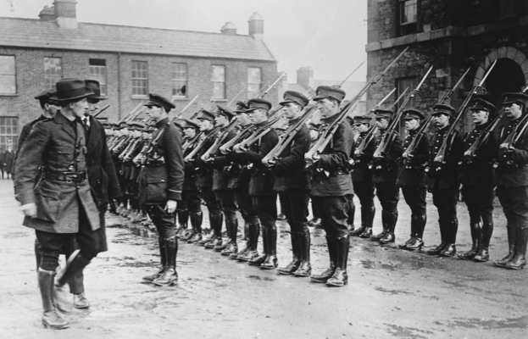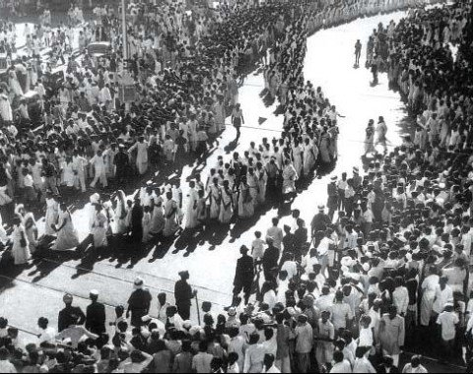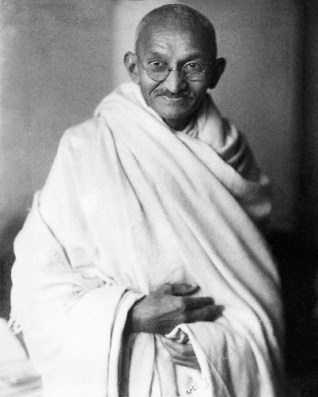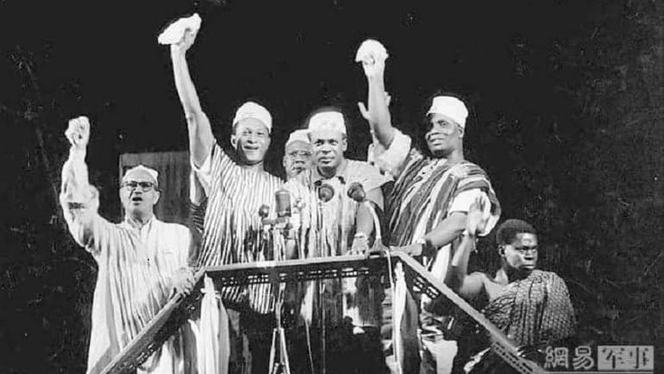

Source 4: From the Dominion Day Address by Queen Elizabeth I in 1959, reflecting on the creation of the Commonwealth in 1949. The term Commonwealth was first adopted in 1926, and was intended to reflect the equality of status of Britain and the independent ex-colonies.

***‘Dominion Day commemorates the birth of Canada as a nation, and the first independent country within the British Empire. So, it also marks the beginning of that free association of independent states which is now known as the Commonwealth of Nations… This is no mere sentimental organisation but a vigorous association for cooperation and mutual help on the widest scale.’***

Source 5: Prime Minister Kwane Nkrumah’s Gold Coast government celebrating the election win that showed a majority of support for Ghanaian independence. On 6 March 1957 Ghana became the first African country to gain independence, when Britain relinquished its control.