Interpretations of the British Empire

Section A
Interpretation 1: An extract adapted from a letter written by Cecil Rhodes in 1891.
“I contend that we are the first race of the world and that the more of the world we inhabit the better it is for the human race. I contend that every acre added to our territory means the birth of more of the English race who otherwise would not be brought into existence… The expansion of the British Empire brings the whole of the uncivilised world under British rule.”

Interpretation 2: An extract adapted from a book by Christopher Hill, written in 1957.
“The profits from the investments in the British Empire went to a fairly small number of British people as shareholders in the companies whose business lay in the colonies. Yet it must be remembered that what made both the interest and the new range of goods possible was the cheap native labour in the new colonies… Plantations, mines, railways, and roads – all depended upon the employment of large numbers of native workmen whose wages were extremely low and whose living conditions were primitive by British standards”.

- What is the main difference between Interpretation 1 and Interpretation 2?
The main difference between Interpretation 1 and Interpretation 2 is that 1 is ___________ about the empire whilst 2 is ____________ about the empire.
Interpretation 1 says that ‘…’
This shows that Rhodes thought…

On the other hand, Interpretation 2 says that ‘…’
This shows that Hill thought…

- Explain one reason why Interpretations 1 and 2 differ.
One reason why Interpretations 1 and 2 differ is due to the personal experiences of the authors. For example, Rhodes felt ____________ about the empire because…

On the other hand, Hill felt ____________ about the empire because…

Challenge: Another reason they might give different views is due to the context of the time when the Interpretations were written…
Section B
Interpretation 2: An extract adapted from a book by Christopher Hill, written in 1957.
“The profits from the investments in the British Empire went to a fairly small number of British people as shareholders in the companies whose business lay in the colonies. Yet it must be remembered that what made both the interest and the new range of goods possible was the cheap native labour in the new colonies… Plantations, mines, railways, and roads – all depended upon the employment of large numbers of native workmen whose wages were extremely low and whose living conditions were primitive by British standards”.
Interpretation 3: An extract adapted from an article by Richard Gott, written in The Guardian on May 5th 2001.
“The First World War over-extended the Empire; the Second World War, which turned out to be a war against racism, accelerated its downfall. If it was right to oppose Hitler, it was necessary to dismantle an Empire built on the same racist principles. The British ruling classes rather enjoyed lording it over people they regarded as their racial inferiors. The Empire involved military conquest and dictatorship, extermination and genocide, slavery and forced labour and of course the transoceanic migration of peoples.”

- What is the main difference between Interpretation 2 and Interpretation 3?
The main difference between Interpretation 2 and Interpretation 3 is that 2 focuses on __________ whilst 3 focuses on ______________.
Interpretation 2 says that ‘…’
This shows that Hill thought the empire was bad because…

On the other hand, Interpretation 3 says that ‘…’
This shows that Gott thought the empire was bad because…
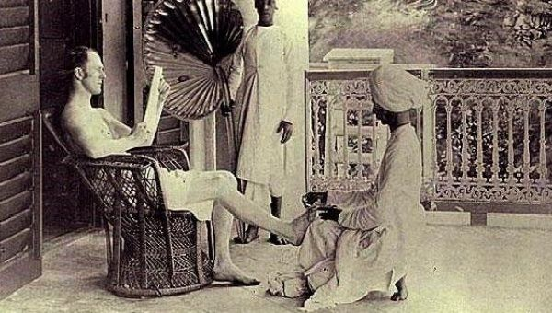
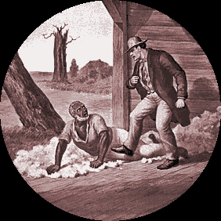

Source 3: A slave being kicked and beaten by his owner, c. 1700.
Source 5: A British man is waited on by Indian servants.

- Explain one reason why Interpretations 2 and 3 differ.
One reason why Interpretations 2 and 3 differ is because the authors used different evidence. For example, Hill might have used evidence such as Source ___, which shows…
This supports his view that… because…
On the other hand, Gott might have used evidence such as Source ___, which shows…
This supports his view that… because…
Challenge: Another reason they might give different views is due to the context of the time when the Interpretations were written…

