Consequences. Where might we find the shadows of the First World War?
Immediate Shadow 1. Collapse of Empires. Three European and One Middle Eastern Empires dismantled at the end of the First World War https://www.theguardian.com/world/ng-interactive/2014/jul/23/a-global-guide-to-the-first-world-war-interactive-documentary
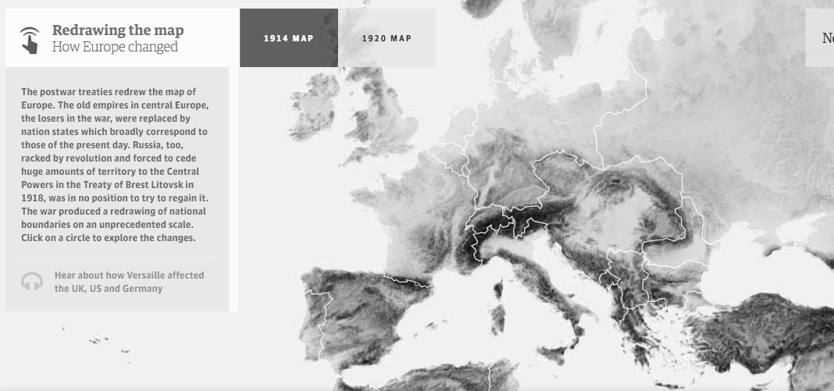 | German Empire. On the eve of the first world war, the German empire was the youngest of the European powers. It’s creator was Otto von Bismarck, who had started the process of unifying Germany at the end of the 19th century, to form the new Reich. A new empire, it started late in its conquest of overseas territories, "scrambling for Africa" to acquire only small pieces of land: German South West Africa (now Namibia), German East Africa (now Tanzania, Rwanda and Burundi), and Cameroon and Togoland plus a few islands in the Pacific, particularly Samoa, and a few cities in China (Tsingtao, Quasi Colony in Shandong). Between 1870 and 1914 Germany underwent rapid industrialisation, and its population soared to over 65 million. Eleven million Germans participated in the first world war.
 | Austro-Hungarian Empire. Sprawling over a vast area of central and eastern Europe, the Austro-Hungarian empire was a multinational entity covering much of modern-day Austria, Italy, Romania, Czech Republic, Slovakia, Poland and the former Yugoslavia. The only thing that united its various nationalities was that they were the subjects of the Habsburgs, one of the great European dynasties, headed in 1914 by Emperor Franz Joseph. In 1914, its population was about 52 million, of which about 7.8 million participated in the war.
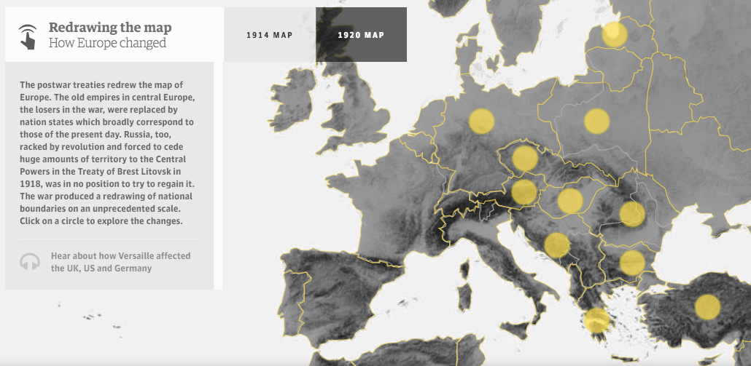  New countries Include; Estonia, Latvia, Lithuania, Poland, Czechoslovakia, Austria, Hungary, Romania, Yugoslavia, Turkey | Russian Empire. Russia in 1914 was a vast, multinational, multi-ethnic empire stretching from Poland to the Caucasus, Central Asia and Siberia, yet still the Russian political elite dreamed of new possible acquisitions such as the Ukrainian territories of Austria-Hungary and parts of the Ottoman empire. Initially the Russian army was patriotic and committed, but unrest on the home front (due to the breakdown of food distribution) and the subsequent ‘revolutions’ undermined the Army and encouraged desertion – particularly by peasant soldiers who wanted to be at home if land was distributed to them.Like the Ottomans, Russia ended up managing a "war inside a war", with civil strife leading to the revolution which toppled the Romanov dynasty in 1917. In the same year, Germany, Austria and France were experiencing food related strikes and riots, but nothing on a par with the civil unrest in Russia which produced a political cataclysm that resounded across the rest of the 20th century.
 | Ottoman Empire. The Ottoman empire stretched from the Bulgarian and Russian coasts of the Black sea to the Arabian peninsula as far south as present-day Bahrain on the Persian Gulf and South Yemen on the Red Sea. It covered 1.5 million square kilometres and was a multi-ethnic and multi-religious empire. In 1914 it was an empire in decline. The great Constantinople, which at the beginning of the 19th century had controlled the Balkans, all of North Africa and the Middle East as far as Iran today, had lost countries such as Serbia, Albania, Bulgaria and Romania.Some 25 million people lived in the Ottoman empire in 1914, including 10 million Turks, 6 million Arabs, 2 million Armenians, 1.5 million Greeks and 1.5 million Kurds. The empire mobilised more than 3 million men during war – mostly ethnic Turks, but also Arabs, Greeks and Armenians.
Immediate Shadow 2. New nation states emerge.
The post-war treaties, especially the Treaty of Versailles, redrew the map of Europe and the Middle East. The old empires in central Europe, the losers in the war, were replaced by nation states which broadly correspond to those of the present day. Russia, too, racked by revolution and forced to cede huge amounts of territory to the Central Powers in the Treaty of Brest Litovsk in 1918, was in no position to try to regain it. The war produced a redrawing of national boundaries on an unprecedented scale, and created tensions between those determined to make the new states work and those keen to see them revised.
GERMANY Lost 13% of its land especially to newly formed Poland, France and Denmark  POLAND Newly independent Polish state set up at the expense of Germany and Russia.  CZECHOSLOVAKIA Independent Czechoslovakia state set up out of territory of the former Austro Hungarian Empire  AUSTRIA The Austro Hungarian Empire was dissolved and a much reduced Austrian state set up with 3 million German speaking Austrians living outside the state.  HUNGARY A much diminished state was set up after the collapse of the Empire and 3 million ethnic Hungarians living in other countries.  YUGOSLAVIA A state set up in the south of the former Austro Hungarian Empire made up of Slovenes, Serbs, Croats. | ROMANIA Huge gains made from support for the Allied powers powers during the FWW  BULGARIA Fought on the side of the Axis powers and lost territory to Greece and and Serbia.  GREECE Joined the war in 1917 on allied side and gained hugely from collapse of the Ottoman Empire.  OTTOMAN EMPIRE Dissolved and partitioned. Turkey was formed, Armenia although short lived. Britain gained Mesopotamia, Palestine and Egypt. France gained Lebanon and Syria.  ESTONIA, LATVIA, LITHUANIA Formerly part of the Russian Empire these Baltic states became independent of Russian control.  RUSSIA Russia was much reduced by the Treaty of Brest Litovsk 1917, but regained much after victory in the civil war by 1921

Longer term Shadow 3. Effect on particular countries and peoples
A) Impact on Germany  Territorial losses of 13% and Reparations of £6.6 billion left many Germans discontent with the Treaty of Versailles and prepared to consider those with agendas to revise the arrangements. There is the possibility that this may have contributed to the rise of Hitler by 1933, and the origins of a SWW by 1939. | B) Russian Revolution  The Russian Empire began to collapse largely as a consequence of fighting the FWW, and into the political vacuum created by the removal of the Tsar stepped the Bolsheviks. They succeeded in consolidating the worlds first Communist state which lasted to 1991, after a long cold war with capitalist states. | C) Division in the Middle East  The collapse of the Ottoman empire resulted in the Sykes Picot Agreement between Britain and France to get control of the Middle East. This secret agreement made in May 1916 went against promises to help the Arabs to become independent and resulted in their resistance to the Mandates European powers were granted.

Consequences. Where might we find the shadows of the First World War?

Activity 1 Copy and Complete
The post-war Treaties, especially the Treaty of -------, redrew the map of Europe and the Middle East. The old empires in central --------, the losers in the war, were replaced by nation states which broadly correspond to those of the present day. --------, too, racked by revolution and forced to cede huge amounts of territory to the Central Powers in the ------- of Brest Litovsk in 1918, was in no position to try to regain it. The war produced a redrawing of national boundaries on an unprecedented scale, and created ------- between those determined to make the new states work and those keen to see them revised.

Europe Treaty tensions Russia Versailles

1 Explain two consequences of the First World War.

2 Write an account that explains the key events of the aftermath of the First World War in the years 1917–21.
You may use the following in your answer:
- The collapse of Empires
- The emergence of new countries
You must also use information of your own. 8 marks

3 Explain the importance of the effects of the First World War for the development of instability in the years 1917-33.

