Dominant FWW Narratives “Tommy’s in the Trenches”
Was it all trenches, mud, rats, sacrifice and poppies?

In British schools when studying the FWW there is a overwhelming focus on the Western Front and the experience of British soldiers in the trenches. The dominant narrative is one of sacrifice amongst terrible conditions often leading to death and pity.There is no doubt that this is a significant part of the FWW and it is well documented by the evidence including photographs, oral testimony, letters, poetry, archive film footage and art to name just a few of the sources. The evidence tells us about

· Trenches
· Conditions
· Battles
· Weapons
· Death
· Poppies

Activity 1
Consider the evidence of the Dominant Narrative of Tommy’s in the Trenches on the Western Front and write about the following elements using the evidence to support your observations.

Trenches on the Western Front | Conditions in the Trenches
Key Battles of the Western Front | Weapons on the Western Front
Sacrifice and Death on the Western Front | Poppies and the Western Front

Year 8 Assessment Thresholds
 | Emerging | Developing | Securing | Excelling
AO1 Key features of different times | - Can describe a time period by giving some facts or examples.  - Can use some accurate knowledge to try to write an explanation.  - Uses some historical key words.  - Has some understanding of chronology. | - Can explain the characteristics of a time period with some examples and may mention some key features.  - Can select and use accurate knowledge to support their arguments.  - Uses some historical key words.  - Has a good understanding of chronology. | - Can define key features to analyse characteristics of a period, with detailed examples.  - Can select, organise and use a range of accurate knowledge effectively in order to support their explanation and arguments.  - May think beyond the period, using own knowledge.  - Uses relevant historical key words.  - Confident understanding of chronology. | - Can confidently define key features to analyse characteristics of period, with detailed examples.  - Selects, organises and uses a wide range of accurate knowledge effectively in order to support their analyses and arguments.  - Thinks beyond the period studied, using own knowledge.  - Confidently uses historical key words to support analysis.  - Detailed understanding of chronology.

Evidence to support the Dominant Narrative of Tommy’s in the Trenches
Source 1.  A photograph  Soldiers of 'A' Company, 11th Battalion, the Cheshire Regiment, occupy a captured German trench at Ovillers-la-Boisselle on the Somme. | 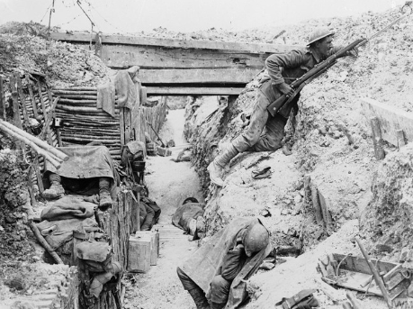
Source 2.  Oral Testimony.  Harry Patch’s testimony of life on the Western Front. Patch was the last surviving British Tommy from the First World war. He died in 2009. | From June 1917 until I left December 1917, I never had a bath. I never had any clean clothes. And...on the way home they took every stitch of clothing off us; vest, shirt, pants, everything and they burnt it all. It was the only way to get rid of the lice. The trenches were about six feet deep, about three feet wide - mud, water, a duckboard if you were lucky. You slept on the firing step, if you could, shells bursting all around you. Filthy. Rats as big as cats. Anything the could gnaw they would - to live. If you didn’t watch it they would gnaw your shoe laces. As you went to sleep you would cover your face with a blanket and you could hear the damn things run over you. If anyman tells you he went into the front line and he wasn’t scared - he’s a liar.
Source 3.  A letter  This is one of many letters sent by staff of the Great Western Railway Audit office at Paddington who had enlisted to fight in the First World War. (RAIL 253/516) | Dear Gerald  Many thanks for letter which was somewhat a surprise to me. No the news was quite fresh as I do not hear from anybody in the office.We have just come from the trenches where we were for seven days and had a most awful time. We were three days in the Reserve and put in the firing line where we took part in an attack and were also under a very heavy bombardment.I am sorry to say we had many casualties thirty five killed and one hundred and thirty eight wounded and I can assure you it was an experience I shall never forget. Anyhow Williams, Kemball and myself came out quite safely.Shall be glad to hear from you. I could write more, only am a wee bit tired after seven days in trenches.  I am yours sincerely, Fred Hull.

Source 4.  A poem  “Suicide in the Trenches,” by the English poet Siegfried Sassoon (1886-1967), is one of the many poems Sassoon composed in response to World War I. | I knew a simple soldier boy  Who grinned at life in empty joy,  Slept soundly through the lonesome dark,  And whistled early with the lark.  In winter trenches, cowed and glum,  With crumps and lice and lack of rum,  He put a bullet through his brain.  No one spoke of him again.  You smug-faced crowds with kindling eye  Who cheer when soldier lads march by,  Sneak home and pray you'll never know  The hell where youth and laughter go.
Source 5. Archive film footage  Published on Nov 9, 2012, Dan Snow visits a reconstruction of a first world war trench, and takes a look at the conditions in the trenches at the Battle of the Somme according to Malins' footage. | 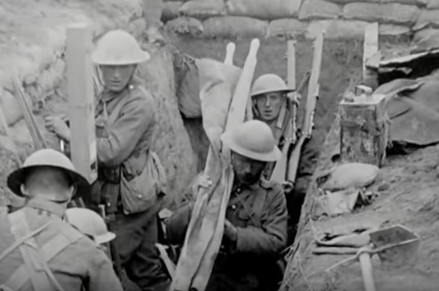
Source 6  Art  Over The Top‘ by John Nash  During the First World War the British government developed a variety of art schemes to record and document all aspects of the conflict from the violence of the fighting fronts to the social and industrial change at home. | 