What happened in America on the morning of September 11th 2001 and how is it possible to think about its consequences?

Activity 1. America’s day of terror begins as four planes are hijacked!
http://news.bbc.co.uk/hi/english/static/in_depth/americas/2001/day_of_terror/
Use the three sources below to write a paragraph which describes what happened on the morning of September 11th 2001 in New York, America.

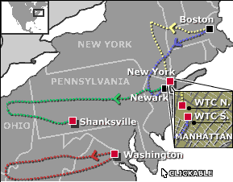

 | Flight 11: Crashed at 0846 EDT
 | Flight 175: Crashed at 0903 EDT
 | Flight 77: Crashed at 0940 EDT |  | A photograph of the Flight 11 North tower crash 08:46 September 11th 2001
 | Flight 93: Crashed at 1003 EDT
Click on the flights or the red locators on the map to navigate

American Airlines Flight 11
Crashed: 08:48 EDT into north tower of World Trade Center
Killed: 92, including nine flight attendants and both pilots, plus many others in the tower.
The Boeing 767 from Boston to Los Angeles, departed from Boston's Logan airport at 07:59 EDT. It hit the north tower between the 95th and the 103rd floor.
Hijackers: Their leader has been identified by the FBI as Mohammad Atta, who had a United Arab Emirates passport and underwent flight training with a number of the suspected hijackers. His suitcase, found at Logan airport, contained a video on flying airliners, a fuel consumption calculator and a copy of the Koran. Other suspected hijackers have been named as: Waleed al-Shehri, and Wail al-Shehri, possibly brothers; Abdulaziz al-Omari; and Satam al-Suqami. The FBI is investigating whether the hijackers could have been using false identification.
On board: When the hijackers took over the aircraft and attempted to communicate with passengers, air traffic controllers overheard what they said. At 08:24 the following transmission came from the plane: "We have some planes. Just stay quiet, and you’ll be OK. We are returning to the airport.” Seconds later another transmission said: “Nobody move. Everything will be OK. If you try to make any moves, you’ll endanger yourself and the aeroplane. Just stay quiet.”

Activity 2. What happened to Flight 11 and 175 after the hijackings?
Use the table below to design a brief mind map complete with information and pictures which describes what happened on the morning of September 11th 2001 in New York, America.

Diagram | Description of what happened to the Flights and the Twin Towers of the World Trade Centre
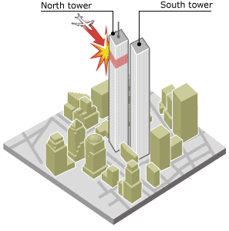 | 08: 46 North tower crash  American Airlines Flight 11 from Boston crashed into the upper floors of the north tower of the World Trade Center at 08:46 Eastern Daylight Time (1246 GMT). It hit the building between the 95th and 103rd floors. Thousands of people were already at their desks in both towers. About 80 chefs, waiters and kitchen porters were also in the Windows on the World restaurant on the 106th floor. Many who worked for firms located in the crash zone were killed instantly. Those on the floors above were already doomed, their escape routes cut off by fire.
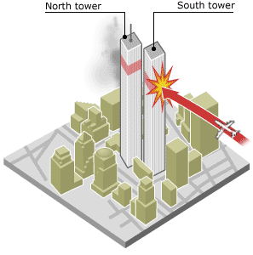 | 09:03 South tower crash  United Airlines flight 175 crashed into the south tower 17 minutes later. The plane caused an explosion on impact and sent a plume of fire out of the opposite side of the building. Many people in the south tower witnessed the first crash and were already trying to leave the building. Some office workers had been told to remain at their desks, resulting in possibly fatal delays. Some people above the fires chose to jump to their death rather than wait for the flames. Hundreds of firefighters and police arrived at the scene to help the office workers escape.
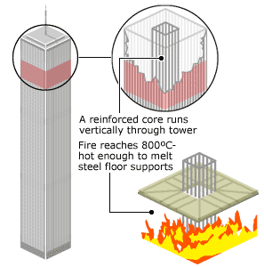 | Fires rage in the towers  At the heart of the towers were vertical steel and concrete cores, housing lift shafts and stairwells. The towers were built to be tough enough to withstand the impact of a plane. The steel was covered in concrete to guarantee firefighters a minimum period of one or two hours in which they could operate if a fire developed. But the fires on 11 September were fed by more than 91,000 litres of jet fuel. The steel cores within the towers heated up to above 800C and the protective concrete cladding on the cores could only keep the heat at bay for a short time. Once the steel frame on one floor had melted, it collapsed, inflicting massive forces on the already-weakened floor below.
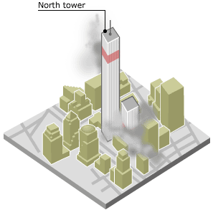 | 09:59 South tower collapses  Once one floor had melted the collapse became inevitable, as each new falling floor added to the pressure on the floor below. Further down the building, even steel at normal temperatures gave way under the enormous weight - an estimated 100,000 tonnes. A little less than an hour after the second crash, the south tower, which had been the second tower to be hit, crumbled to the ground. Hundreds of fire fighters, police officers and people who were trying to escape the towers were crushed.
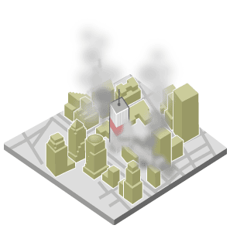 | 10:28 North tower collapses  Twenty-nine minutes later the north tower joined its twin. The floors "pancaked" down and crushed the many people who remained inside. People on the ground ran for their lives as a cloud of debris hit the streets of lower Manhattan. The dust clouds coated the city.
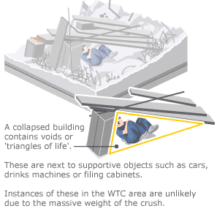 | Rescuers search rubble  After the collapse of the World Trade Center more than 5,000 people were declared missing. Rescuers worked around the clock, carefully searching the ruins in the hope of finding people alive. Five survivors were found in the first 24 hours. Often people can survive for many days in collapsed buildings, but the weight of the floors and scale of the disaster made this possibility unlikely in New York. Initial hopes that many people would be discovered alive soon began to fade.
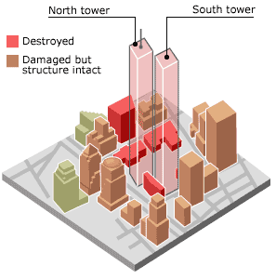 | City devastated.  After the collapse, police cordoned off the city below 14th street. The place where the twin towers once stood became known as "ground zero". A number of other buildings in the same block were also severely damaged. Engineers on the site said they were concerned that the Trade Center foundations might have been severely weakened by the collapse of the twin towers. If the foundations had caved in, the Hudson river could have flooded the area.

Activity 3. Thinking about the short term consequences. “I saw it with my own eyes!!” An eyewitness account of the event.
Read Anshuman Das’s eyewitness account from How useful is Anshuman Das account to historians studying the events of September 11th 2001 in New York, America?
"Feel dust in throat. TV people going on shooting footage like mad… People are crying, cursing. Everybody looks white from the dust."

Anshuman Das is from India
I saw history with naked eyes today. And fate just stared me in the face and made me realize how small we are. Thank God, for having spared us from any harm. And let us not forget the souls that have departed. Now the whole story as seen through my eyes. All times according to my watch.
8:35 am - I get out of the PATH train from Newark at WTC. Usually, I respond to the "Good morning New York" display with a good morning. Today, I am feeling low. Also cursing myself for being late by 10 minutes.
8:37 am - I cross the only block (50-75m) that separates my office (222, Broadway)from WTC. I am reading my mails on the 5th floor.
8:42 am - There is a tremendous noise (like a plane flying really low), the glasses on the windows (1 m from me) bend inwards and straighten out. There is a thundering crash and I look out the window to see - people lying on the street. Glasses of adjoining buildings blown off. Paper flying in the air, Dust and smoke. I run towards a window that offers better view. North Tower, WTC has caught fire. I feel it is a plane, people say it is a bomb.
8:55 am - I am making phone calls to ensure none of my friends are hurt. Get only my cousin on the line. Scan websites, radio programmes and send u updates.
8:59 am - Hear a similar (plane) noise and go to the window. Watch a plane crash into the South Tower. Jump away from the window and duck. The windows develop cracks.
9:10 am - Bldg Security ask us not to evacuate.
9:30 am - Radio reports of Pentagon crash, Whitehouse evacuation, Washington Mall Fire and other hijacked planes come in.
9:40 am - Third (Plane) noise begins. Some one says they see a 3rd plane (A third plane did not hit. The noise was actually the South Tower - first to fall - coming down.) (lie). But the bldg starts shaking. I am one of the first people to reach the floor exit. Doors are Jammed. Push thru and reach the fire exit. Running down flights like mad. Crowd goes on increasing and howling. Reach the reception - get directed towards the rear. The rear door is not opened coz of smoke and dust. Head towards the front. People are crying. There is that pungent smell of electric fire. Check out the CCTV's and see that outside there is only darkness. Somebody shouts for people with asthma. I think they want help. I realize I have left my bag and inhaler at my desk on the 5th floor. I go on as I have some tabs in my pocket. Instead, they want all asthma patients to leave ASAP. we are given water and food. I take neither and step out of the bldg. It is as good as a night without light. The hanky on my face is not enough. I am breathing thru my mouth. Feel dust in throat. TV people like mad - going on shooting footage. Injured and terrified cops brought in for attendance. people are crying, cursing...Everybody looks white from the dust. And wet. Some were bleeding and hence appeared wet. Immobile people on the streets.

