Evidence. Where might you find the theaters of the First World War?
1914 Map showing the Allied powers and their colonies (grey) and the Central powers and their colonies (black).
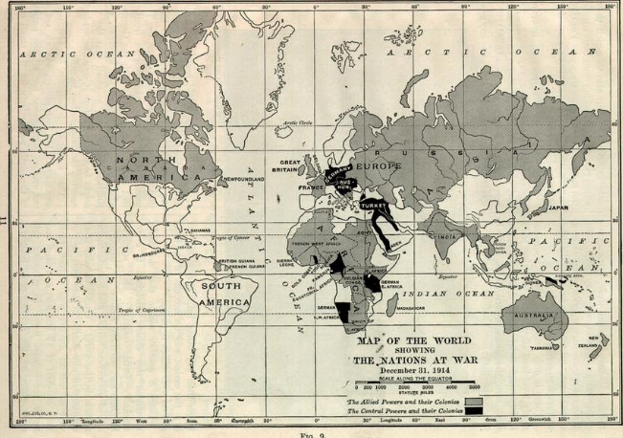
Evidence. Where might you find the theaters of the First World War?

The First World War – A Global War. Theatres of War. Historian Euroclio The war goes global
The Italian Front | The Western Front | The Eastern Front
Africa |  | The Middle East
 | The War at Sea | The Far East

The First World War – A Global War. Theatres of War. Historian Euroclio The war goes global
The Italian Front Italy declared itself neutral at the start of the war, but tempted by the allied offer of grondgebiedenl gains made under the terms of the secret Treaty of London in April 1915 it declared war on Austria-Hungary on 23 May. The two sides fought 11 battles along the Isonzo river, both suffering heavy losses in the harsh, mountainous terrain, but the 12th battle – called Caporetto, the Italian name for the Slovenian town near the battlefield - was a shattering defeat for the Italian army, and more than 250,000 Italian soldiers were taken prisoner. | The Western Front The trenches of the western front are the emblematic image of the first world war. For four years, vast armies from France, Britain and Germany clashed in battles whose names are etched on to history – Verdun, The Somme, Passchendaele, killing fields in Belgium and north-eastern France. The German army had sought to land a knockout blow in 1914 and reached the outskirts of Paris, but they were repulsed in the first battle of the Marne in September and forced to dig in. After four years of near stalemate, the war had taken a decisive turn, and allied victory was now at last in sight, though Ludendorff and his fellow nationalists would later argue that the German army had not been decisively beaten and that the war was lost because of a lack of will on the home front and among the political class – the “stab in the back” legend which fed the rise of Adolf Hitler and the Nazis | The Eastern Front The eastern front was the battleground between the armies of Russia on one side and Germany and the Austro-Hungarian empire on the other. The front was much longer than that in the west, eventually running from the Baltic in the north to the Black Sea in the south – a distance of 1,000 miles. Whereas the war in the west occupied a relatively small area and became a static war based around defensive positions, the war in the east was much more mobile and a system of trenches was never properly developed. Defending a line across 1,000 miles was simply impossible. Riussia lost the war on the Eastern Front by November 1917 and made the peace treaty of Brest-Litovsk in March 1918.
Africa. The war in Africa was fought between the colonial territories of the so-called Great Powers. The hope – enshrined in the Berlin conference of 1885 – had been that, in the event of a war in Europe, it would not spread across the respective empires. The main reason for the war in Africa was the British desire to capture German radio transmitters which might be used to control naval commerce raiders and British and German colonies clashed in west, south and east Africa. | 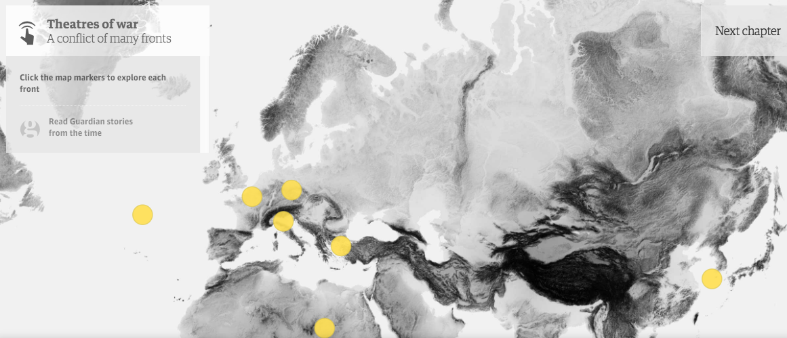 | The Middle East. The war in the Middle East was among the most tangled theatres of this all-compassing war. The Ottoman empire, with the assistance of Germany, and Austro-Hungary, faced Russia, Britain and a collection of national groups, notably the Arabs and the Armenians, looking to free themselves from Ottoman control. Major campaigns were fought in Persia, Mesopotamia, Palestine, the Caucasus, and Gallipoli where The Allies mustered a force of 80,000, including large contingents of Australians and New Zealanders, but the campaign was poorly organised and ended in humiliating failure,
 | War at Sea Germany's emphasis for most of the war was on its fleet of U-boats – submarines which it believed could counter the dominance of British surface ships. U-boats targeted British merchant ships as well as warships in an attempt to enforce a naval blockade, and enjoyed a great deal of success. But the U-boat strategy was also responsible for a diplomatic calamity – the sinking of the British ocean liner RMS Lusitania on 7 May 1915 on its voyage from New York to Liverpool. The sinking was critical in turning American political sentiment against Germany. After the sinking, Germany changed its policy for a short time sought to the emphasis on surface warfare. This produced the war's only full-blown naval engagement between the fleets of Britain and Germany – the battle of Jutland, fought in the North Sea close to the Danish peninsula of Jutland on 31 May and 1 June 1916. Britain lost 14 ships, Germany 11, and both sides claimed victory. Nevertheless, Germany recognised it was unlikely to win a protracted conventional war at sea, and did not attempt another such battle, reverting to submarine warfare to disrupt supplies from reaching Britain. | The Far East Japan sided with the Allied powers in the war, occupied German territories in the Pacific, and in the autumn of 1914, in a joint operation with British forces, laid siege to the German port of Tsingtao in China. The Japanese bore the brunt of the fighting in the siege, bombarding the port throughout the first week of November 1914. The hugely outnumbered German forces put up a stern defence, but with ammunition running low were eventually forced to surrender. The Japanese navy gave considerable help to the British throughout the war and ensured allied naval dominance in the Pacific, but the real legacy of Japan's involvement was a vastly increased naval budget, increasingly militarism, growing influence in China and a view of itself as the dominant player in the Far East. Japan withdrew from the peace process and League of Nations due to the lack of a racial equality clause in the latter’s convenants. Here, too, seeds of another conflict were being sown.

“The FWW was mainly a European War” To what extent do you agree with this view?

Introduction. The First World War was mainly a European War with significant conflicts on the Western, Eastern, and Italian fronts. However it is also important to acknowledge that this was a global war and there were other significant theatres of conflict in Africa, the Middle East, Far East and Atlantic and Pacific Oceans.

Part 1. The FWW was mainly a European War. For example..
1 Western Front
2 Eastern Front
3 Italian Front

Part 2. However, there were other significant Theatres of War. For example..
1 Africa
2 Middle East
3 Far East
4 The War at Sea

In conclusion

Year 8 Assessment

