1 What were the immediate causes of the First World War?
Activity 1.
Put a sub title “International Alliances in 1914”
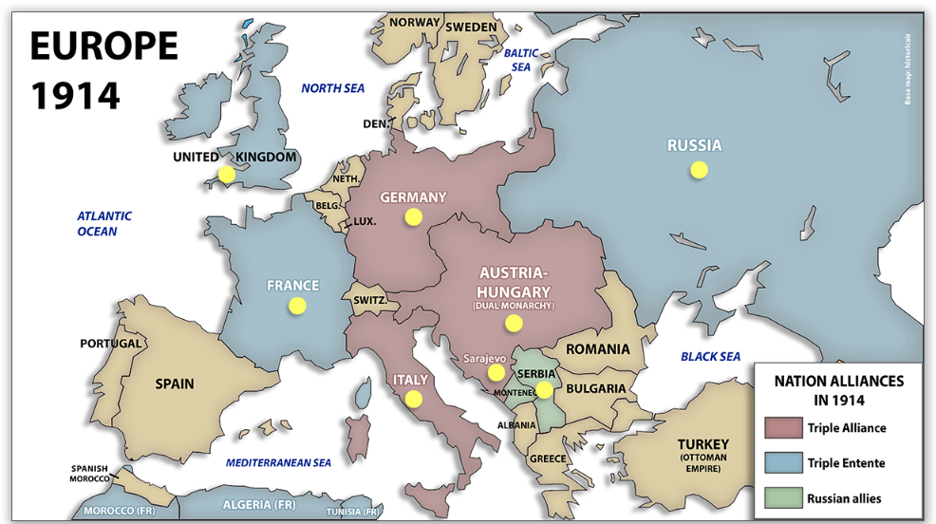

The formation of the Triple Alliance | The formation of the Triple Entente
In 1879 | In 1893
In 1882 | In 1904
 | In 1907
The Germans thought that Britain  had formed the Triple Entente to | The British said that they had  formed the Triple Entente to

Activity 2. Put a sub title “The Assassination of Archduke Franz Ferdinand”.
Put the following statements in chronological order and write them out into best.
Since 1878 Serbia had gained independence and wished to unite all serbs in the area some of whom were in the Austrian Empire. | From 1878 onwards Austria was very suspicious of Serbia. Serbia won the friendship of Russia to help her achieve her aims.
As the Archduke’s car drove along the riverside in Sarajevo, Princip climbed aboard and shot him and his wife. | From 1908 onwards some serbs in Bosnia began to oppose Austrian control.
Gavrilo Princip was one Serb determined to resist Austrian control and he and some fellow supporters planned to kill Franz Ferdinand. | On the 28th June the heir to the Austrian throne Franz Ferdinand went to visit the Austrian Army based in the capital of Bosnia, Sarajevo.
In 1908 Austria gained control of Bosnia, which was a province with many Serbs in it. Serbians and Serbs were disappointed about this. | Since 1867 Austria Hungary had been a multi ethnic Empire determined to stop different ethnic groups gain independence.

Activity 3. Put a sub-title “International reaction to Franz Ferdinand’s assassination”.
Below are 9 statements of what happened from the 28th June to the 6th August 1914. You need to select a statement to go with each of the pictures that you have been given. Stick the picture in your book and write the statement that goes with it next to it.
1st August:  Germany declared war on Russia. It also began to move its army towards France and Belgium. | 28th June:  Austria Hungary declared war on Serbia. Belgrade the capital of Serbia was attacked. | 2nd August:  The French army was put on war  alert, ready to fight any German invasion.
6th August:  to complete the picture, Austria Hungary declared war on Russia. | 28th June:  The heir to the Austrian throne Archduke Franz Ferdinand was  assassinated in Sarajevo by a Bosnian Serb. | 23rd July:  Austria Hungary blamed Serbia for the assassination of Archduke  Franz Ferdinand.
30th July:  Germany sent a message to Russia  ordering it not to help Serbia. | 3rd and 4th August:  Germany declared war on  France and invaded Belgium. Britain ordered Germany to withdraw and when Germany refused, Britain declared war. | 29th July:  The Russian army got ready to help  Serbia defend itself against the Austrian attack.

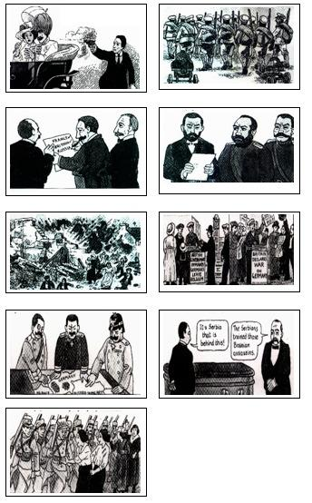

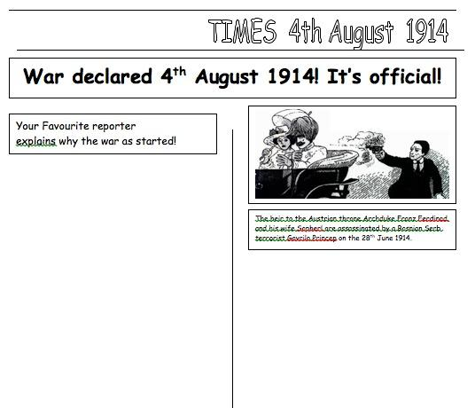

2 What were the deep rooted causes of the outbreak of the First World War in the Europe of 1914?
Although the assassination of Archduke Franz Ferdinand and the response of the Great Powers in Europe to this in July 1914 was an immediate cause of the First World War, it is not the only explanation. It should be noted that many historians argue that there are much deeper background factors which explain why this event in the Balkans erupted into a world war, and some of those events involve struggles beyond Europe.

Activity 1
Causal factors of FWW | Evidence to support this causal factor
Immediate Cause  Reason 1  The alliance system,  FF assassination and  Great Powers response. | During the period 1879-1914 Europe split into two main alliance systems, the Triple Alliance (Germany, Austria, Italy) and the Triple Entente (France, Russia and Britain). The assassination of FF provoked conflict between Austria and Russia and the response of the Great Powers in August 1914 was to support their alliance partners and this led to the outbreak of the FWW.
Background factor  Reason 2  The Arms race between  the powers and military  planning. | 1 There was a great naval rivalry between Britain and Germany during the period 1897-1914. Britain is an island and needed a strong Navy to protect herself from invasion and to look after her Empire. Germany was keen to build up her Navy because German trade was increasing and she to wished to build up an Empire. Britain felt very threatened by this and an naval race between the two powers. Between 1906-1914 Britain built 29 Dreadnoughts and Germany 17 Dreadnoughts  2 The major powers of mainland Europe were building up their permanent armies (excluding reserves).
Background factor  Reason 3  Tension between the  powers as a result of the race to gain influence in different parts of the world. | 1 All of the Great Powers were keen to expand their Empires and influence. Britain had 27 million square km of overseas colonies, France 11 and Germany 2.5. There was a race for colonies and this caused tension, particularly between Germany on one side and Britain and France on the other. Examples of this conflict can be seen in the First and Second Morocco crises of 1906 and 1911.  2 Both Russia and Austria were more interested in gaining influence over developments in the Balkans. In 1908 Austria took over the province of Bosnia which had many Serbs in it. This angered not only Serbia but more importantly Russia. Russia was very keen to support Serbian independence and gain influence in the Balkans herself.
Background factor  Reason 4  Germany was alone  responsible for the  outbreak of the FWW. | 1 German army staff faced a major problem. They knew that if war broke out they would probably have to fight a war in the East against Russia as well as in the West against France. In order to solve this problem they developed the Schlieffen Plan. The aim of this plan was to respond so quickly to any crises that they would attack and defeat France within six weeks and then turn and deal with Russia afterwards. This plan reduced the time for the Great Powers to talk to try and solve any crises.  2 The German army generals believed that war in Europe was unavoidable and they actually planned for this war in advance. The German General Von Moltke said in December 1912, “I believe war is unavoidable. War the sooner the better because our enemies are arming more strongly than we are”. This is why a world war emerged in 1914, the assassination of Archduke Franz Ferdinand was the excuse for it.

Activity 2 The year is 1914. Billy Brown is 18 years old and is training to be a mechanic in an engineering factory in Glasgow. On October 2nd he returned to the family home late one evening looking very pleased and excited. “I’ve joined up” he announced, “four of us went down after work”. Why did Billy go to war in October 1914? Read the Following statements and decide which support each cause.
1 Billy was a very proud young man who was healthy and fit. He had developed some good engineering skills and felt that it was his duty to serve his country with them. | 2 On August 1st Germany put the Schlieffen plan into action. In order to attack France they needed to go through Belgium. This caused Britain to declare war on Germany on the 4th August 1914. | 3 The assassination of Franz Ferdinand provoked conflict between Austria and Russia and the response of the Great Powers in August 1914 was to support their alliance partners and this led to the outbreak of FWW.
4 Since 1878 Serbia had gained independence and wished to unite all Serbs in the area some of whom were in the Austrian Empire. | 5 The aim of the Schlieffen plan was to respond so quickly to any crises that they would attack and defeat France within six weeks and then turn and deal with Russia afterwards. This plan reduced the time to talk and try and solve any crises. | 6 In 1908 Austria gained control of Bosnia, which was a province with many Serbs in it. Gavrilo Princip was one Serb terrorist determined to resist Austrian control and he and some fellow supporters planned to kill Franz Ferdinand.
7 There was a great naval rivalry between Britain and Germany during the period 1897-1914. Britain is an island and needed a strong Navy to protect herself from invasion and to look after her Empire. Germany was keen to build up her Navy because German trade was increasing and she to wished to build up an Empire. | 8 From 1878 onwards Austria was very suspicious of Serbia. Serbia won the friendship of Russia to help her achieve her aims. | 9 Since war with Germany broke out on August 4th Billy and his friends had discussed the situation. His friends talked about how they would be able to look after each other if they joined up together.
10 German army staff faced a major problem. They knew that if war broke out they would probably have to fight a war in the East against Russia as well as in the West against France. In order to solve this problem they developed the Schlieffen Plan. | 11 In August 1914 Lord Kitchener the Minister for War made an appeal for volunteers to join the British Army. By the middle of September 1914 almost half a million had joined up. | 12 All of the Great Powers were keen to expand their Empires and influence. Britain had 27 million square km of overseas colonies, France 11 and Germany 2.5. There was a race for colonies and this caused tension between countries.
13 During the period 1879-1914 Europe split into two main alliance  systems, the Triple Alliance (Germany, Austria, Italy) and the  Triple Entente (France, Russia and Britain). | 14 The German army generals believed that war in Europe was unavoidable and they actually planned for this war in advance. The German General Von Moltke said in December 1912, “War is unavoidable.” | 15 All the main powers of Europe were building up the size of their armies during the period 1900-1914.This included Germany, Russia, France and Austria.
16 Britain felt very threatened by the growth of the German navy and a naval race between the two powers developed. Between 1906-1914 Britain built 29 Dreadnoughts and Germany 17 Dreadnoughts. | 17 Both Russia and Austria were more interested in gaining influence over developments in the Balkans. In 1908 Austria took over the province of Bosnia which had many Serbs in it. This angered not only Serbia but more importantly Russia. Russia was very keen to support Serbian independence and gain influence in the Balkans.

The four big reasons | Statement numbers 1-17.
Immediate Cause  Reason 1  The alliance system,  FF assassination and  Great Powers response.  Numbers | 1  2  3  4
Background factor  Reason 2  The Arms race between  the powers and military  Planning.  Numbers | 1  2  3  4
Background factor  Reason 3  Tension between the  powers as a result of the race to gain influence in different parts of the world.  Numbers | 1  2  3  4
Background factor  Reason 4  Germany was alone  responsible for the  outbreak of the FWW.  Numbers | 1  2  3  4
Reason 5  Billy’s character and decision making  Numbers | 1  2  3

Activity 3
“The most significant factor in why Billy went to war in October 1914 was the immediate circumstances of FF assassination and the response of the Great Powers.” How far do you agree with this view?

Totally agree with some minor qualifications regarding the utility of soldiers letters. | Mostly agree with some major qualifications regarding the utility of soldiers letters. | Mostly disagree with some major qualifications regarding the utility of soldiers letters. | Totally agree with some minor qualifications regarding the utility of soldiers letters.

Introduction
There were many factors that help to explain why Billy went to war in October 1914. I agree/partly agree/disagree with the view that the triggering factors and immediate circumstances of the assassination of FF and the response of the Great Powers was the most significant factor. I think this because..

· The immediate circumstances of the assassination of FF and the response of the Great Powers was certainly important in the decision of Billy to go to war in October 1914. This is because..

· However there are other reasons including background conditions and Billy’s situation, which help to explain Billy’s decision to go to war in October 1914. For example..

· Overall it is important to recognise that all the factors are interlinked. For example..

Conclusion
The key to understanding the causes of the Billy’s decision are the context in which he made the decision. Therefore the most important factors were..

Activity 4
You now have to deal with eight witness statements. You need to decide what each witness thinks is the main cause of the war by ticking the appropriate reason.
Witness | Reason 1 | Reason 2 | Reason 3 | Reason 4
1
2
3
4
5
6
7
8

Witness 1. W. Hines US Ambassador in 1914  German militarism had been working for this for the last 50 years. | Witness 2. Prince von Bulow in 1918.  The German Bethmann Hollwegg said in 1914 that he had no idea how the war had come about.
Witness 3. LCF Turner 1983  The rulers of the Great Powers acted in accordance with the demands of military planning of their General Staffs. | Witness 4. Count Szogyeny, Austrian.  The Kaiser gave Austria German approval to take warlike action against Serbia after Franz Ferdinand’s assassination
Witness 5. Encyclopaedia Britannica 1926  It was the actions of international powers in August 1914, along with the alliance systems which caused the FWW. | Witness 6. D E Marshall 1988  It was the German military plans which led directly to the war. It reduced the German government’s ability to act.
Witness 7. Hungarian woman 1914  The murder of the Archduke is provoking a storm in Austria and this might lead to war with Serbia. | Witness 8. French PM Clemanceau 1914  German: I wonder what history will say?  Clemanceau: History will not say that Belgium invaded Germany.

